Review Module1-Module6教学设计
四块石小学 王雪
I.Revision and lead-in
- Greetings
- T:We had a short holiday for Labour Day.Where did you go?
S:I went to...
T:I went to Pulandian.I went there by ship.Look,that’s the sea.
- Look and read then fill in the blanks.
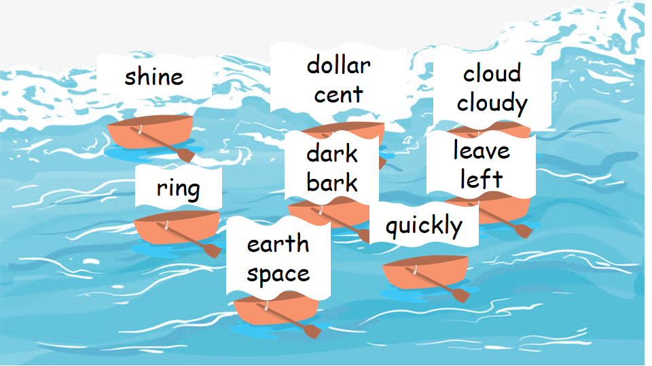 | 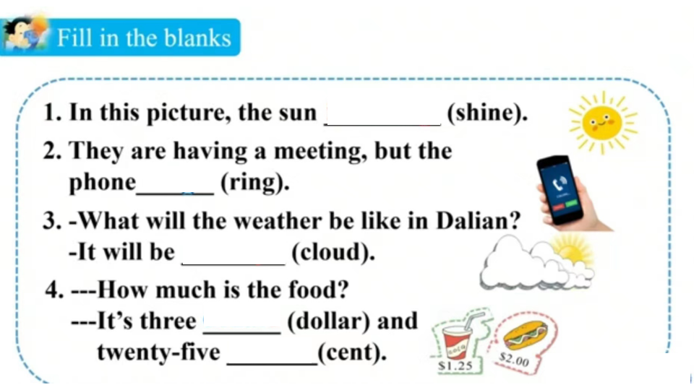
- Then I went to the field.
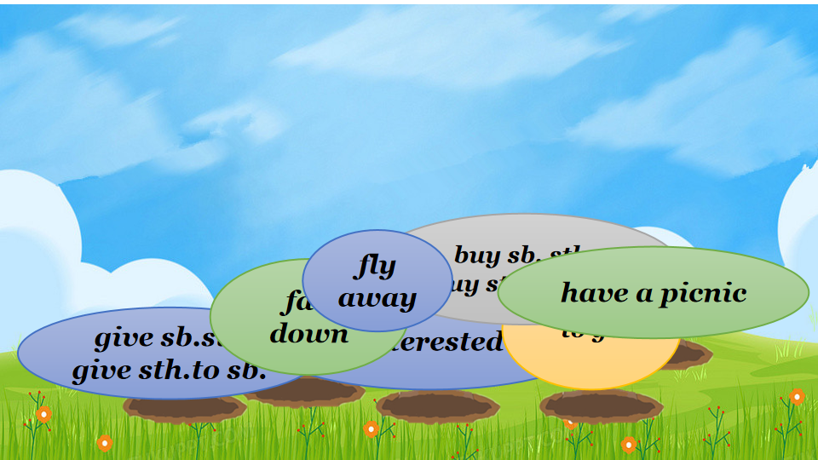 | 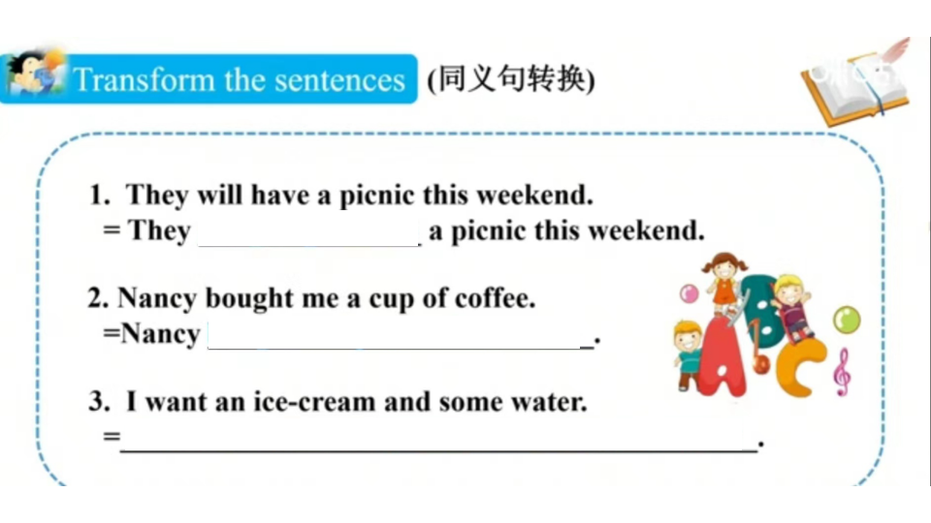

II.Task presentation
I had a good time.Daming is in the US.What about his travel?
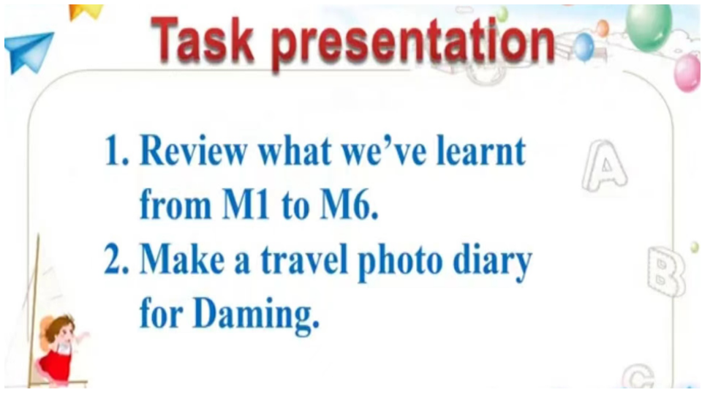

III.Practise
- Look,Daming is in the restaurant now.What’s he doing?Let’s listen and order.
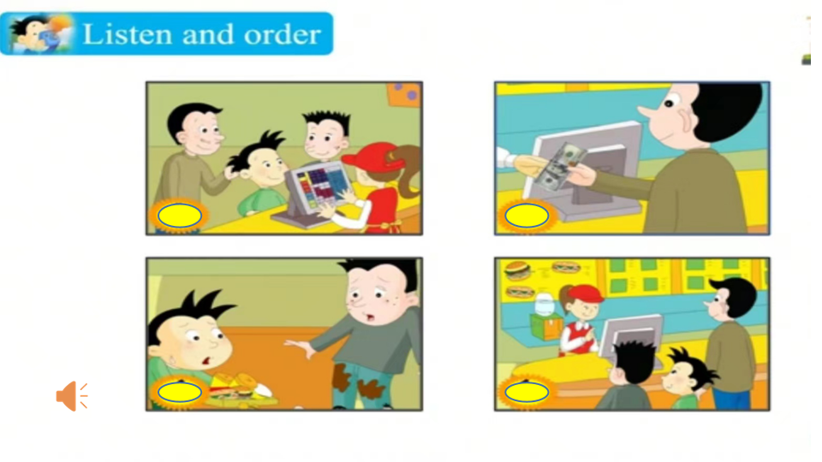
- Daming really enjoyed American fast food.What do you want?Let’s make a dialogue.
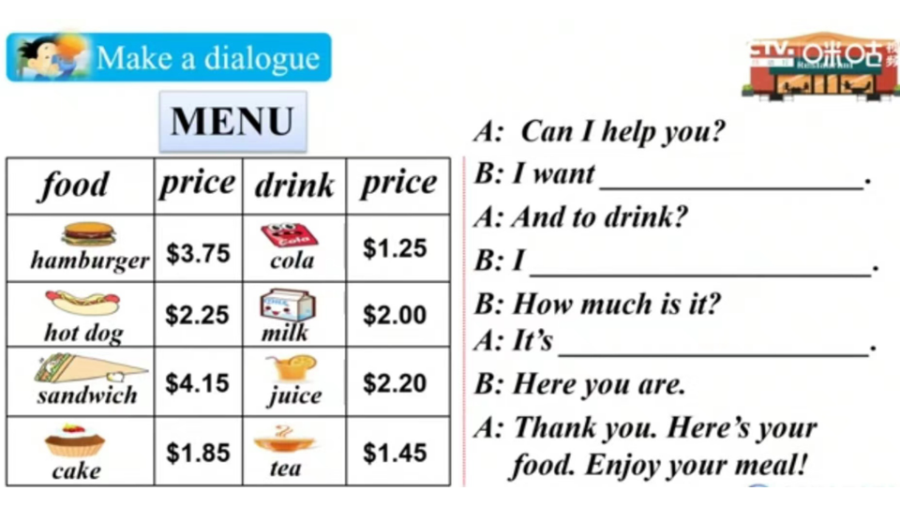
- Look at the pictures .Here is a park.What’s the weather like?What are they going to do?
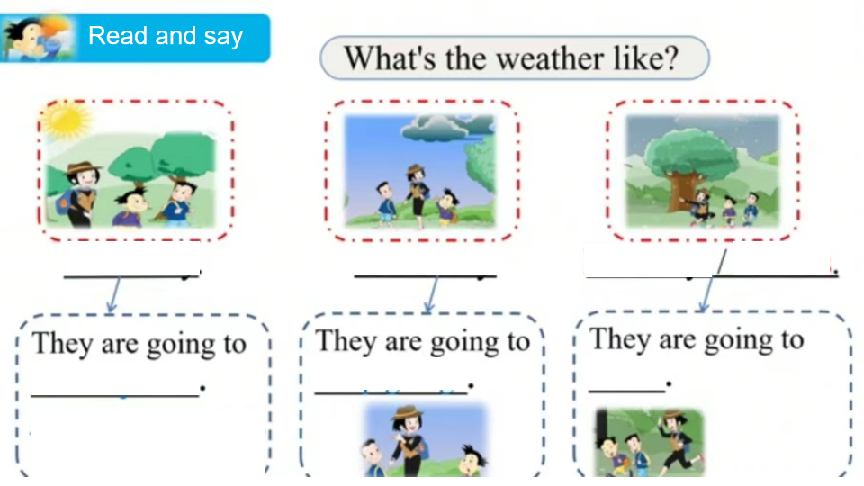
- Daming’s birthday is coming.Simon’s mum bought lots of things at the supermarket.What happens when she comes back?
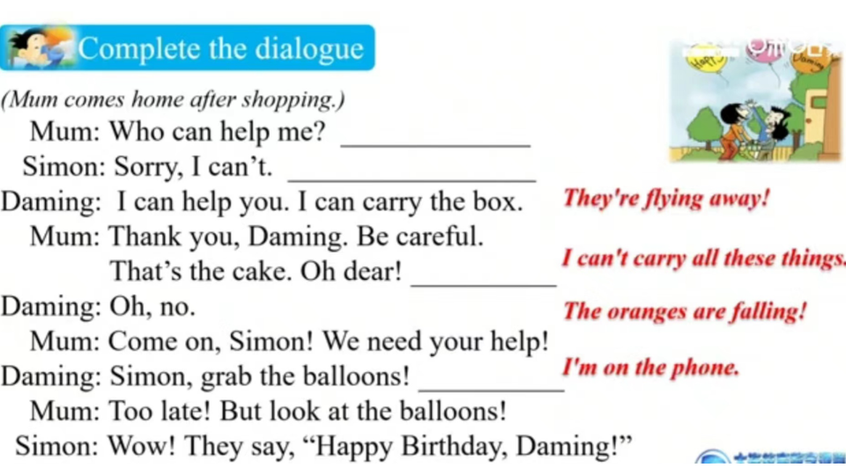

IV.Production
- Look,Daming is having an American birthday party.What’s happening?
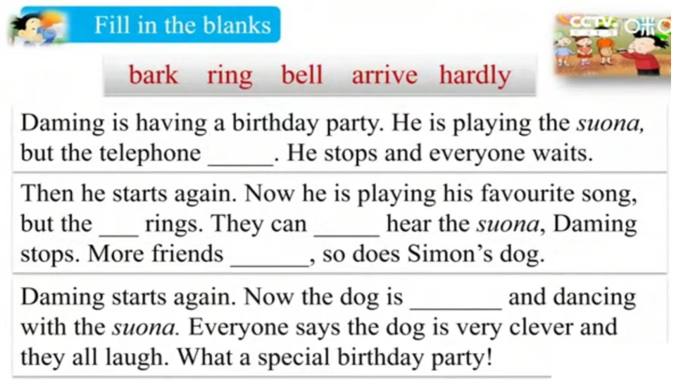
- That’s a special birthday for Daming.And Daming got a book.Then Daming and Simon read the book together.What did they see in the book?
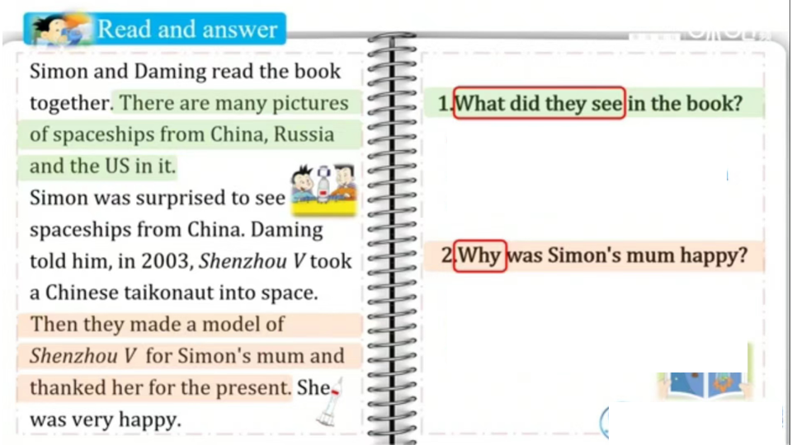
V.Task completion
Well,Daming really enjoyed his travel in the US.And he took lots of photos there.Now he wants to make a photo diary with these photos.Can you help him?
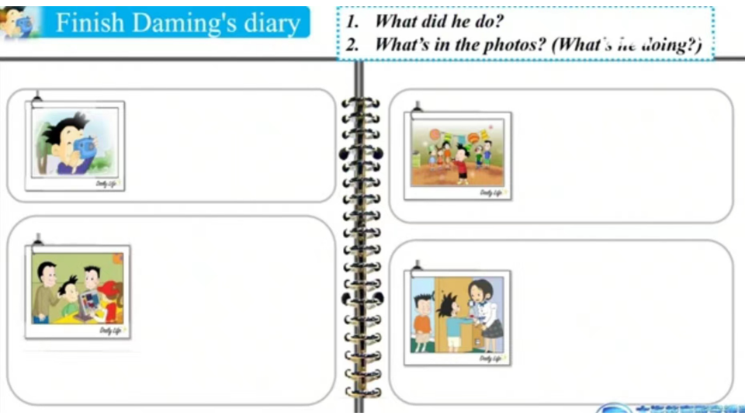
VI.Summary and homework
- Review the tenses of each module
- Homework
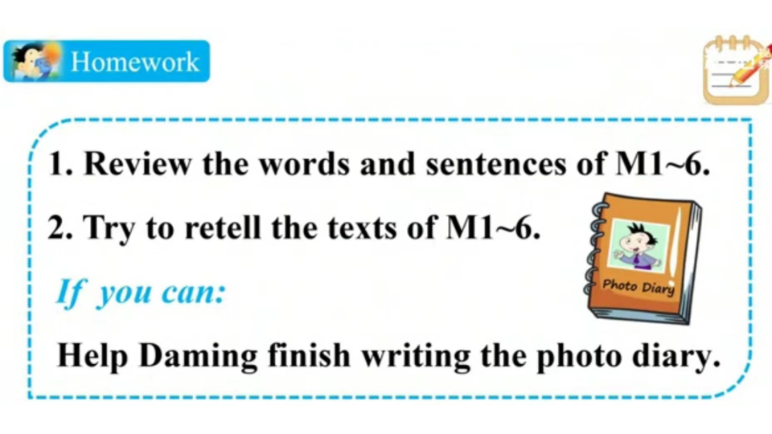

板书设计
