大长山岛镇中心小学三年级英语期末质量检测（2022.1）
学 校
班 级
姓 名
听力部分（60分）
听音选单词或短语，将序号写在题前的括号里（10’）
（ ）1、A. long jump B. high jump （ ）2、A. uncle B. umbrella

（ ）3、A. get out B. go out （ ）4、A. fly B. cry

（ ）5、A. class B. grass （ ）6、A. visit B. which

（ ）7、A. have got B. has got （ ）8、A. water B. want

（ ）9、A. cold B. cough （ ）10、A. these B. those

二、听录音，用数字为下列图片重新排序（10’）
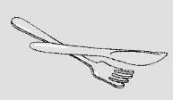
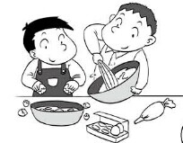
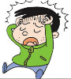
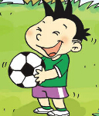


（ ） （ ） （ ） （ ） （ ）

三、听对话，画笑脸(can)和哭脸(can’t) （10’）
1. have a drink
2. have an ice cream
3. have a cake
4. go to the shop
5. watch TV

四、听音选择你所听到的句子（10’）
（ ）1、A. I can see a bird. It can fly.
B. I can see a bird. It can’t fly.
（ ）2、A. I’m going to do the long jump.
B. I’m going to do the high jump.
（ ）3、A. I’m going to Hainan.
B. I’m going to Hong Kong.
（ ）4、A. These ducks are very naughty.
B. Those ducks are very naughty.
（ ）5、A. Can I have a drink, please?
- Can I have a cake, please?
五、听音连线（10’）
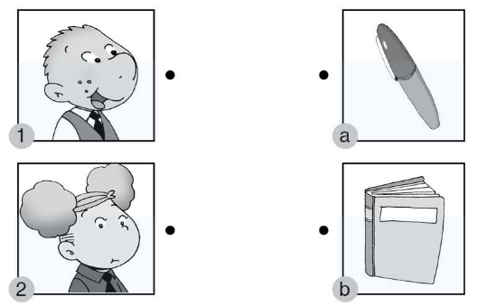
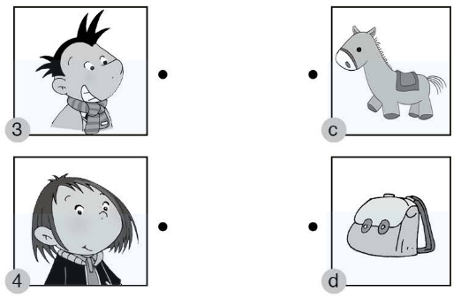

六、听录音，按你听到的顺序用（1.2.3.4.5）给下列句子重新排序（10’）
( ) Yes. Good idea!
( ) Let’s make a cake for Mum and Dad.
( ) What are you doing ?
( ) Please be quiet ! I’m working.
( ) We’re making a cake.
笔试部分（40分）
七、选择(10’)
（ ）1、Let’s get _______ umbrella.
- an B. a C. the
（ ）2、I’m going to _____a doctor.
A. is B. am C. be
（ ）3、We are______a cake for you.
- make B. makeing C. making
（ ）4、I _______ jump far.
A. am not B. can’t C. isn’t
（ ）5、This is_______ red pen.
- Sam B. Sam’s C. Sam’
（ ）6、He _______a new dress.
- have got B. has got C. got
（ ）7、Do you use chopsticks in the UK? No,______.
- we do B. we don’t C. you do
（ ）8、We have classes _____ Fridays.
A. at B. on C. in
（ ）9、_____ bag is broken?
A. Which B. How C. What
（ ）10、 I can jump far. I’m the ______.
- win B. winner C. wins
八、根据语境，填入所缺单词（10’）
1. Do you _________ (使用) a knife and fork?
2. People row on this _______ (湖).
3. Let’s ________ (制作) a _______ (蛋糕).
4. You can’t run ________ (快速地). You are _________ (慢的).
- I can see a bird. It can’t _______(飞).
6. Where are your _________(妈妈) and __________（爸爸）?
7. Where are you going to go ? I am going to go to a _____（商店）.
九、读一读，连一连（10’）
（ ）1、Have you got a test today? A、I’m watching TV.
（ ）2、What are you doing? B、Yes, I have.
（ ）3、What are you going to do? C、Yes, you can.
（ ）4、Can you run fast? D、I’m going to play football.
（ ）5、Can I have an ice cream, please? E、No, I can’t.
十、连词成句（5’）

1、 Amy the high jump is going to do .

2、headache you got a Have ?

十一、阅读短文，判断判断正（T）误（F）。（5’）
It’s going to be sports day in my school on Sunday. I’m going to swim. Wang Fei is going to do the long jump. David can play basketball well. So he is going to play basketball. Susan is good at(擅长) the high jump. She is going to do the high jump. What about Lily? She is going to run a race.
( ) 1. It’s going to be sports day in my school on Saturday.
( ) 2. I’m going to swim.
( ) 3. Wang Fei is going to do the high jump.
( ) 4. David can play football.
( ) 5. Susan is going to run a race.
三年级英语听力题签
注意：每道听力试题读两遍，听力时间控制在15分钟内。
一、听音选单词或短语，将序号写在题前的括号里。
1、long jump 2、umbrella
3、get out 4、fly
5、grass 6、visit
7、has got 8、want
9、cold 10、those
二、听录音，用数字为下列图片重新排序。
1、We are making a cake.
2、He’s got a headache.
3、We use a knife and fork.
4、Dad is watering the flowers.
5、Daming has got a football.
三、听对话，画笑脸(can)和哭脸(can’t)。
1、Amy: Mum, can I have a drink, please?
Mum: Yes, Here you are.
2、Amy: Can I have an ice cream?
Mum: No, you can’t. Look, no ice cream.
3、Amy: Can I have a cake?
Mum: Yes, you can.
Amy: Thanks, mum.
4、Amy: Can I go to the shop?
Mum: No, you can’t go out. You’re ill.
5、Amy: Can I watch TV?
Mum: Yes, you can.
四、听音选择你所听到的句子。
1、I can see a bird.It can’t fly.
2、I’m going to do the high jump.
3、I’m going to Hong Kong.
4、These ducks are very naughty.
5、Can I have a drink,please?
五、听音连线。
1.This is Sam’s book.
2.This is Amy’s toy horse.
3.This is Daming’s schoolbag.
4.This is Lingling’s pen.
六、听录音，按你听到的先后顺序给下列句子重新排序。
( 2 ) Yes. Good idea!
( 1 ) Let’s make a cake for Mum and Dad.
( 3 ) What are you doing ?
( 5 ) Please be quiet ! I’m working.
( 4 ) We’re making a cake.

三年级英语答案及评分标准：
听力部分
一、(1×10＝10分) A B A A B A B B A B

二、(2×5＝10分) 3 2 1 5 4
三、(2×5＝10分) 1. 2. 3. 4. 5.

四、(2×5＝10分) B B B A A
五、(2.5×4＝10分)

六、(2×5＝10分) 2 1 3 5 4
笔试部分
七、(1×10=10分) A C C B B B B B A B
八、(2×5＝10分) use, lake, make, cake, fast, slow, fly, Mum, Dad, shop
（注意黑色粗体部分没有变形扣0.5分）
九、（2×5＝10分） B A D E C
十、（共5分） Amy is going to do the high jump.（3分）
Have you got a headache? （2分）
（请批卷教师酌情把握，统一标准）
十一、（1×5＝5分） F T F F F

