新标准英语一年级起点第九册

Module2 Unit2

They sell many different things. 教学设计

长海县四块石小学
王莺歌
2020年9月15日

Module2 Unit2 They sell many different things.教学设计
教学目标
语言技能目标
读：1.全体学生能够借助自己所学，自主快速阅读文本并能理解文本大意；
2.全体学生能够流利跟读、自读课文。部分学生能够流利并带语音语调的自主朗读课文。
写：1.全体学生能够根据提示写出课文填空；部分学生能够依据范文进行控制性的写作。
看：1.全体学生能够通过老师的讲解，借助视频、板书以及图片看懂文本内容。
听：全体学生能借助老师的板书及课文音频听懂文章大意及与主情景相关的英文句子。
说：1.大部分学生通过学习基本能说出与主情景相关的重点句型；
2.部分学生能够用英语来描述其他场所的的不同特点。
语言知识目标
功能：部分学生能够用英语来描述超市等场所或物品的不同，也各自有特色。
情感态度目标：学生们能够从中体会事物的不同带来的不一样的感受。培养学生的民族情怀，对中国独具特色的文化感到自豪和骄傲。
教学重点： 学会用文中的主句型进行更多关于场所的介绍，口头表达和写作能力的训练。
教学难点：学会用正确的句子结构表达介绍场所和写作。
教学准备及资源：PPT课件，CD-ROM，卡片，task paper
教学内容：
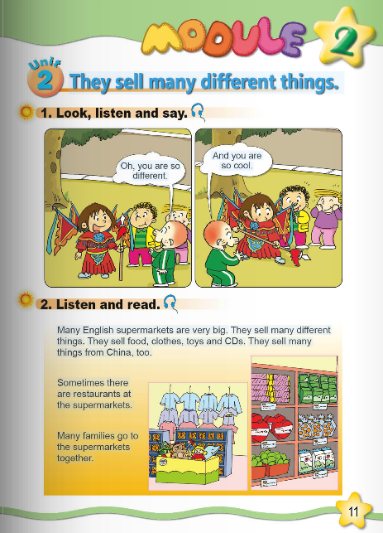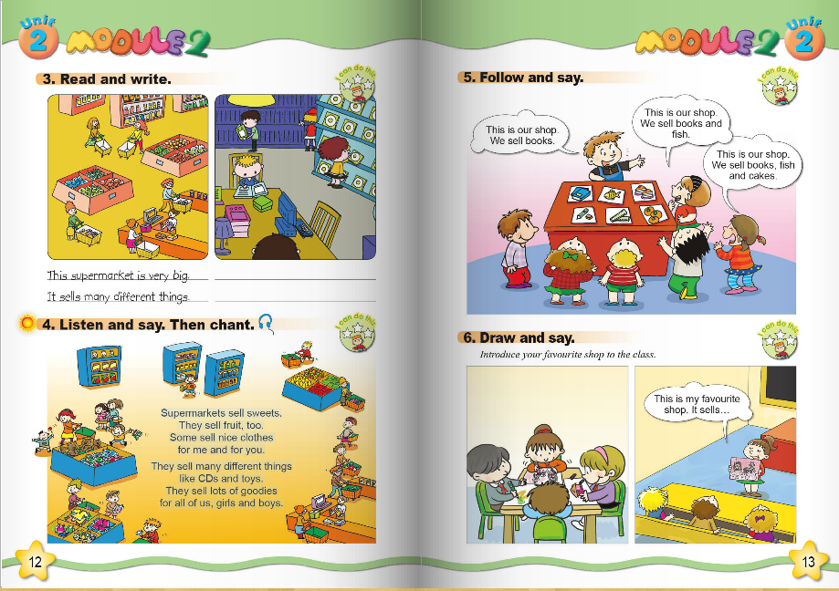

教学过程：
I Warming up and lead in
1. Greetings.
2.PPT show a picture of a supermarket and say：This is a supermarket .There are many things in it. Let`s go and have a look.
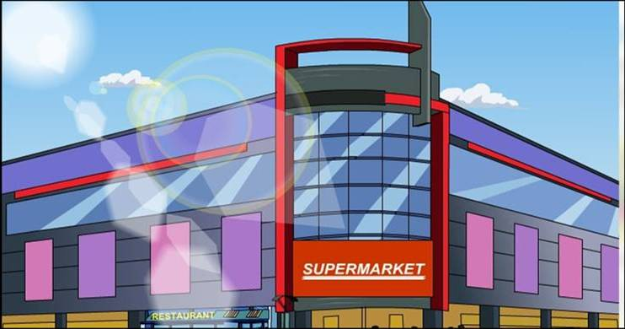
3.Ask the children answer:There is \There are…. according to the pictures.
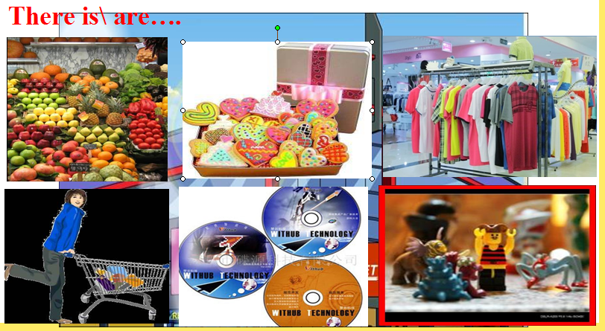
4.Look at the photos of Lingling and answer:Does Lingling look different?
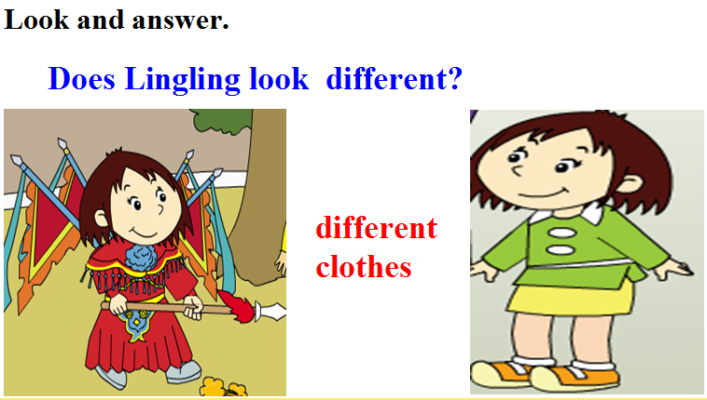
She wore different clothes.
5.Watch the CD-ROM and answer:What`s Lingling doing?
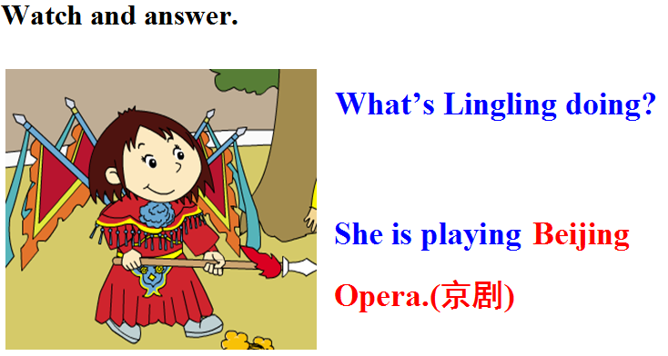
Ts:Beijing Opera is a traditional culture of China .Do they look beautiful?
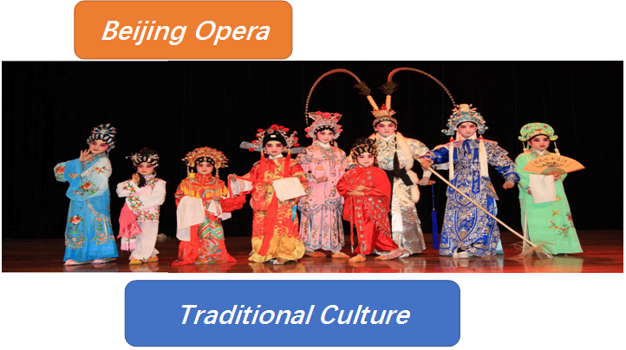
6.Listen and repeat.
II Task Presentation
Today we`re going to learn Module2 Unit2.The task is to use the present tense to introduce your favourite shops.
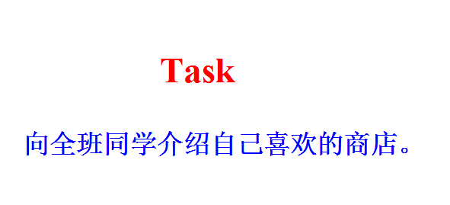
III Text Learning
- Watch the CD-ROM and choose:What`s the text about?
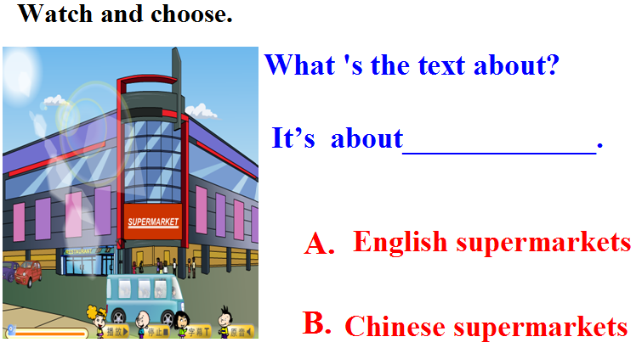
- Listen and imitate.Then choose.
Teach:sell .Read the words:tell ,well ,fell ,bell
sometimes:I sometimes go to school at 7.
Sometimes I eat hamburgers for lunch.
- Practise to read by themselves.Then ask some children to read and complete.
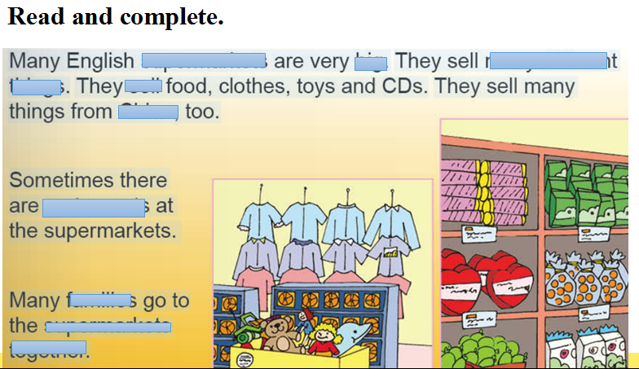
- Let`s retell the text.
IV Practice
- Listen to a chant.then answer the question: What do they sell?
- Read and write.
- Read and judge Tor F.
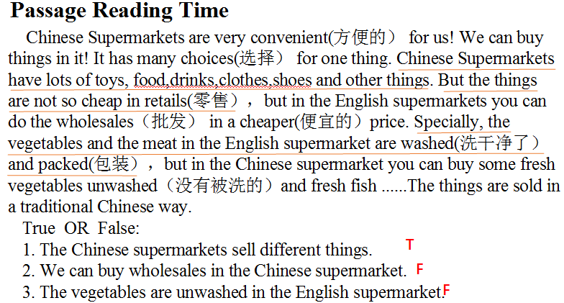
V Task Completion
- Talk about the shops in Changhai.
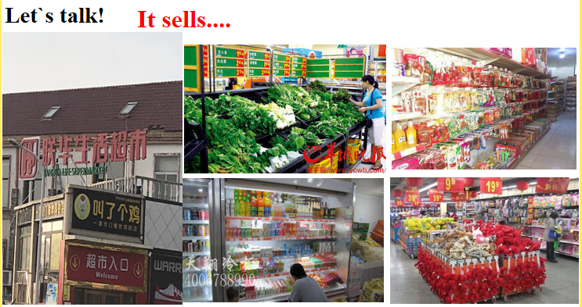
- Talk about your favourite shops according to my example.
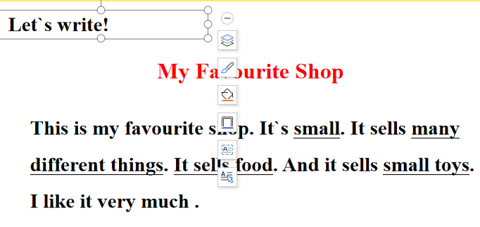
- Then write down.
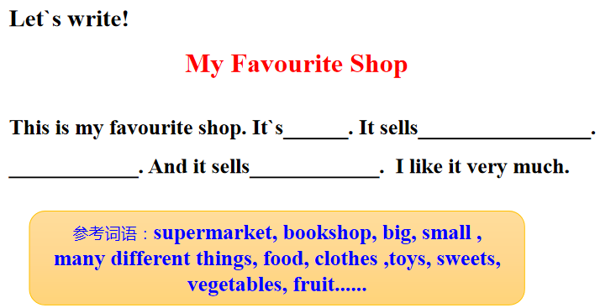
VI Summary and homework
- What have we learnt today?
- Test.
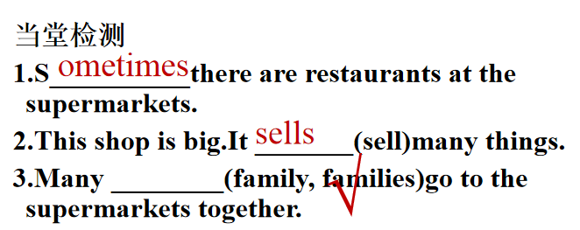
- Homework.
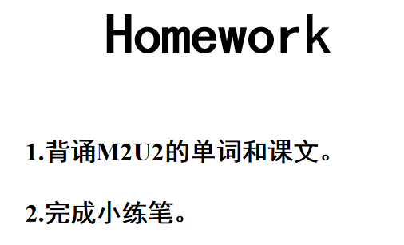

板书设计

English supermarkets

clothes
toys
food
CDs
restaurant
families
They
sell
They sell many different things.
M7U1

