四块石小学2019~2020学年度第二学期期末质量监测
小学六年级 英语
听力部分 (共四大题 30分)

Ⅰ. 听音选词。请选出你所听到的单词。（每题1分，共5分）
( )1.A. interest B. interested C. interesting
( )2.A. make B. lake C. made
( )3.A. word B. world C. work
( )4.A.ground B. proud C. around
( )5.A. bought B.bring C.brought
Ⅱ.听音标号。用数字标出图片的先后顺序。（每题1分，共5分）
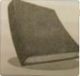
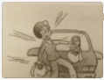
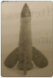
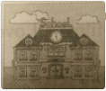
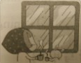

（ ） （ ） （ ） （ ） （ ）
Ⅲ. 听对话，选答语。将正确答案的序号填在括号内。（每题2分，共10分）
( )1. What can Simon drink? A. Water. B. Juice. C. Milk.
( )2. What has Lingling got? A.A ball. B. A doll. C. A dog.
( )3. What will the weather be like tomorrow?
A. It will be windy. B. It will be sunny. C. It will be hot.
( )4. Who can help Mum? A. Sam. B. Simon. C. Daming.
( )5.How will the girl get there?
A.By car. B. By train. C. By plane.
Ⅳ.听短文,判断对错，对的写“T”，错误的写“F”。（每题2分，共10分）
( )1.Simon is going to have a birthday party.
( )2.Everyone is busy for the party.
( )3.Mum is cleaning the house.
( )4.Simon and his friends are shopping.
( )5.Daming is calling to his mum in China.

笔试部分（共六大题，70分）
Ⅴ.单项填空。将正确答案的序号填写在前面的括号里。(每题1分，共15分)
1.It’s easy to make mistakes ______ English words. A. heavy B. high C. with
2.I want some . A. cake B. soup C.book
3.What do you want _______? A. drink B.to drink C. drinks
4.How did Helen Keller learn______and write? A. read B. to read C. reading
5. middle school are you going to go to? A.How B.Where C.Which
6. --Who ____you this present? --Ms Smart did. A. gives B. gave C. giving
7.—Oh, my kite is ____ the tree. —Don’t worry! I’ll help you.
A. on B. in C. under
8.— Here is a present ______you. —Thank you. A. to B. for C. from
9.It started to rain. We ran quickly to hide. We______ our food. We didn’t get wet.
A. leave B. left C. brought
10.He is playing the suona, but the telephone __. A. is ringing B. rings C. ring
11.Everyone ______ the dog is very clever. A. is saying B. says C. say
12.—And to drink? — ______,please. A. Cake B.Cola C. Meat
13.—____ are we going to eat? —At half past eleven. A. When B.Where C. Who
14.In October 2003, Yang Liwei ______ into space in ShenzhouV.
A. fly B.flies C. flew
15.Tomorrow it will ______ in Dalian. A. sunny B.rain C. rainy
Ⅵ.根据语境提示，写出正确单词补全句子。（每空1分，共10分）
1.Her baby is __________(哭，喊). She can ________(几乎不) do anything.
2.Hurry up! The shop will________（关闭）at 7:00.
3.Look！There are some dark _________（云） in the sky.
4.The book about space__________（旅行） is interesting.
5.You are a ____________ (极好的)friend. I will miss you.
6. Wishing you h____________ every day.
7.Yang Liwei s__________21 hours in space.
8.Six years ago, we spoke only very _________(极少量的) English.
9.The train usually _________（到达）at the station on time.

Ⅶ.句子理解。（共15分）
A.找出相对应的答句，将序号填入题前括号内。（每题1分，共5分）
( )1. What are you going to do tomorrow? A.I am doing my homework.
( )2. What are you doing? B. I am going to learn English.
( )3. Did you go to a park? C. I played football.
( )4. How did you go to the park yesterday? D. By bike.
( )5. What did you do last Sunday? E. Yes, I did.
B.根据图文提示，完成下列句子。（每空1分，共10分）
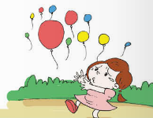
1. The balloons are ______ ________.

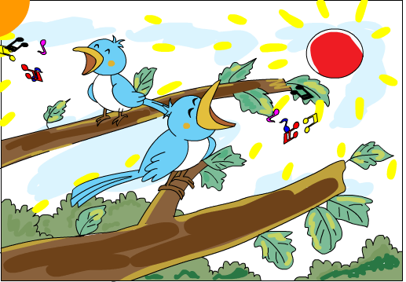
2. In this photo, the sun is __________.
The birds _______ _______ in the trees.
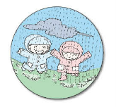
3. Some children _________ _________ in the water.
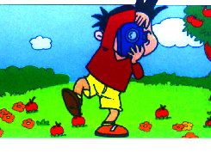
4.What did ______ do?
He________ some ________.

Ⅷ.情景交际。根据对话内容，从方框中选择正确选项，将其序号写在横线上。
（每题2分，共10分）
A. Here you are.
B. How much is the food?
C. Enjoy your meal.
D. Here's your food.
E.What do you want, Lingling?

Cashier: Can I help you?
Dad: ________
Lingling: I want a hamburger and milk.
Dad: I want some noodles and a cola.
Cashier: _________
Dad: Thank you._________
Cashier: It's thirteen dollars and seventy cents
Dad: _________
Cashier: Thank you.________
Ⅸ.阅读理解。（共2大题，计15分）
- 阅读短文，判断正（T），误（F）。（每题1分，共5分）
Fast food is very popular(受欢迎的)now. You can see fast food restaurants everywhere in China. Most of children like to eat KFC and MacDonald’s. They like hamburgers, chips and also some drinks. But fried food (油炸食品)is not good for our health(健康).So boys and girls don’t eat too much fast food. You should eat more vegetables and fruits. They are healthy food.
( )1.There aren’t any fast food restaurants everywhere in China.
( )2.Children like to eat hamburgers and chips.
( )3.Vegetables and fruits are healthy food.
( )4.We should eat too much fast food.
( )5.Eating healthy food is good for our health.
- 阅读短文，选出正确选项。(每题2分，共10分）
Mr Brown lives in a nice house in a small town with his wife. Mrs Brown. From Monday to Friday he works in an office near his house. He is free(空闲的) on Saturdays and Sundays. He has a nice garden beside his house. He likes growing flowers and he often works in the garden on weekends. The flowers are very beautiful and Mrs Brown likes them very much. She often helps Mr Brown in the garden.
1. Mr Brown lives in _______with his wife.
A. a city B. a small town C. a big town
2. He works ________days a week in his office.
A. four B. five C. six
3. He isn't _______on Saturdays and Sundays.
A. free B. busy C. happy
4. He likes ________on Saturdays and Sundays.
A. working in his garden
B. walking in his garden
C. looking at his garden
5. Mrs Brown _________the flowers.
A. likes B. doesn't like C. often sells
Ⅹ.书面表达。(共5分）
同学们，小学生活即将结束，九月份，你们就要升入中学了。给你的好朋友写
一封信，谈一谈你的感受及打算吧！40个单词左右。
Dear______________,
__________________________________________________________________
__________________________________________________________________
__________________________________________________________________
__________________________________________________________________
From,
_____________
六年级英语听力题签：
注意：每道听力试题读二遍，听力时间控制在15分钟内。
听力部分（30分）
Ⅰ、听音,选出你所听到的单词，将其序号填入括号内。
1. He's very interested in painting.
2. We made a spaceship. The name of number 12.
3. People travelled around the world to tell their story.
4.Ning Kang is Yang liwei’s son. He is proud of his dad.
5.Yesterday was Daming’s birthday. Sam brought a present to school for him.
Ⅱ.听音标号。用数字标出图片的先后顺序。
1.I’m looking out of the window. It is raining.
2. She is crossing the road, but a car comes.
3. I’m going to Lake Middle School this September.
4. In our science class, we made a model spaceship together.
5.I got a present from my teacher. It’s a book!
Ⅲ. 听对话，选答语。将正确答案的序号填在括号内。
1.A: Mum, I want to drink some juice.
B: But there's no juice here. You can drink some water.
Question: What can Simon drink?
2. A: Have you got a ball, Lingling?
B: No, I haven't got a ball. But I have got a doll. Do you want to play it?
A: Sure. Thank you.
Question: What has Lingling got?
3. A: Let's have a picnic tomorrow.
B: Will it be sunny?
A: Yes, of course.
B: Great.
Question: What will the weather be like tomorrow?
4.A: Who can help me?
B: Mum，I can help you.
A: Thank you, Daming!
Question: Who can help Mum?
5. Boy: Where are you now?
Girl: I'm on the train. I'll get there at 7o’clock.
Question: How will the girl get there?
Ⅳ.听短文,判断对错，对的写“T”，错误的写“F”。
Daming is going to have an American birthday. Everyone is busy. Simon's mum is making a cake for him. Simon's dad is cleaning the house. Simon and his friends are shopping. They are buying so many things. Hamburgers, hot dogs, colas and balloons. Daming is busy, too. He is calling to his mum in China. He is telling her he will have an American Birthday.

听力部分到此结束！

六年级英语参考答案

听力部分
Ⅰ. (1×5＝5分) 1.B 2.C 3.B 4. B 5. C
Ⅱ. (1×5＝5分) 5—2—4—3 —1
Ⅲ. (2×5＝10分) 1.A 2. B 3. B 4. C 5.B
Ⅳ. (2×5＝10分) 1. F 2. T 3. F 4.T 5. T
笔试部分
Ⅴ. (1×15＝15分) C B B B C B B B B B B B A C B

Ⅵ. (1×10＝10分) 1.crying hardly 2. close 3.clouds 4. travel
5. wonderful 6. appiness 7. pent 8. little 9.arrives
（请注意画线红体部分,如果没有相应形式的变化将各扣0.5分，其他单词完全准确方可得1分。）
Ⅶ. A. (1×5＝5分) 1. B 2.A 3.E 4.D 5.C
B. 1. flying away （2分） 2. shining, are singing（3分）
3. are jumping （2分） 4. he ,took, photos （3分）
（请注意画线红体部分,如果没有相应形式的变化将各扣0.5分，其他单词完全准确方可得1分。）
Ⅷ. (2×5＝10分) E D B A C
Ⅸ. (1×5＝5分) A. 1. F 2. T 3. T 4. F 5.T
(2×5＝10分) B. 1.B 2.B 3.B 4. A 5. A
Ⅹ.略。(5分)
备注：卷面满分为100分。（听力30分，笔试70分。）
优秀：90---100
良好：80---89
及格：60---79
不及格：0---59

