小学三年级英语期末质量检测（2020.7）
听力部分（50分）
学校
班级
姓名
听音选单词，将序号写在题前的括号里（10’）
（ ）1、A.last B.lazy （ ）2、A.will B. wide
（ ）3、A.fun B. forty （ ）4、A.quiet B. quite
（ ）5、A.pick B.report （ ）6、A. afraid B. always
（ ）7、A.hard B. helpful （ ）8、A.were B. was
（ ）9、A.shy B.so （ ）10、A.more B. Monday

二、听录音，用数字为下列图片重新排序（10’）


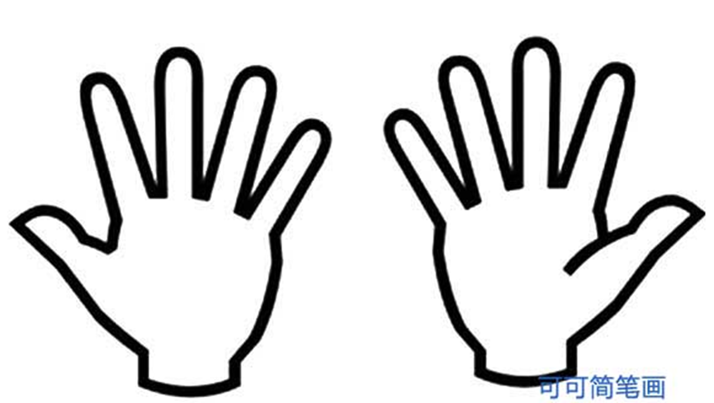

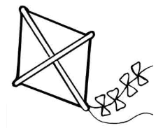

（ ） （ ） （ ） （ ） （ ）
- 听音,选出你听到的句子，将选项写在题前的括号内（10’）
( ) 1. A. We’ll see lions. B. We’ll see tigers.
( ) 2. A. I’ll pick ten apples. B. I’ll pick twelve pears.
( ) 3. A. Here are his arms. B. Here is his leg.
( )4. A. They were very young. B. They were very old.
( )5. A. He is very clever. B. He is very nice.

四、听短文，给下列句子排序（10’）
( ) This river is very wide.
( ) It’s very tall.
( ) Look at this book. It’s about London.
( ) This is Big Ben.
( ) And it’s very long.
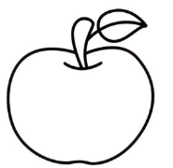
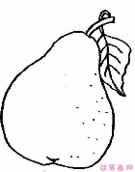
五、听句子，选择正确的图片，在正确的图片下打“√”（10’）
14 40
1. 2.



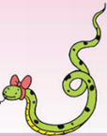

3. 4.

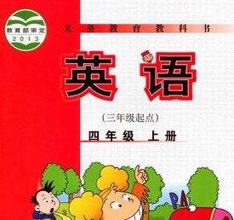
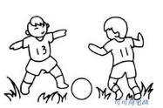

5.

笔试部分（50分）
六、选择(10’)
（ ）1、This girl can’t do her Maths. I’m going to help .
- she B. her C. he
（ ）2、We will ________to the zoo this weekend.
A. go B.goes C. going
（ ）3、We’ll have dinner ______7.
- in B. on C. at
（ ）4、She’s quite good ______ English.
- at B. to C. for
（ ）5、I’ll go swimming________Monday.
- in B. on C. at
（ ）6、Here______his foot.
- is B. are C. am
（ ）7、Your hair ______very short then.
- was B. were C. is
（ ）8、His work is good. His mum is happy____ that.
- to B. with C. in
（ ）9、They ______ very young then.
- was B. were C. are
（ ）10、I’ll pick twelve _______.
- pear B. apple C.pears

七、根据语境，填入所缺单词（10’）

1.We will have a (茶) party tomorrow.

- He is on the first (层).
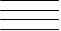
I can （找到） . (宾格他）

- I can (说) English.

4. I (感觉) happy in my . (班级)

5 .It was (也) beautiful （那时）.

- We are on holiday (下一个的) week.

八、根据语境，选择恰当的单词, 将其序号填写在横线上。（10’）
A. see B. breakfast C. pick D. was E. tall

( )1. This is Big Ben. It’s very________.
( )2. We’ll _______ lions in the zoo.
( )3. He ______ in HongKong yesterday.
( )4. We’ll have ______ at 7.
( )5. They will _____ fruit on the farm.

九、读一读，选一选（10’）
（ ）1、Will you take your ball tomorrow? A、There are 20.
（ ）2、Is Daming naughty? B、We’ll see lions and tigers.
（ ）3、How many children are there? C、No, I won’t.
（ ）4、Were you on the second floor? D、Yes, we were.
（ ）5、What will you see? E、No, he isn’t.

十、阅读短文，判断正（T）误（F）（10’）
It’s a fine day. Dongdong is going to the bookstore(书店）with his brother. He puts on his blue shirt and black shoes. They say goodbye to their parents and go to the bus stop(车站）. The bookstore is very far, but the No.6 bus will take them right there. They will see lots of books in the bookstore(书店），and they will buy some books. They will feel very happy.

( )1.Dongdong is going to the park with his brother.
( )2.He puts on his blue shirt and black shoes.
( )3. The bookstore is very far.
( )4. The No.2 bus will take them right there.
( )5.They will buy fruit in the bookstore .

小学三年级英语期末质量检测（2020.7）
听力题签

听音选单词，将序号写在题前的括号里（10’）
1、last 2、 wide
3、 forty 4、quiet
5、report 6、 afraid
7、hard 8、were
9、shy 10、Monday

二、听录音，用数字为下列图片重新排序（10’）
- There is a small monster.
- Here are his hands.
- This house is very old.
- On Sunday, he will ride his bike.
- Will you take your kite to the picnic tomorrow? Yes, I will.

三、听音,选出你听到的句子，将选项写在题前的括号内（10’）
1. We’ll see tigers.
2. I’ll pick ten apples.
3.Here are his arms.
4. They were very young.
5. He is very nice.

四、听短文，给下列句子排序（10’）
( 2 ) This river is very wide.
( 5 ) It’s very tall.
( 1 ) Look at this book. It’s about London.
( 4 ) This is Big Ben.
( 3 ) And it’s very long.

五、听句子，选择正确的图片，在正确的图片下打“√”（10’）
- I will pick 14 peaches on the farm.
- We’ll pick apples there.
- This snake is very long.
- This panda is fat.
- I’m good at English.

小学三年级英语期末质量检测答案
一、听音选单词，将序号写在题前的括号里（10’）
A B B A B A A A A B
二、听录音，用数字为下列图片重新排序（10’）
3 5 2 1 4
三、听音,选出你听到的句子，将选项写在题前的括号内（10’）
B A A A Bd
四、听短文，给下列句子排序（10’）

2 5 1 4 3
五、听句子，选择正确的图片，在正确的图片下打“√”（10’）
14 苹果 长蛇 胖熊猫 英语
六、选择(10’)
B A C A B A A B B C

七、根据语境，填入所缺单词（10’）
1. tea 2. floor find him 3. speak 4. feel class 5. also then 6. next
八、根据语境，选择恰当的单词, 将其序号填写在横线上。（10’）
E A D B C
九、读一读，选一选（10’）
C E A D B
十、阅读短文，判断正（T）误（F）（10’）
F T T F F

