四块石小学2019-2020学年第二学期期末质量监测
小学五年级 英语

2017.5
学 校
班 级
姓 名
听力部分（共四大题，30分）
Ⅰ.听音，找出句子中含有的单词。（每题1分，共8分）
C. sandwiches
C. man
C. delicious
C. driver
C. brown
C. any
C. sent
C. talk
B. messages
B. women
B. different
B. drove
B. borrow
B. uncle
B. show
B. told
( ) 1. A. sausages
( ) 2. A. woman
( ) 3. A. dish
( ) 4. A. drive
( ) 5. A. broken
( ) 6. A. answer
( ) 7. A. send
( ) 8. A. tell

Ⅱ.听音，标号。用数字标出图片的先后顺序。（每题2分，共10分）

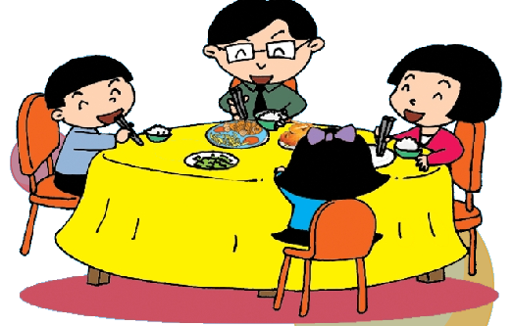

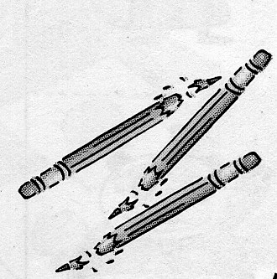


( ) ( ) ( ) ( ) ( )

Ⅲ.听问句，选答句。将正确答案序号填在括号内。 （每题1分，共6分）
（ ）1. A. He will work in a hospital. （ ）2. A. At eight.
B. He works in a hospital. B. Mount Tai.
C. He worked in a hospital. C. Amy will leave.

（ ）3. A. I can go swimming. （ ）4. A. She has eggs and sausages.
B. I can play with the snow. B. It`s delicious.
C. I can play with the leaves. C. She had eggs and sausages.

（ ）5. A. By bus. （ ）6. A. I got it.
B. It will take two hours. B. Yes, I have.
C. We’ll see lots of stones. C. Yes, I did.

Ⅳ.听短文，判断正误。正确写“T”, 错误写“F”。（每题1分，共6分）
（ ）1. Daming is going to the UK this summer.
（ ）2. Simon`s parents aren`t getting ready for Daming`s visit.
（ ）3. Simon and Dad are going to ask Daming some questions.
（ ）4. Mum bought new chopsticks for Simon.
（ ）5. Simon`s favourite subject is History.
（ ）6. Daming will have a good time in the US.

笔试部分（共六大题，70分）
Ⅴ.单项选择。将正确的序号填写在前面的括号里。（每题1分，共15分）
( ) 1. He ____ a doctor. He worked in a hospital.
A. was B. is C. were
( ) 2. _______bag is brown, __________is pink.
A. Yours, mine B. Your, my C. Your, mine
( ) 3. A: What did you have for lunch yesterday? B: I ______ noodles.
A. has B. had C. have
( ) 4. I’ve got a maths game. I played ___________ last week.
A. it B. them C. they
( ) 5.Look, I’ve got ______ email from Daming.
A. a B. an C. the
( ) 6. I_______ some flowers on a piece of paper yesterday evening.
A. drew B. draw C. paint
( ) 7. You _________talk to your friend in the library.
A. will B. can`t C. can
( ) 8. Dongdong’s bag is ___________. He can’t take it to travel.
A. break B. broken C. nice
( ) 9. A:_______ is it ? B: It`s 30 pounds.
A. How many B. How C. How much
( ) 10. In autumn, the leaves fall _________the trees.
A. for B. with C .from
( ) 11. My school bag is red. I carry it ______ my shoulder.
A. on B. over C. with
( ) 12. ___________ are special in the UK.
- Fridays B. Saturdays C. Sundays
( ) 13.My father_______ at 8 o`clock every morning. He`s a policeman.
A. go to work B. goes to school C. goes to work
( ) 14. The ______ come from China. They are famous doctors.
A. man B.woman C. men
( ) 15. A: ______ did your uncle work? B: He worked in a shop.
A. Where B. When C. What
Ⅵ.用词汇的适当形式完成下列句子。（每空1分，共10分）
- People usually eat ______________(鸡肉)，potatoes and vegetables.
- There are four _________（季节）in a year. I like winter. I can play with the s______.
- That is my grandpa. He is _____________(钓鱼).
- This bag is heavy, but that one is l___________. I carry it on my _________(背部).
- My mum was a driver before. She __________(驾驶) a bus.
- I__________(遇见)my classmates in the park yesterday.
- The park is far from my home. It will take three____________(小时).
- My father is a teacher. He teaches children every day. He is very b_________.

Ⅶ.句子理解。
A.情景反应。请将对应的答句的序号填在括号里（每题1分，共5分）
( ) 1. What did she have for dinner? A. We`ll see lots of stones.
( ) 2. Have you got the Wolf, Wolf ? B. Sorry, we haven’t.
( ) 3. What will we see ? C. She had fish and chips.
( ) 4. What did you put in your bag? D. OK. I will.
( )5. Will you help me ? E. My clothes,my shoes,my ticket…

B.根据图文提示，写出句子。(每题2分，共10分)
1. He worked _______ _________ _________.
2. ______ _______ _______ ______ for lunch?
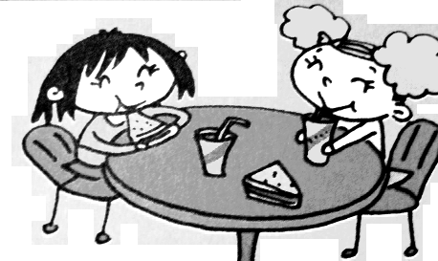
B: They had sandwiches for lunch.
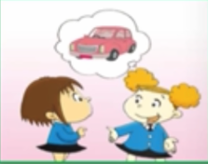
3. A:How will we get there ?
B: ______ ___________.
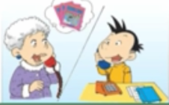
4.I________ you English books.
Did ________ ________ _______?
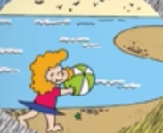
5.What did you do ? (根据图片回答问题)
_____________________________.
Ⅷ.情景交际。选择恰当的句子补全对话, 将序号写在横线上。（每题2分，共10分）
A. Excuse me. B. But we have got the books.
C. Here you are. D. I’ll look on the computer. E. Where are they?

Amy: _______________ Have you got the Snow White videos?
Librarian: _______________ Sorry, we haven’t got the videos. _______________
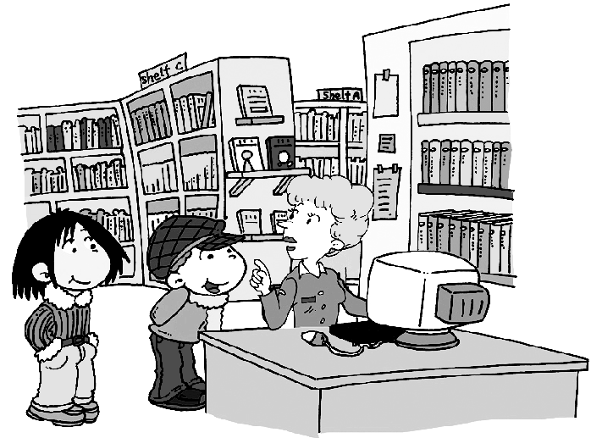
Amy: Oh good. _______________
Librarian: They’re on Shelf B.
Librarian: Your library card, please.
Amy: _______________
Librarian: Please return the books in a week.
Ⅸ.阅读理解。
- 阅读短文并选择，将正确答案的序号填在括号中。（每题2分，共10分）
I’m Jim. My grandma lives in the US. She sent me chocolate, basketball, English books, robots, Maths game and videos last Sunday. I got them yesterday. I love them very much. So I read the English books and ate chocolate. This morning, my grandma gave me a call. I told her that I got the gifts. She invited me to the US this winter. I’m very happy to hear that.
( )1.Jim’s grandma lives in _______ A. the UK B. England C. America
( )2.Jim’s grandma sent_________ to him .
A. English game B. Maths books C. chocolate
( )3.She sent some gifts to Jim ____________.
A. yesterday B.last Sunday C. this morning
( ) 4. Jim’s grandma gave Jim a call_____________.
A. yesterday B.last Sunday C. this morning
( )5. Jim is very happy, because __________
A. His grandma gave him a call B.His grandma will visit him.
C. His grandma invited him to the US.
B.阅读短文，判断正（T）误（F）.(每题1分，共5分)
Yesterday Lucy was very sad, because her cat was in the tree. She called it again and again, but it couldn't get down. Peter was a good boy. He came there and asked Lucy, "What's wrong with you?" Lucy said, "Mimi can't get down from the tree. It's afraid. Look, it's there." "Don't worry, I can help you.” said Peter. Then he climbed up the tree. Mimi saw him and jumped down from the tree and ran away. Lucy was happy and ran after her cat. What about Peter? He was sad! Because he didn't know how to get down!
( ) 1.Yesterday Lucy was very happy,because her cat wasn`t in the tree.
( ) 2.Mimi is afraid, so it can`t get down from the tree.
( ) 3. Peter climbed the tree and helped the cat jumped down from the tree.
( ) 4. Peter is a helpful boy.
( ) 5. At last, Peter and Lucy were very happy.
Ⅹ.书面表达。（本题共5分）
亲爱的同学们，愉快的暑假就要来了，请给你的好朋友Sam写封信，告诉他你的暑假计划吧！注意：语法正确，语句通顺，不少于5句话，不能使用自己的真实姓名哦！
Dear______________,
_________________________________________________________________________________________________________________________________________________________________________________________________________________________________________________________
___________________________________________________________________________________
Love,
______________ 同学们，试卷已完成，要认真检查哦，祝大家取得好成绩！
五年级英语听力题签：
注意：每道听力试题读二遍，听力时间控制在15分钟内。
Ⅰ.听音，找出句子中含有的单词，将序号写在前面的括号内。
No.1 We had bread and sausages this morning.
No.2 The women wore men`s clothes.
No.3 Fish and chips is a traditional English dish.
No.4 My grandpa drove a taxi before.
No.5 My school bag is brown, what about you?
No.6 Maybe you will find the answer.
No.7 I sent you an email. Did you get it?
No.8 The actors told lots of jokes.
Ⅱ.听音,标号。用数字标出图片的先后顺序。
No.1 My bag is new. I carry it with my hand.
No.2 My pencils are broken.
No.3 Where does your father work? He works in an office.
No.4 In the UK, families usually eat lunch together on Sundays.
No.5 Have you got Snow White?
Ⅲ.听问句，选答句。将正确答案序号填在括号内。
No.1 Where does your father work?
No.2 When will you leave?
No.3What can you do in autumn?
No.4 What did Lingling have for breakfast?
No.5 How will they get there?
No.6 Lingling, I sent you a present,did you get it?
Ⅳ. 听短文，判断正误。正确写“T”, 错误写“F”。
Daming is going to the US this summer. His cousin Simon lives there. And they are getting ready for Daming`s visit. Mum bought new chopsticks for Daming. Dad put another bed in Simon`s room, and he read a book about Chinese history. History is Simon`s favourite subject. Dad and Simon are going to ask Daming some questions .They will visit a lot of places together. And it will be fun !

五年级英语参考答案
听力部分
Ⅰ.听音，找出句子中含有的单词，将序号写在前面的括号内。
每题1分：A B A B C A C B
Ⅱ.听音,标号。用数字标出图片的先后顺序。
每题2分：2 3 5 1 4
Ⅲ.听问句，选答句。将正确答案序号填在括号内。
每题1分： B A C C A C
Ⅳ. 听短文，判断正误。正确写“T”, 错误写“F”。
每题1分：F F T F T T
笔试部分
Ⅴ.单项选择。将正确的序号填写在前面的括号里。
每题1分：A C B A B A B B C C B C C C A
Ⅵ.用词汇的适当形式完成下列句子。
每空1分： chicken , seasons , snow , fishing , light , back , drove, met , hours, busy
（请注意画线红体部分,如果没有相应形式的变化将各扣0.5分，其他单词完全准确方可得1分。）
Ⅶ.句子理解。
- 情景反应。请将对应的答句的序号填在括号里
每题1分：C B A E D
- 根据图文提示，写出句子。
每题2分: 1.in an office ,
2.What did they have ,
3. By car,
4.sent,you ,read ,them ,
5.I played on the beach.
Ⅷ.情景交际。选择恰当的句子补全对话, 将序号写在横线上。
每题2分: A D B E C
Ⅸ.阅读理解。
A.阅读短文并选择，将正确答案的序号填在括号中。
每题2分: C C B C C
B.阅读短文，判断正误
每题1分: F T F T F
Ⅹ.书面表达。
本题共5分: 答案略。

