大长山小学2019—2020学年度第二学期期末质量检测试卷
班级
姓名
学号

小学六年级 英 语 完成时间：80分钟
题  号 | 听力部分 |  |  |  | 笔试部分 |  |  |  |  |  | 总分
题  号 | Ⅰ | Ⅱ | Ⅲ | Ⅳ | Ⅴ | Ⅵ | Ⅶ | Ⅷ | Ⅸ | Ⅹ
得
分

听力部分（共四大题，30分）
Ⅰ.听音，找出句子中含有的单词，将序号写在前面的括号内。（每题1分，共5分）
( ) 1. A. cent
( ) 2. A. cat
( ) 3. A. enjoy
( ) 4. A. bell
( ) 5. A. stay

( ) 6. A. work
B. spent
B. cap
B. dry
B. dark
B. study

C. sent
C. cup
C. joy
C. bark
C. start

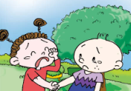
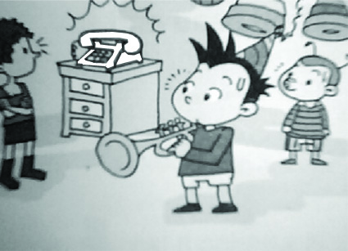
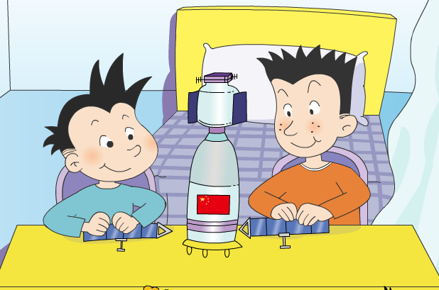

Ⅱ.听音，将下列图片用数字（1,2,3,4,5）排序。（每题1分，共5分）

( ) ( ) ( ) ( ) ( )

Ⅲ.听对话，选答语,将正确答案序号填在括号内。（每题2分，共10分）
（ ）
（ ）
( ) 1. Where are they talking now?
A. In the shop. B. At the restaurant. C. In the library.
( ) 2. What are they going to do tomorrow?
A. See a film. B. Watch the rain. C. Watch TV.
( ) 3. What’s the time now?
A. It’s 9:00. B. It’s 10:00. C. It’s 11:00.
( ) 4. How does the woman feel now?
A. Surprised. B. Excited. C. Bored.
( ) 5. When is Tom going to a new school?
A. In September. B. In October. C. In December.
Ⅳ.听短文，判断正误，对的写“T”，错的写“F”。（每题2分，共10分）
( ) 1. This letter is for Lingling.
( ) 2. Daming and Simon had a very funny day on Sunday.
( ) 3. They brought sandwiches and drinks to have a picnic.
( ) 4. The ducks ate all their sandwiches.
( ) 5. They were happy with the ducks.

笔试部分（共六大题，70分）
Ⅴ.单项选择。将正确答案的序号填写在前面的括号里。（每题1分，共15分）
( )1. I’m hungry. I want _______ some noodles.
A. drink B. eat C. to eat
( )2. It ______ snow in Harbin tomorrow.
A. will B. will be C. going to
( )3. The birds are singing _______ the trees. A. on B. in C. at
( )4. A: What ______ she doing? B: She’s ________ to her friends.
A. does, writes B. does, writing C. is, writing
( )5. Everyone is listening and clapping, but a friend ________.
- arrive B. arrives C. arriving
( )6. This song is beautiful. The girl is singing _______ it.
A. like B. with C. to
( )7. Tingting likes reading and she asks Linda _______ books with her.
A. read B. reads C. to read
( )8. Lingling will have American birthday this year.
A. a B. / C. an
( )9. We’re going to play football_____ half past four.
A. on B. at C. in
( )10. A: _______ are you laughing? B: Because I saw a funny film.
A. What B. Why C. How
( )11. Lucy is falling. Let me help _______. A. she B. her C. hers
( )12. What will you do _______?
A. last Sunday B. every day C. tomorrow
( )13. A: What did you bring to class? B: I ______ the flute.
A. bring B. brings C. brought
( )14. Keep on ________ baseball. You can be a good baseball player.
A. play B. playing C. to play
( )15. A: Can you help me, please? B: ________________
A. Good idea! B. See you! C. Sure!
Ⅵ.结合所给语境，根据汉语或首字母提示，补全句子。（每空1分，共10分）
1. It’s raining heavily outside. C _________ the windows, please.
2. The baby is naughty. Listen! He is _________ (喊,叫) now.
3. After school, I usually go h ________and do my homework.
4. Betty is _________ ________ (对……感兴趣) collecting stamps.
5. Last month, I __________ (飞) to Shanghai to have a holiday.
6. Yesterday, my mother ___________(制作) me a cake. I liked it very much.
7. Daming had a birthday party yesterday. He had a w___________ time with his family.
8. Sam and Amy spoke very __________ (极少量的) Chinese _________(单词,字).
Ⅶ.句子理解。（共2大题，共15分）
A.情景反应，请将对应的答句的序号填在括号内。（每题1分，共5分）
( )1. Where is my bag? A. Yes, I am.
( )2. When were you born? B. Sorry, I’m doing my homework.
( )3. How long did he spend in space? C. In November.
( )4. Are you going to read books? D. He spent about twenty-one hours.
( )5. Who can help me? E. It’s under the bed.
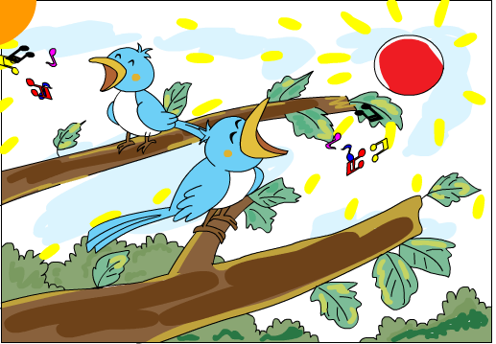
B.根据图文提示，补全句子。（每题2分，共10分）
1. In this photo, the sun ________ _________.

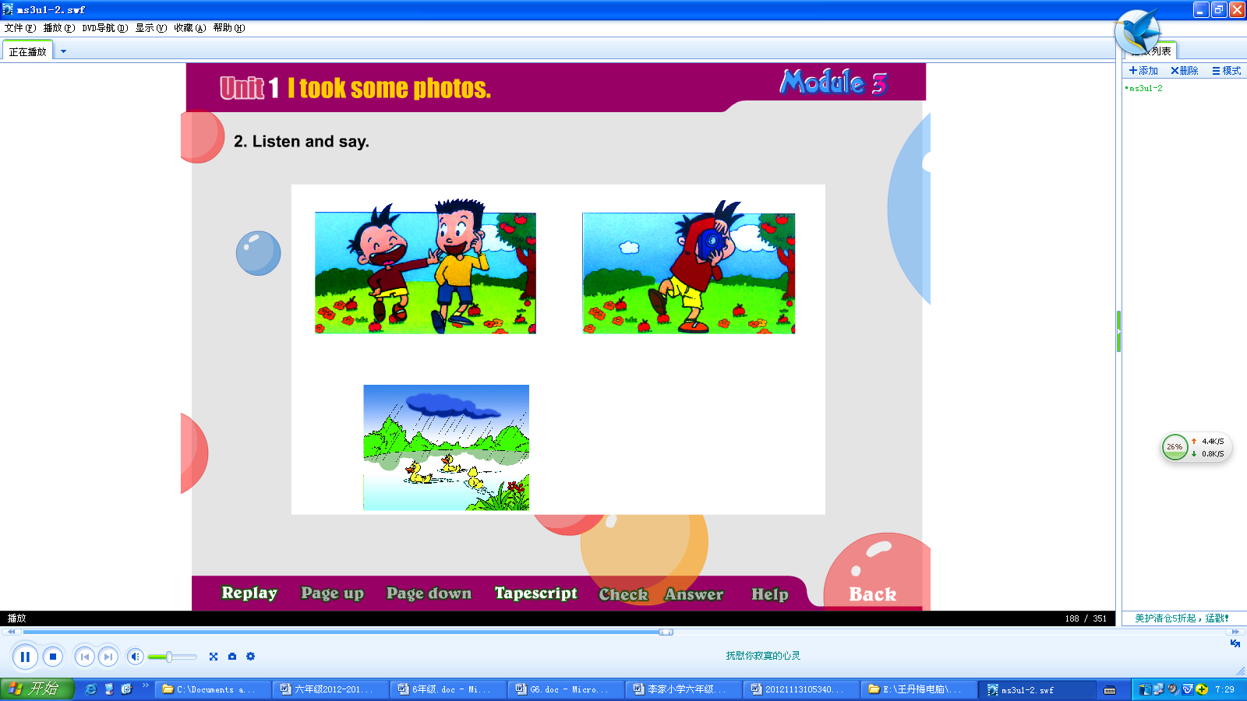
2. A: What did he do yesterday?
B: He ________ some _________.

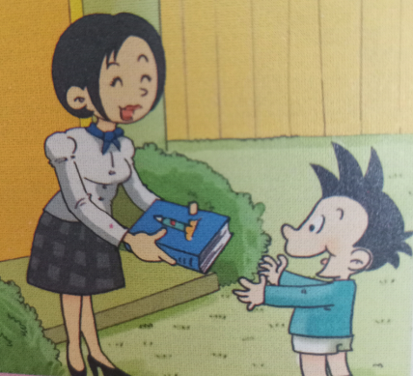
3. Simon’s mum _________ a book ________ Daming yesterday.
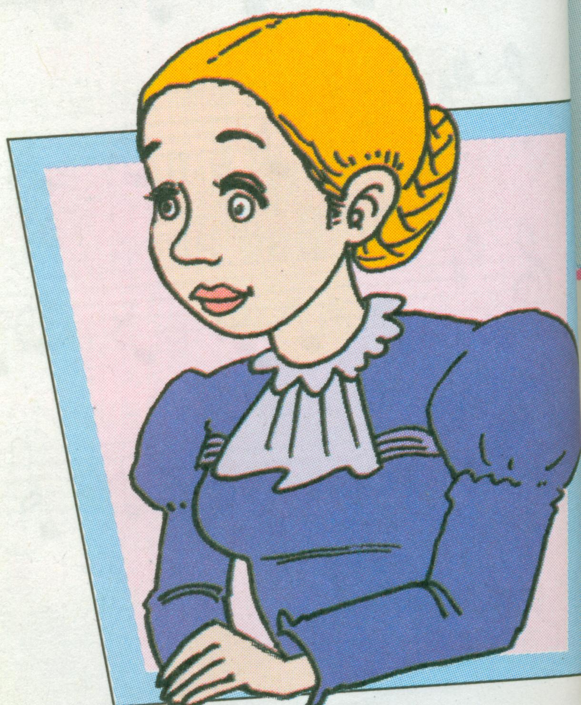
4. Helen was blind. So she _________ _________.

5. A: Which middle school are you going to this September?（根据自己实际情况作答）

B: ___________________________________________.

Ⅷ.情景交际。选择恰当的句子补全对话, 将序号写在横线上。（每空2分，共10分）
Daming: look! Who’s he over there ?
Sam: ______________
A. Who can help me?
B. Because all the apples are
falling down the stairs.
C. What’s the matter?
D. Thank you.
E. He’s Jim.
Daming: Hi, Jim !_________ Why are you crying?
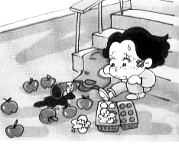
Jim: ___________________
Sam: The cola is falling , too.
Jim: ________________
Daming and Sam: We can help you.
Jim: _______________

Ⅸ.阅读理解。（共15分）
- 阅读短文，判断正误。正确的写“T”，错误的写“F”。（每题2分，共10分）

Simon's mum is at the supermarket. She is buying birthday things for Daming. Simon is making a birthday card. Simon's mum can't carry all things. Daming comes out to help her. He helps her carry the box. It's the cake. Simon's mum tells Daming to grab the balloons. At last, the oranges are falling. The balloons are flying away. Simon comes out to help them. But he can't get the balloons. But they are very happy, because in the sky, the balloons make "Happy birthday".

( ) 1. Simon's birthday is coming.

( ) 2. Simon is at the supermarket with her mum.

( ) 3. Simon's mum needs help.

( ) 4. Daming can't come out to help.

( ) 5. Daming will get a card from Simon.
- 阅读短文，回答下列问题。（每题1分，共5分）
There are many famous people in the world. Nick Vujicic (尼克.胡哲) was born in Australia in 1982. He was born without(没有) arms and legs. He only has two little toes (脚趾). But he learnt to write and type when he was six. It was difficult for him, but Nick was very clever and he tried hard. He can swim, dive (跳水), play football, play golf… He can do all the things as you and me. When he was 19, he began to make speeches. He wrote many books and made lots of videos. His first book is Life Without Limits. Nick travelled round the world and told his story. He is famous all over the world.
1. Are there many famous people in the world?
_________________________________________________________
2. When was Nick Vujicic born?
_________________________________________________________
3. What did he learn when he was six?
_________________________________________________________
4. Can he do all the things as you and me?
_________________________________________________________
5. What’s the name of Nick’s first book?
_________________________________________________________
Ⅹ.书面表达。（5分）
难忘的小学生活即将结束，假如你是Mike，请你给好朋友Qiqi写一封告别信，回忆你们共度的六年小学时光，留下你对他的感谢和祝愿吧！
要求：格式正确，条理清晰，表达准确，语句通顺，语意连贯，书写规范，40个单词左右。
Dear_______,
____________________________________________________________________________________________________________________________________________________________________________________________________________________________________________________________________________________________
_______________________________________________________________________ From,
________
六年级英语听力题签
※注意：每道听力试题读二遍。时间控制在15分钟以内。

Ⅰ.听音，找出句子中含有的单词，将序号写在前面的括号内。
1. This food is thirteen dollars and twenty-five cents.
2. Why do you have cups on your heads?
3. You brought us lots of joy. I will miss you.
4. There are some dark clouds in the sky.
5. I’m going to study Chinese, English, Maths and Geography in middle school.

Ⅱ. 听音，将下列图片用数字（1,2,3,4,5）排序。
1. I want a hamburger and some eggs.
2. It will be windy tomorrow. You can fly a kite with friends.
3. He is playing the suona, but the telephone rings.
4. Daming and Simon made a paper spaceship together.
5. I’m very sad to say goodbye to you.

Ⅲ.听对话，选答语,将正确答案序号填在括号内。
1. W: Can I have some soup?
M: Sorry, we don’t have any soup. But you can have a hot dog.
Question: Where are they talking now?

2. M: Lucy, let’s have a picnic tomorrow.
W: Oh, no. It will rain tomorrow.
M: That’s too bad. Then let’s watch TV at home.
W: Good idea!
Question: What are they going to do tomorrow?

3. M: When are we going to the supermarket?
W: At ten o’clock. One hour to go.
Question: What’s the time now?
4. M: China sent another spaceship into space!
W: Wow. I’m very excited to hear that!
Question: How does the woman feel now?

5. W: When are you going to start a new school, Tom?
M: In September. But I will go back to England in December.
Question: When is Tom going to a new school?

Ⅳ.听短文，判断正误，对的写“T”，错的写“F”。
Hi Lingling,
I had a very funny day on Saturday. I went to a park with Simon and his mum. We brought sandwiches and drinks. We wanted to have a picnic. There was a big lake in the park and there were lots of ducks. Then it started to rain. It rained and rained and rained. We ran quickly to hide. Then those naughty ducks went to our picnic and ate all the sandwiches! I took some photos for you. Then we went home. We were wet, hungry and angry with the ducks!
From,
Daming

听力部分到此结束！

六年级英语参考答案及评分标准
听力部分(30)
I. (1×5 = 5 分) A C C B B
II. (1×5=5分) 5 3 2 4 1
III. (2×5＝10分) B C A B A
IV. (2×5＝10分) T F T T F
笔试部分(70分)
V、(1×15＝15分) CABCB BCCBB BCCBC
VI、(每空1分×10=10分)
1. Close 2. crying 3. home 4. interested in
5. flew 6. made 7. wonderful 8. little words
(画线黑色粗体部分没有形式上的变化，扣0.5分。）
VII、 A.（1×5=5分） ECDAB
B. (每题2分×5=10分)
1. is shining 2. took photos 3. bought for / gave to
4. couldn’t see 5. 语用准确，贴合实际情况即可
(画线黑色粗体部分没有形式上的变化扣0.5分，第5小题酌情扣分，其他单词完全准确方可得分。)
Ⅷ. (2×5＝10分) ECBAD
Ⅸ. (2×5 + 1×5＝15分)
A. F F T F T
B. 1. Yes, there are. 2. He was born in 1982. 3. He learnt to write and type.
4. Yes, he can. 5. His first book is Life Without Limits.
Ⅹ.（5分）略 (请任教六年级的英语老师批阅作文，并自行把握评分标准,做到心中有数。)
备注：卷面满分为100分。（听力30分，笔试70分。）
优秀：90---100
良好：80---89
及格：60---79
不及格：0---59
2020年7月

