新标准英语一年级起点第十一册

Revision of Module 7
Describing the animals.

大连市长海县小长山岛镇中心小学

吴巧丽

新标准英语一年级起点第十一册
Revision of Module 7教学设计
〔语言功能〕谈论日常生活习惯
〔语言结构〕一般现在时
〔教学目标〕
1. 语言知识目标：a. 复习词汇：bamboo, gave, its, almost, deaf, frightened,roar,fox, at night
复习目标语句：Pandas love bamboo.
They eat for twelve hours a day!
Do snakes love music?
No, they don’t. They’re almost deaf.
A child sleeps for ten hours a night.
b. 复习并阅读运用一般现在时描述人或动物的生活习惯
2. 语言技能目标: a. 能听懂对日常生活习惯进行的简单的英语描述；
b. 能在读懂短文的基础上，运用一般现在时对人或动物的生活习惯进行描述和问答；
c. 掌握并运用目标语句和词汇书写简单的关于动物话题的小练笔。
3. 情感态度目标：激发学生热爱动物的情感及养成良好生活习惯。
〔教学重、难点〕
重点: 能掌握一般现在时态，体会第三人称单数的用法。
难点：能正确运用一般现在时，描述人或动物的生活习惯。
〔学生分析〕
一般现在时态是小学阶段四个时态中最不利于学生理解的，尤其是一般现在时态中的第三人称的用法，经常被学生们忽视。本节课以学生喜闻乐见的动物为载体，描述它们的生活习性，使学生在课堂上能积极运用所学语言知识。
〔教学准备〕
PPT课件， task paper，奖励图片
〔教学内容〕

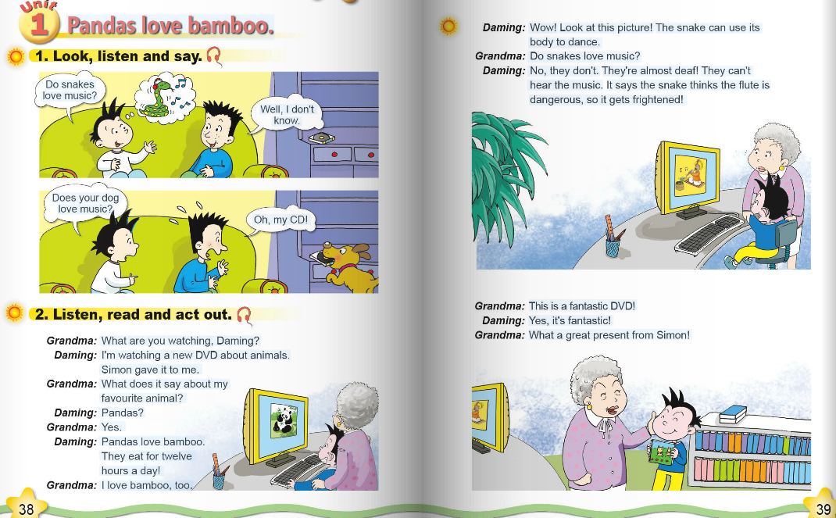
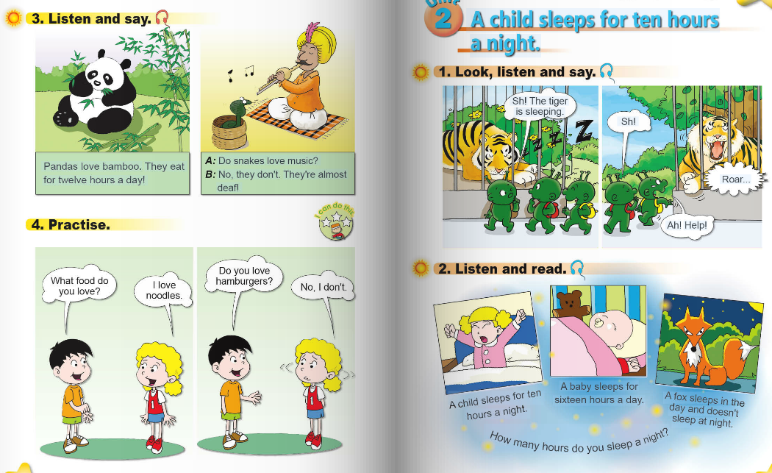

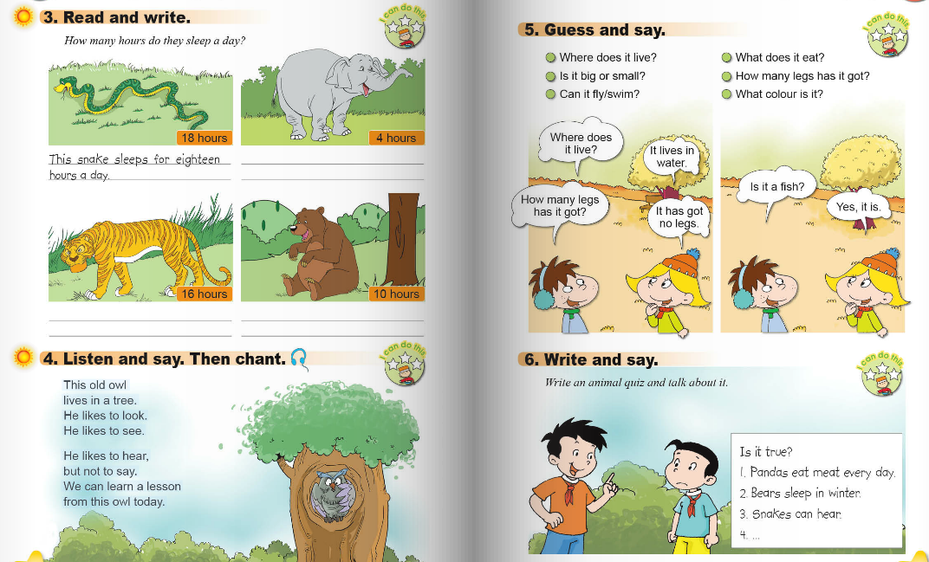

〔教学过程〕
Step 1、Revision and lead in
Let’s have a competition today. You are Team A and the others are Team B.
1. Greetings.
2.First let’s enjoy a chant.
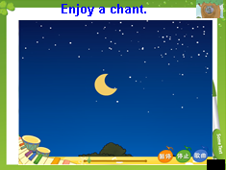
3.Free talk
T：Do you love animals? What animals do you love? Why?
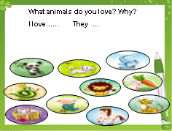
Step2.Task presentation
Today we’ll review Module7. Our task is using the present tense to introduce your favourite animal.
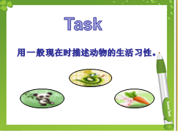
Step 3、Practice
- Please take out your task paper. Let’s read the text by yourself and think: How many animals are there in the text?
Review the text of Unit1 and Unit2. （文本再构，将Unit1与Unit2的文本整合）
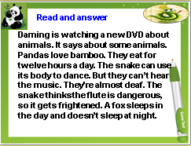
Read the text by yourselves. Answer the questions:
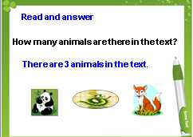
Can you talk about the pandas/snake/fox?
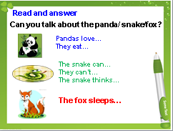
- Can you talk about the 3 animals? Let’s practice in your groups.
- Try to retell the text and fill in the blanks.
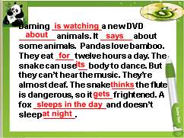
- Read the text again and pay attention to the red words.
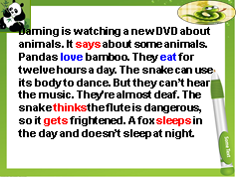
- Why we use “ says, thinks, gets, sleeps”? Why we use “love, eat”?
- Sum up the rules of the present tense.
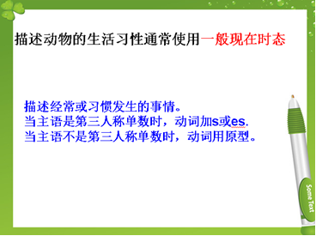
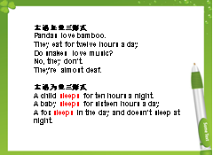
- How many hours do you sleep a night?
- Do a survey in your groups. You can ask and answer one by one.
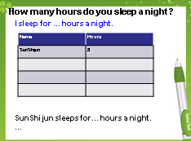
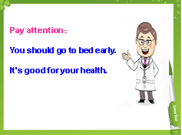
9.

Pay attention. Your should go to bed early. It’s good for your health.
Step4. Production
- There are 3 children: Lijie, Max and Lix. Do you know what are their favourite animals? Let’s listen and match,
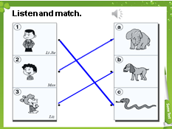
- Let’s play a guessing game. Read the sentences and guess the animals.
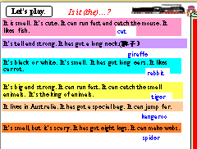
3.Spiders are small, but they are scary. Let’s read a passage about spiders, and answer the questions.
Pay attention: You can underline the answers in the text. Have a good comparision.

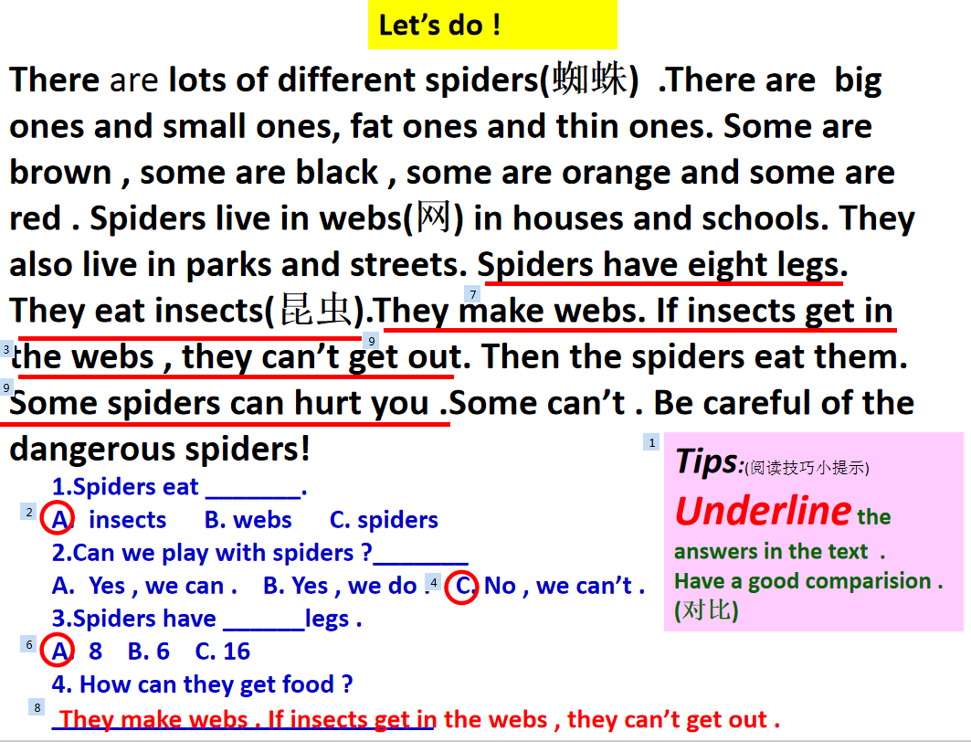
Step 5、Task completion
- Boys and girls, do you know what is my favourite animal? Can you guess? Let’s look at here. They’re fat and cute. They’re black and white…
Ss: Pandas.
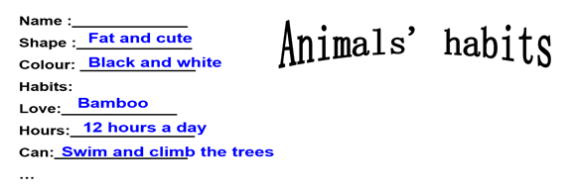

- Yes. Look! I introduce my favourite animals according “Name, Shape, Habit…”
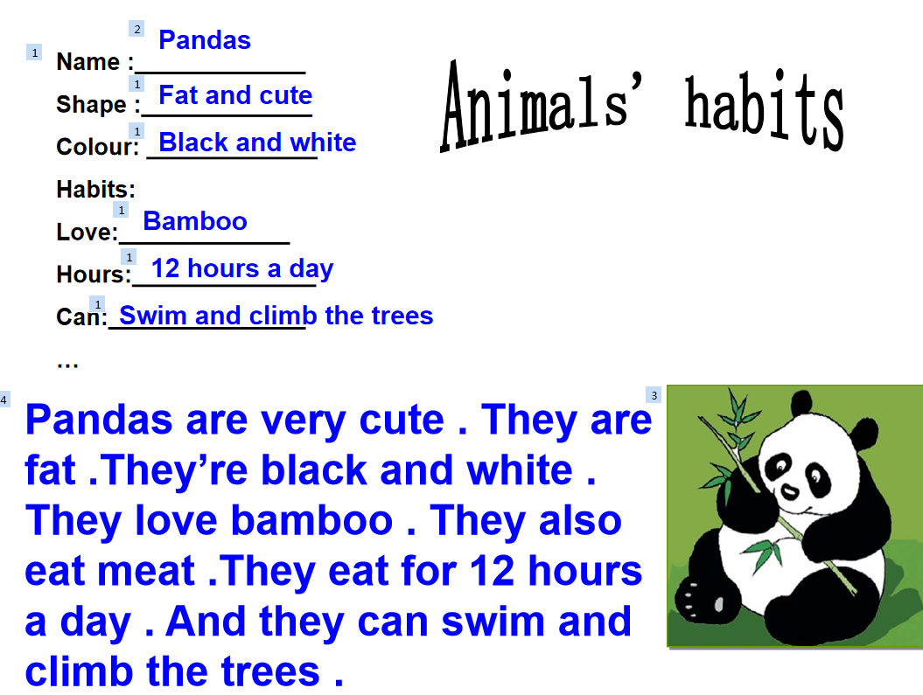

- Can you talk about your favourite animals like this?
(学生结合板书来谈论)
4.Now let’s write about your favourite animals. If you write about the pandas, you can get one star, if you write about the other animals, you can get two stars.
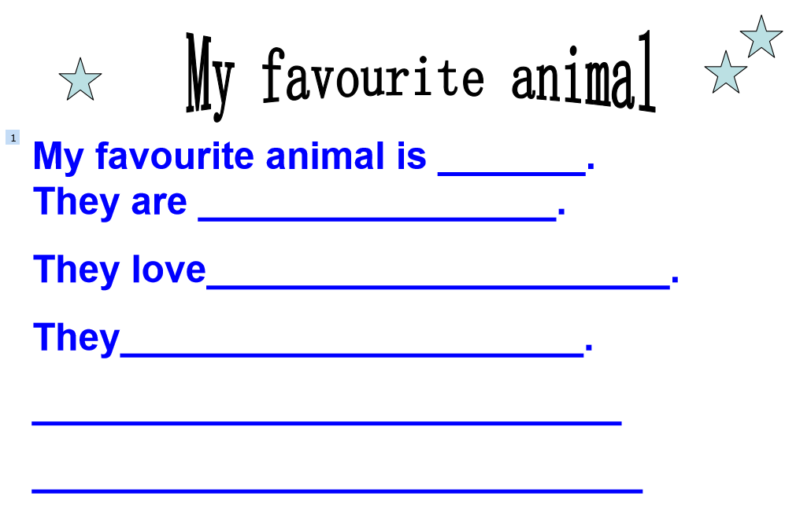
4.Share in class.
Step6.Summary and homework.
- Watch a video about the animals.
They’re our friends. They’re cute. They have love. And they’re the same as us. But they are killed. They’re destroyed.
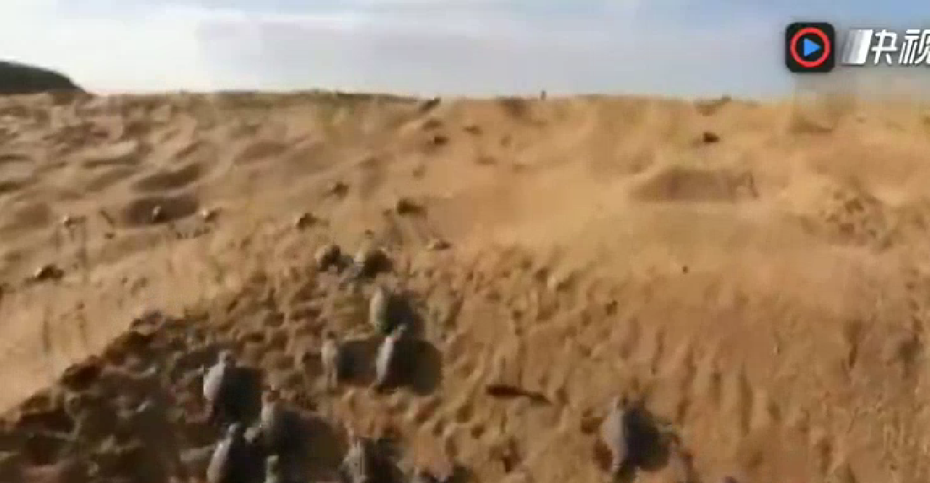

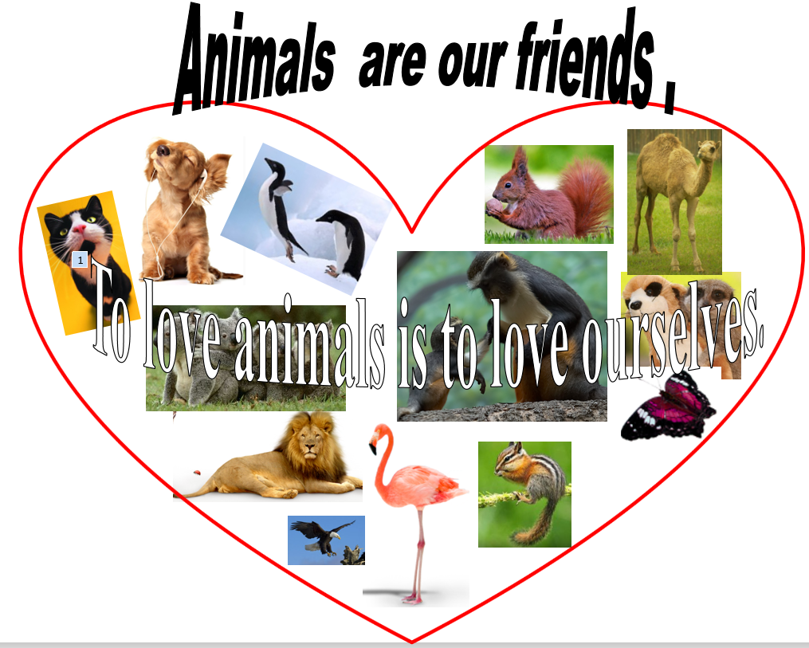
- 评价：To love animals is to love ourselves. Animals are our friends.

- What have we learned today?
引导学生总结一般现在时的规律，总结怎么描述最喜欢的动物。
- Let’s have a test.
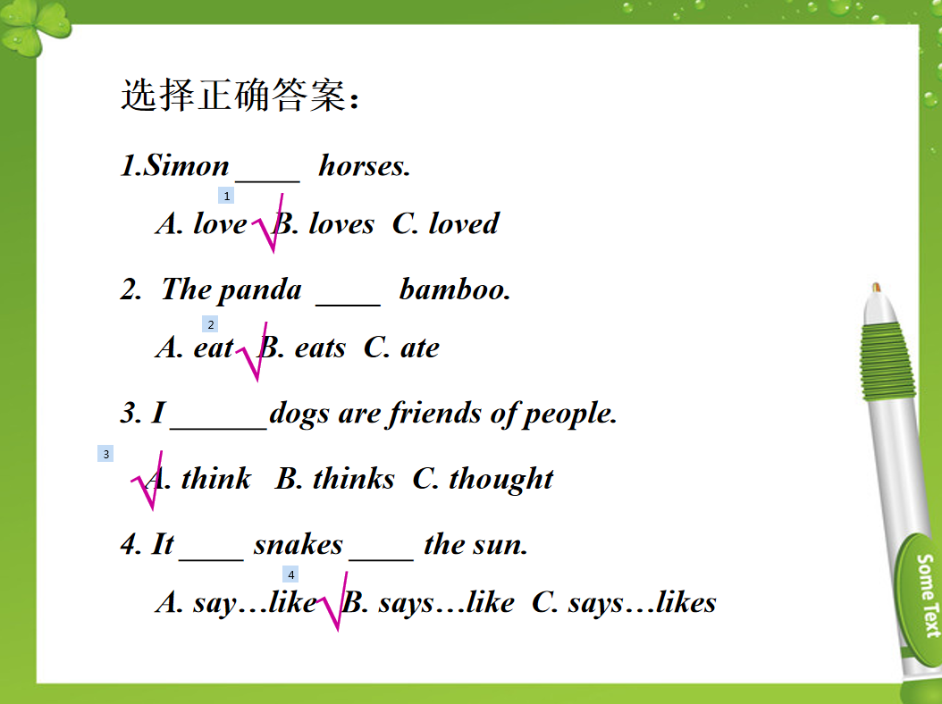
- Homework:
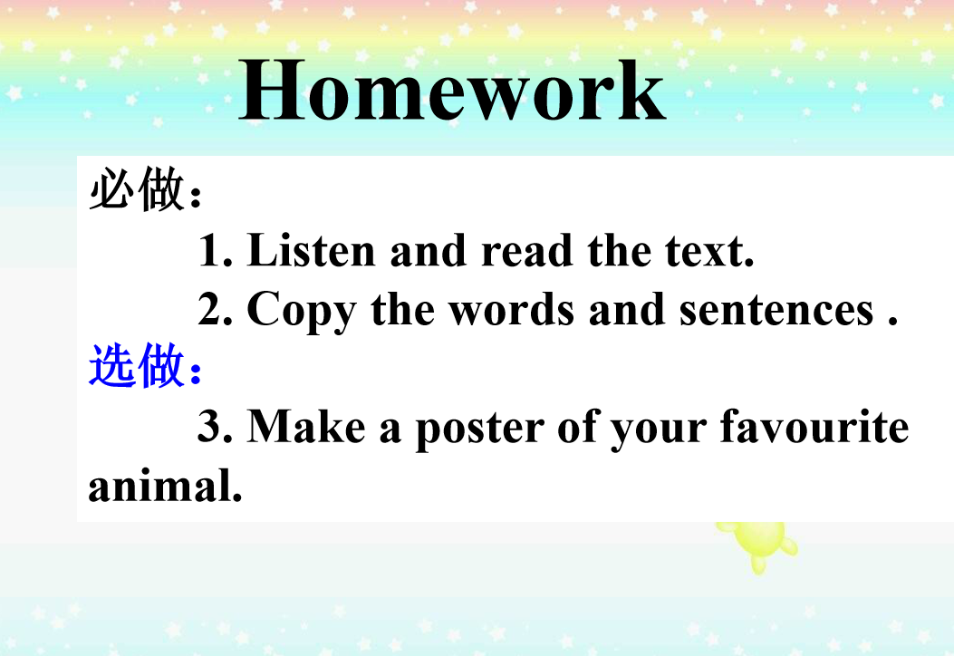

Blackboard design:
