小学五年级英语检测（2019.5）
Ⅰ.听音选词，选出你所听到的相应信息。（每题1分，共5分）
学校
班级
姓名
C. show
C. broken
C. circle
C. subject
C. paint
B. sent
B. broke
B. climb
B. factory
B. place
( ) 1. A. short
( ) 2. A. borrow
( ) 3. A. clothes
( ) 4. A. history
( ) 5. A. piece

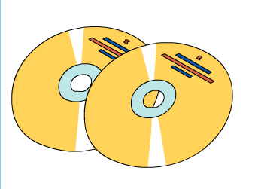
Ⅱ. 听音判断，请根据所听内容判断与图片内容是否相符，相符的打“√”，不符的打x,(10分）
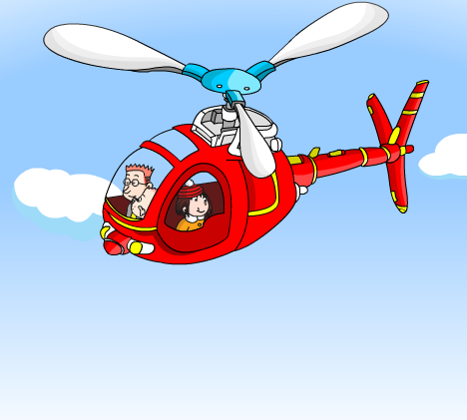

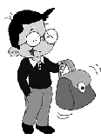

（ ） （ ） ( ) ( ) ( )
Ⅲ. 听对话选答语，请根据所听对话及问题选出正确的答语，并将其序号写在题前括号内。 （每题2分，共10分）

( ) 1. Where will Daming go?
- The airport. B. The park. C. My clothes, my shoes.
( ) 2. How will they get there?
A.Take a short helicopter ride B.Take a bike ride. C. By car.
( ) 3. What does Fangfang’s cousin do?
- He’s a policeman. B. She’s a taxi driver. C. He’s an actor.
( ) 4. What’s Daming’s favourite season?
- It’s cold. B. Autumn C. I can go swimming.
( ) 5. Will Lingling help Daming?
- Of course, she won’t. B.Yes, she will. C. No, thank you.
Ⅳ.听音理解短文，请将正确答案序号填在括号内。（10分）
( )1. Daming’s letter is about _______.
A. English food B. English theatre
( )2. What time did Lingling have lunch?
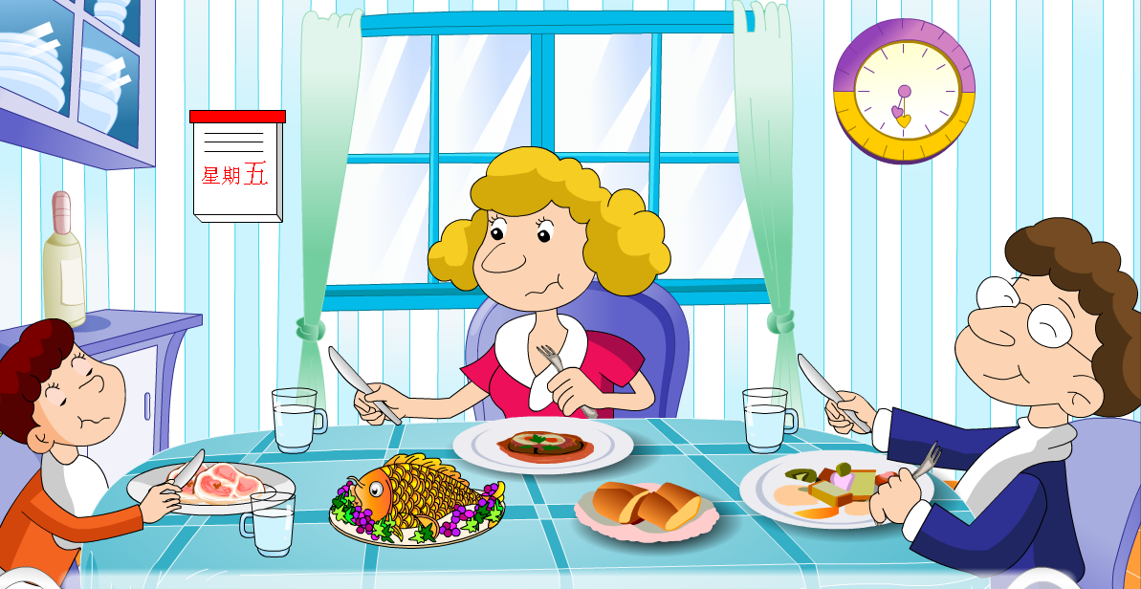
A. 7 o’clock B. 12:30 o’clock
( )3. Lingling had _______ for the traditional dinner.
A. sandwiches B. fish and chips
( )4. ________ are special in England.
A. Sundays B. Fridays
( )5. Many people eat ______ on Fridays.
A.eggs and sausages B. fish

笔试部分 （65分)
Ⅴ. 用词汇的适当形式完成下列句子。（共10分）
- I __________(提；背) my bag on my_________.(背；背部)
- My grandpa is __________(钓鱼) now.
- The books are very _____________.(有趣的)
- I had two ____________(三明治) for lunch.
5. My grandma ________(寄) me some English books. I ________（阅读）them yesterday.
6. This bag is thirty____________(英镑)
7. In winter, I can play with the __________.(雪)
8. People usually eat ___________(鸡肉) on Sundays.
Ⅵ.单项选择。（每题1分，共10分）
( ) 1.In spring, there are flowers ____the trees. A. in B .on C. at
( )2.I carry my bag _______ my hand. A. with B. over C. on
( )3.What did she ________? She _______ a bus.
A. drive ,drove B. drove, drive C. drive , driver
( )4.I’ll look ____ the computer. A.at B. with C. on
( )5._______ bag is brown .______is pink .
A. Your, My B. Your, Mine C. Yours , Mine
( )6.On___,many people eat fish. A. fridays B. Fridays C.Friday
( )7._____ usually eat lunch together.
A. family B. Family C. Families
( )8.Please return the books ___ two weeks. A. for B. in C. on
( )9.The leaves fall ___ the trees in autumn. A. to B. from C. over
( )10 Mimi is ___my chocolate. A. eat B. eats C. eating
Ⅶ.请将对应的答句的序号填在括号内。（每题1分，共5分）
( )1、What’s your favourite season ? A.Yes , it is.
( ) 2、Is it round ? B. She has dinner at six o’clock.
( ) 3、Where did your grandpa work? C. No,we haven’t
( ) 4、Have you got The Three Bears ? D. Spring.
( )5、When does Amy have dinner ? E. He worked in a hospital.

Ⅷ.根据图文提示，写出句子。（每空1分，共20分）

1.He worked _______ ________ ________ .


2.This ________ bag ____ ________.
It’s big.
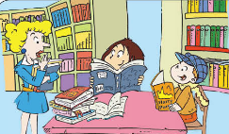
3.You _____ ___ lots of Harry Potter books here.
Yes, we have.

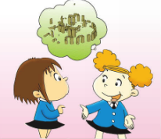
4.What ______ we ______there?

We _______ _______ ____ _____very big_______.

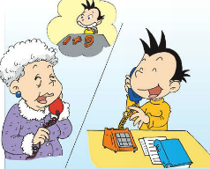
5. I _______ ______ a maths ________.

Did you_____ _____?
Ⅸ.情景交际。选择恰当的句子补全对话, 将序号写在横线上。（每空2分，共10分）
Lingling: Look,Mum! My bag is broken. I can’t take it to China.
Mum:_________.
Lingling: Look! This bag is nice. It’s big._____________
Mum:______________________Lingling: ___________________
Mum: Ok, we’ll buy the red one.________
Sales assistant: It’s 60 yuan.Lingling: Thank you , mum.

A. Yes, it’s small and light.It’s easy for me.
B. How much is it?
C. I’ll buy you a new one.
D. Look at the red one. It’s light.
E. But it’s very heavy. I can’t carry it.

X.阅读理解,判断下列句子的正（T）误（F）。 （每题2分，共10分）
There is a doctor in a small city. He is seventy-five years old. He is very kind. He often helps people. People always go to see him when there is something wrong with them.
A few years later, the doctor becomes old. He begins to forget(忘记) things. People are afraid(担心) of him and don’t go there. The old doctor asks, “Why does no man come to me now?” No one wants to hurt him, and they don’t want to tell him the truth(真相) because they love him. So they all tell the old man, “Everyone is healthy(健康的) now.” The old man is very pleased when he hears that.
( )1.The story is about an old doctor in a big city.
( )2. The doctor begins to forget things a few years later.
( )3. No one tells the truth because they love him.
( )4. The old doctor is very kind and everyone loves him very much.
( )5. He is unhappy(不高兴) when he hears everyone is healthy.
XI.小习作。（ 5分）
My favourite season请描述你最喜欢的季节。要求语句通顺，不少于30个词。
____________________________________________________________________________________________________________________________________________________________________________________

五年级英语听力题签
注意：每道听力试题读二遍，听力时间控制在15分钟内。

Ⅰ.听音选词，选出你所听到的相应信息,将序号写在前面的括号内。
No.1 Daming’s grandma sent him a Maths game three days ago.
No.2 In the libraries, you can borrow books, CDs and DVDs. .
No.3 The stones are in a circle.
No.4 English is my favourite subject.
No.5 I took out a piece of yellow paper.

Ⅱ.听音判断，请根据所听内容判断与图片内容是否相符，相符的打“√”，不符的打“×”。
1.We’ll get there by car.
- I love skiing in winter.
- I’ve got big ears. I hear with my ears.
- My schoolbag is broken. I can’t carry it.
- I’ve got some CDs. I listened them last week.

Ⅲ. 听对话选答语，请根据所听对话及问题选出正确的答语，并将其序号写在题前括号内。
No.1 Grandma: Hello, Daming.
Daming: Hello,Grandma.
Grandma: Are you ready for your trip tomorrow?
Daming: I don’t know, Grandma.
Grandma: What did you put in your bag?
Daming: My clothes, my shoes.
Grandma: And where will you go tomorrow?
Daming: I’ll go to the airport.
Question:Where will Daming go?

No.2 Amy: On Saturday, we’re going to see Stonehenge.
Lingling: What will we see?
Amy: We will see lots of big stones.
Lingling: How will we get there?
Amy：We will take a short helicopter ride to get there.
Question: How will they get there?
No.3 Daming: Hi Fangfang. My cousin goes to work at 8 o’clock every morning.What does your cousin do?
Fangfang: My cousin goes to work at 6 o’clock every evening. He’s an actor. He’s very busy.
Question: What does Fangfang’s cousin do?

No.4 Hi, I’m Daming. My favourite season is autumn. It’s cool. The leaves fall from the trees. I can play with them .
Question: What’s Daming’s favourite season?

No.5 Daming: I’m going to the US to visit my Grandma. What present can I take?
Lingling : What about a kite?
Daming: Good idea! I’ll make a kite.
Lingling: Will you help me, Lingling?
Daming: Of course, I will .
Question: Will Lingling help Daming?

Ⅳ. 听音理解短文，请将正确答案序号填在括号内。
Daming is reading a letter from Lingling. It’s about English food. Lingling had eggs and sausages for breakfast at seven o’clock. She had sandwiches for lunch at half past twelve. And fish , chips is for the traditional dinner at half past six. Lingling likes English food very much. She says it’s delicious and it’s very different. Sundays are special in England. Families usually eat lunch together. On Fridays, many people eat fish.

听力部分到此结束！

