海洋岛学校2016—2017学年度第二学期期末质量检测
…………………………………………………………密………………………………封……………………………………线…………………………………………………
学校
班级
姓名
小学五年级 英 语 完成时间：80分钟
题  号 | 听力部分 |  |  |  | 笔试部分 |  |  |  |  |  | 总分
题  号 | Ⅰ | Ⅱ | Ⅲ | Ⅳ | Ⅴ | Ⅵ | Ⅶ | Ⅷ | Ⅸ | Ⅹ
得
分

听力部分（共四大题，30分）

Ⅰ.听音，找出句子中含有的单词，将序号写在前面的括号内。（每题1分，共10分）
( ) 1. A. red B. read C. ride
( ) 2. A. actress B. player C. actor
( ) 3. A. history B. factory C. subject
( ) 4. A. ours B. flowers C. hours
( ) 5. A. go shopping B. go skiing C. go skating
( ) 6. A. sent B. send C. get
( ) 7. A. broke B. break C. broken
( ) 8. A. brown B. borrow C. busy
( ) 9. A. family B. father C.factory
( ) 10. A. read B.red C.ride

Ⅱ.听音，标号。用数字标出图片的先后顺序。（每题2分，共10分）
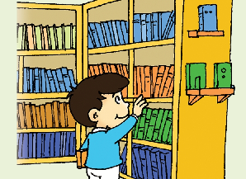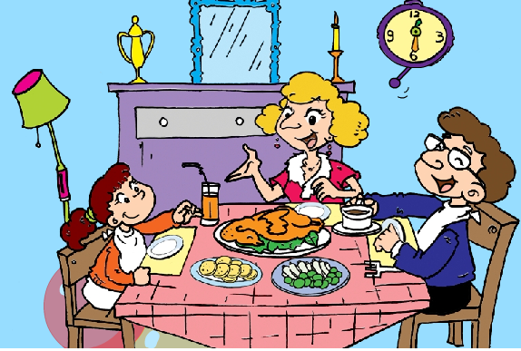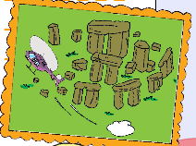
( ) ( ) ( ) ( ) ( )
Ⅲ. 听问句，选答句。将正确答案序号填在括号内。（每题1分，共5分）
( )1. A. At the office. B. In a shop. C. In the library.
( )2. A.Sending an email. B. Writing a message. C. Playing a computer game.
( )3. A. By car. B. By bus. C. By plane.
( )4. A. Some Chinese books. B.A Chinese kite. C.Chinese chopsticks.
( )5. A. Blue. B. Black. C. Green.
Ⅳ. 听短文，选择填空。将正确答案序号填在括号内。（每题1分，共5分）
( )1. We went to ____________ with Ms Smart.
A. a theatre B. a zoo C.an office
( )2. We ___________ there.
A. danced B.told jokes C. wached a show
( )3. The actors wore ______________ clothes.
A. women’s B. men’s C.animals’
( )4. We had an English dish for ____________.
A. breakfast B. lunch C. dinner
( )5. We all ate _______________.
A. fish and chips B. hamburgers C.noodles
笔试部分（共六大题，70分）
Ⅴ. 根据语境提示，用词汇的适当形式完成下列句子。（每空1分，共10分）
A.根据汉语提示，结合语境，填入所缺的单词的正确形式。（每空1分，共5分）
1. My grandpa was a driver before. He __________(驾驶) a train.
2. You can __________ （借来）books in a library.
3. The schoolbag is ______________(轻的). I can carry it on my back.
4. Beijing is a very important __________(地方 ) in China.
5. I ___________（遇见）my classmates at the gate yesterday.

B. 根据语境和首字母提示，写出正确单词补全句子。（每空1分，共5分）
1. I will t______ a plane to the US this summer.
2. Last winter, I went to Harbin and visited The Ice and S______ World.
3. There are four s_______ in a year. But I like spring very much.
4. It will take us half an h______ to get to the Discoveryland(发现王国) by car.
5. –They are in a circle. Some stones are on top of others. –It’s very i_______.

Ⅵ. 单项选择。（每题1分，共15分）
( ) 1.What______ your father _______before?
A. does,do B. did,do C. did,does
( ) 2.We had _________English breakfast yesterday.
A. a B. an C. /
( ) 3.We can give these books back _____two weeks.
A. in B. on C. for
( ) 4._______ does Daming have breakfast?
A. How much B. Where C. When
( ) 5.Will you still _______ home at 7 o’clock?
A. are B. be C. /
( ) 6.Are you ready ________your trip to the UK?
A. on B. of C. for
( ) 7.---___________? --- He’s a policeman.
A. What does he do ? B. What did he do ? C. Where does he work?
( ) 8. Last summer I went to Brighton and ________some friends here.
A. made B. talked C. had
( ) 9. In______ , I can play with the snow.
A. winter B. autumn C. summer
( )10. ---Is this your dress , Amy? ---No, _____is pink.
A. my B. mine C. me
( ) 11. She ________TV on Sundays.
A. watched B. is watching C. watches
( )12. -----Will you help me? -----_____________ !
A. Of course B. Thank you C. Good idea
( )13. _________Day is on the eighth of March.
A．Women’s B．woman C．men
( ) 14. I carry it _______ my back. A . on B . with C . over
( )15. The leaves fall from the trees. I can play with _______.
A. it B. them C. they

Ⅶ.句子理解。（共15分）
A. 根据问句找出相对应的答句，将序号填入题前括号内。
( )1. What did she do ? A. I’m going to clean my car.
( )2. What are you doing? B. Some animals .
( )3. What music does he play ? C. We’re taking some photos.
( )4. What will we see in the zoo ? D. She played on the beach.
( )5. What are you going to do ? E. He plays Chinese music .

B.根据语境提示，选词并用其恰当的形式补全下列短文。
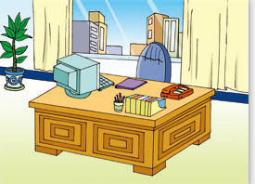
- A: Where did he work?.
B: He _______ _____ ____ ______
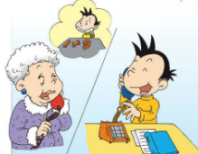
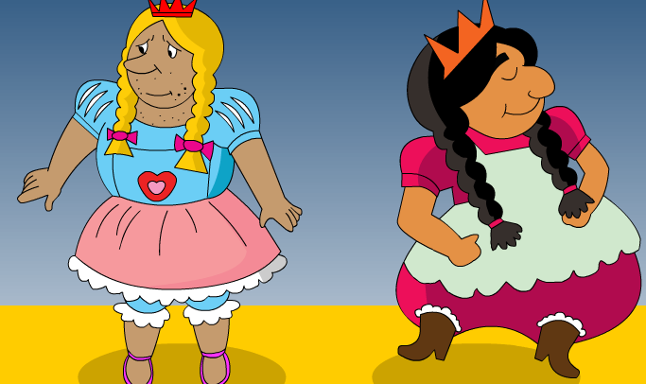
- A: I ______ you a _________game.
A: Did you ______ ________?

3. A: What did you see?
B: The men _______ ________ clothes.
Ⅷ.情景交际。根据对话内容，从方框中选择正确选项，将其序号写在横线上。（每题2分，共10分）
A:Lingling ,______________
B:No, I;m not. He ceme to China last Sunday.
A:Wow.I think you had a good time together. What did you do ？
B:We went to a theatre.___________.
A:Does he like Chinese food?
B:Yes._____________ Dumplings and noodles are his favourite.
A:____________
B:He will leave this Sunday.
A:He bought a present for me. Look!
B:That’s an Ipad. What present will you give me ?
A:I’m going to give him some books about Chinese history.______________
B:That’s a great idea.
A: When will he leave China ?
B: History is his favourite subject.
C: He liked the jokes in the show.
D:He had many traditional Chinese dishes.
E: are you getting ready to visit your cousin in the US?

Ⅸ.阅读理解。（共15分）
- 阅读短文，判断正误。正确的写“T”，错误的写“F”。

Mr and Mrs James are going to have a winter vacation. They thought they were

all ready for their vacation. They put their toothbrushes,clothes in the suitcase several

days ahead of time. And they went to the bank and bought traveler checks. They asked their nextdoor neighbour to water their plants, feed their their dog , and shovel their driveway in case it snowed. However , as soon as they arrived at the airport , they

realized thatthey didn’t put their plane tickets into the bag, and there wasn;t enough
…………………………………………………………密………………………………封……………………………………线…………………………………………………

time to go back home and get the tickets. They were all ready for their vacation , but

they had forgotten to do the most important thing.

( ) 1.They are going to have a winter vacation.

( ) 2.Their friends would water their plants.

( ) 3.They put toothbrushes ,clothes and dog in their suitcase.

( ) 4.Mr and Mrs James have a dog.

( ) 5.They didn’t take passports so they couldn’t take the plane.

- 阅读短文，选择最佳答案。
What’s the most popular food in the UK? It must be fish and chips. They
love the dish very much! Fish and chips has a long history in the UK. People
started to eat it 150 years ago. Now there are about 10,500 fish and chips shops
in the UK.The chips are cut much thicker than French fries. People like to eat
fish ,which is covered with batter and fries. Some people like to eat a pie or
sausages with their crisps.Fish and chips is the favourite takeout food in the UK.
People like to take it home as lunch or dinner. Fish and chips is delicious. But it’s
not very healthy. So don’t eat too much!
( ) 1._ _________is the most popular food in the UK.
A.Fish and chips B.Sausages C. Roast beef
( ) 2.Fish and chips is not very ________ for people to eat.
A.delicious B.healthy C. popular
( ) 3.______People stared to eat fish and chips 150 years ago.
A.English B.Chinese C. American
( ) 4. Many people eat fish and chips as _____________
A.breakfast B.special dinner C. lunch
( ) 5.Most people eat fish and chips ___________
A.in a restaurant B.at home C. in a shop

Ⅹ.书面表达。（5分）
同学们，暑假就要到了，请你这个假期你做主，你打算干什么呢？
请你写一写这个假期的打算。

_____________________________________________________________________

______________________________________________________________________

______________________________________________________________________

______________________________________________________________________

五年级英语听力题签
※注意：每道听力试题读二遍。
Ⅰ.听音，找出句子中含有的单词，将序号写在前面的括号内。
- Grandma sent me English books. I read them.
2. The actors told lots of jokes. They were very funny.
3. Susan likes Chinese history.
4. It will take us three hours to get there .
5. I like skiing in winter . I love skiing with my father.
6. Daming’s grandma sent him a Maths game three days ago.
7. My schoolbag is broken.
8. You can’t borrow books in the bookshop.
9. My mother works in a factory.
10. I take a bike ride.
Ⅱ.听音，标号。用数字标出图片的先后顺序。
1. The black bag is big and nice but it’s very heavy.
2. My father worked in a hospital before.
3. We took a helicopter ride over Stonehenge.
4. Families usually have lunch together on Sundays.
5. If you like reading.You can borrow books in the library.
Ⅲ. 听问句，选答句。将正确答案序号填在括号内。
- W: This black bag has got wheels. It will be easy for her.
M : Great ! We’ll take it,please. How much is it?
W: Fifty yuan.
Q: Where are they?
- W: What’s an email ?
M: It’s a computer message ]. It goes from one computer to another.
W: Let’s send an email to dad.
M:Click on “email” ! Now click on “write ”and write your message. Ok ,click on “Send” .The message is going to your dad’s computer.
W: Thank you!
Q: What are they doing？
- W：When will we visit Stonghenge?
M: Tomorrow morning.
W: How will we get there?
M: We’ll take a helicopter there.
Q: How will they go to Stonehenge.
- W：I’m going to visit my cousin this summer .What present can I take?
M: What has he got?
W:Last time I gave him a Chinese kite and my father gave him some Chinese books.
M: What about chopsticks?
W: It will be a great present.
Q: What present can the girl take?
- W：Whose bags are there?
M: The blue one is Tom’s and the black one is Simon’s. Amy ‘s is green.
Q: What colour is the Amy’s bag?

Ⅳ. 听短文，选择填空。将正确答案序号填在括号内。
Last week Ms Smart took us to a children’s theatre. We watched a very interesting show there. The actors wore animals’ clothes. They sang, danced and told a lot of jokes. It was very funny and we laughed a lot. We loved the theatre very much. After the show ,we had our lunch in an English restaurant. We all ate fish and chips. We loved this traditional English dish. It was very delicious.

听力部分到此结束！

五年级英语参考答案及评分标准
听力部分
Ⅰ. (1×10＝10分) BCACBACBCC
Ⅱ. (2×5＝10分) 5—-4—-1---3---2
Ⅲ. (1×5＝5分) BACCC
Ⅳ. (1×5＝5分) ACCBA
笔试部分
Ⅴ.
- (1×5＝5分) 1、drove 2、borrow 3、light 4、place 5、met
- (1×5＝5分)
- take 2、Snow 3、seasons 4、hour 5、interesting
Ⅵ. (1×15＝15分)
1.A 2. B 3. A 4.C 5.B 6.C 7. A 8.A
9.A 10. B 11.C 12.A 13. A 14. A 15. B
Ⅶ. A. (1×5＝5分) 1. D 2.C 3.E 4.B 5.A
B. (1×10＝10分) 1.worked in an office 2. sent maths get it
3.wore women’s
Ⅷ. (2×5＝10分) ECDAB
Ⅸ. (2×5＝10分) A. 1.T 2.F 3.F 4.T 5.F
(1×5＝5分) B. A B A C B
X、（5分）略
请任教五年级的英语老师批阅作文，并自行把握评分标准,做到心中有数。

备注：卷面满分为100分。（听力30分，笔试70分。）
优秀：90---100
良好：80---89
及格：60---79
不及格：0---59

