海洋岛学校2016—2017学年度第二学期期末质量检测
…………………………………………………密………………………………封……………………………………线…………………………………………………

小学四年级 英语 完成时间：60分钟
学校
班级
姓名
题  号 | 听力部分 |  |  |  | 笔试部分 |  |  |  |  |  | 总分
题  号 | Ⅰ | Ⅱ | Ⅲ | Ⅳ | Ⅴ | Ⅵ | Ⅶ | Ⅷ | Ⅸ | Ⅹ
得
分
听力部分（共四大题，40分）
Ⅰ. 听音选词。请选出你所听到的单词。（每题2分，共10分）
( ) 1. A. send B. sheep C. stick
( ) 2. A. country B. cost C. concert
( ) 3. A. rest B. best C. restaurant
( ) 4. A. north B. month C. south
( ) 5. A. plan B. postcard C. please
Ⅱ. 听音标号。用数字标出图片的先后顺序。（每题2分，共10分）
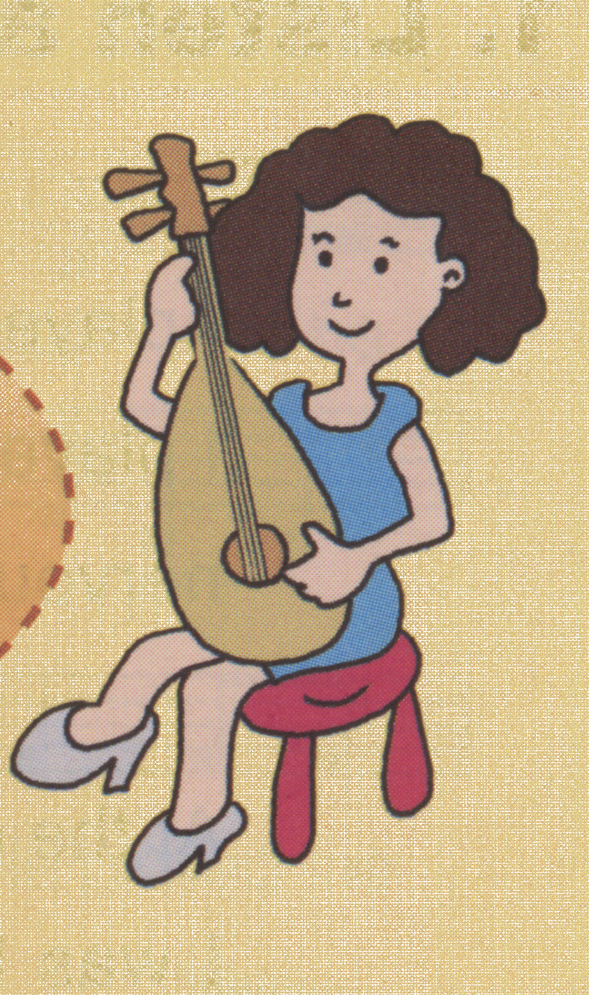
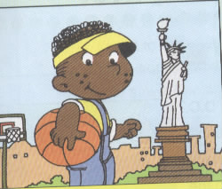
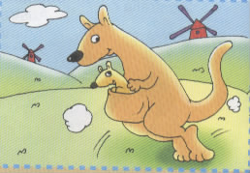
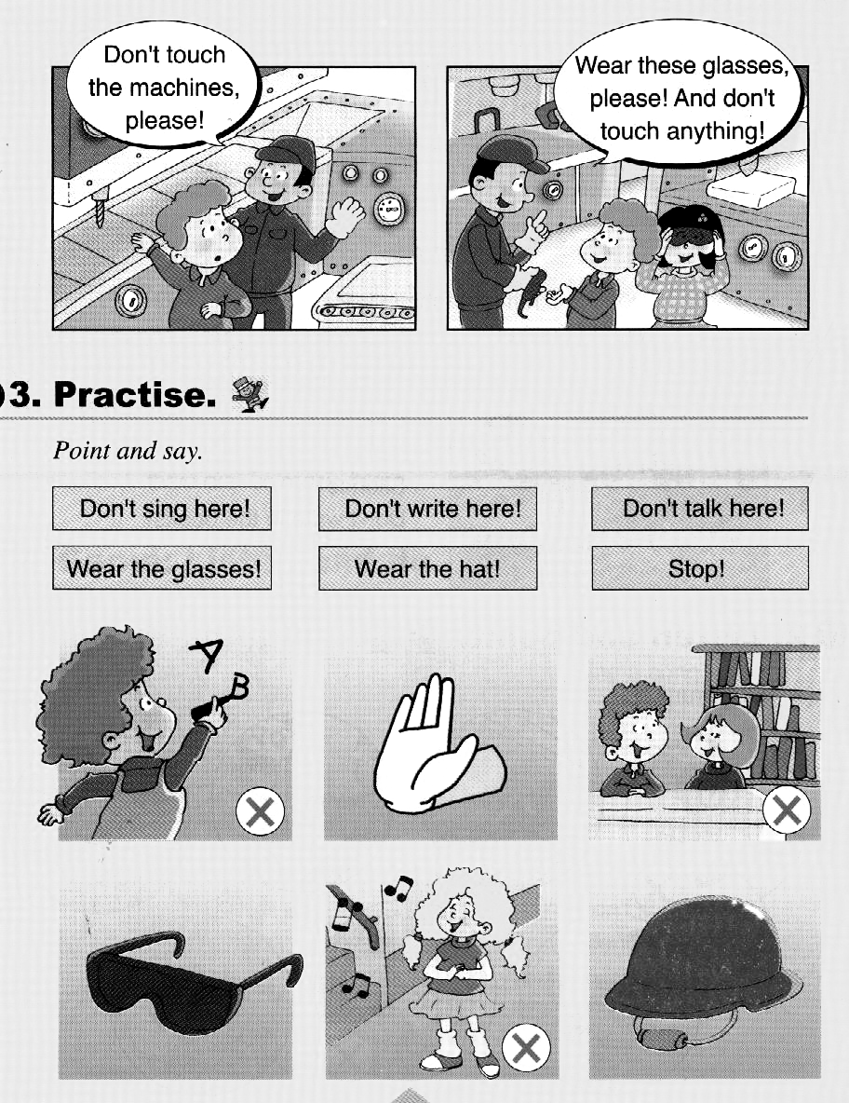
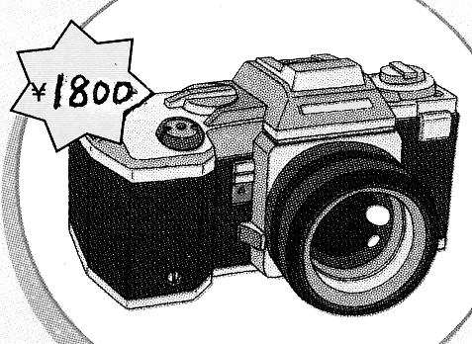

( ) ( ) ( ) ( ) ( )
Ⅲ. 听音选句。把正确的选项填在前面的括号内。（每题2分，共10分）
( )1. A. It’s dinner time. B. It’s lunch time .
( )2. A.It’s in the east of China. B. It’s in the west of China.
( )3. A.Why do you like cats? B. Why do you like Australia?
( )4. A. She bought some cheese. B. She ate the cheese.
( )5. A. Don’t touch the machines! B. Don’t write on the books.
Ⅳ. 听短文判断正误。正确的写T, 错误的写F。（每题2分，共10分）
( )1.Dongdong will make a newspaper with his friend.
( )2. Fangfang is good at English.
( )3. Taotao is good at Art.
( )4. Dongdong will cut the paper.
( )5. Haohao will draw the pictures.
笔试部分（共六大题，60分）
Ⅴ.单项填空。（每题1分，共10分）
( )1. What _______ your father __________ before?
A.does ,do B. did ,do C. did, does
( )2. This pen _______ one hundred and eighteen yuan.
A. cost B. costs C. costing
( )3. ______ the end, everyone clapped. I _______happy.
A. In , am B. on ,were C. In , was
( )4. A: What’s __________now? B: Tom is singing.
A. happen B. happened C. happening
( )5. --_______ does Daming have breakfast？
--At seven o’clock.
A. How much B. Where C. When
( )6. I’m good at English. I’ll _________ the reports.
A. writing B. write C. writes
( )7.This is a map ________ English.
A. of B. at C. in
( )8. He lives ________ the east of the US.
A. in B. to C. into
( )9. A: Why do you love koalas? B: ________ they are very cute.
A. Because B. So C. And
( )10. I want ____________ to school.
A. go B. to go C. /
Ⅵ. 根据所给语境，补全句子。（共15分）
A. 根据汉语提示，结合语境，填入所缺单词。（每题2分，共10分）
1. These __________ (绵羊) are very cute.
2. Those blue shoes _________(花费) one hundred and seventy-nine yuan.
3. _________(澳大利亚的) animals are my favourite.
4. –Will you __________(粘贴) the newspaper together？--Yes , I will.
5. London is the _____________(首都) of the UK.
B. 根据语境，选择恰当的单词, 将其序号填写在横线上。（每题1分，共5分）
Mother’s Day, Australia, paint, be good at, west, cute

- East or _________ , home is the best.
- On ____________________, what did you do for your mother?
- Koalas live in __________________. They are very _________________
4. Daming ______________ Art. He will _____________some flowers and birds.
Ⅶ. 情景反应。（每题2分，共10分）
( )1. What are you doing? A. Because it’s so beautiful.
( )2. What did you play last year? B.I went to a shop.
( )3. Where are you going ? C.I played the violin.
( )4. Where did you go ? D.I;m going to school.
( )5. Why do you like China? E. I’m playing a computer.

Ⅷ. 情景交际。选择答案的序号填写在空格处。(每题2分，共10分)
Lingling: I went to a concert yesterday.
Amy: ______________________
Linging: Yes, it was. ____________
Amy: What did they play?
A. Dad played the erhu.
B. Was it Chinese music?
C. It looks like a violin.
D. My mum and dad played
in the concert.
E. It looks like a guitar.
Lingling: _____________________
Amy: What’s an erhu?
Linging: It’s a Chinese instrument
Amy: ___________________
Lingling: And Mum played the pipa.
Amy: ____________________

Ⅸ. 短文阅读,判断正(T)误(F)。（每题2分，共10分）
A crow is thirsty. He wants to drink some water. He finds a bottle , and there is a little water in it. But the neck of the bottle is too long; the crow can’t get the water. The crow thinks over and over again, and then he has a good idea. He puts some small stones in the bottle , and the water rises up to the top. Now he can drink the water. What a clever crow!
…………………………………………………密………………………………封……………………………………线…………………………………………………
1．--What does the crow feel? It feels __________
A. hungry B. thirsty C. hot D. cold
2. --What does the crow want to do ?
-- It wants to drink _________
A. some milk B. some tea C. some juice D. some water
3. ---What is the crow ‘s problem?
-- There is not _________water in the bottle.
A. some B. much C. little D. no
4. --How does the crow drink the water?
--It puts __________ in the bottle.
A .two stones B. some small stones C. some big stones D. some water
5. The crow is ____________
A. foolish B. clever C.big D. fat
Ⅹ.想一想，写一写。(共5分）
暑假将至，假如你是Sam，请给你的朋友Lucy写一个明信片，介绍你的暑假计划。
提示词：the US / the UK / Shanghai/ Dalian / Beijing…
send you a postcard / go swimming / read books/ listen to music /see kangaroos/ fly a kite…
Dear Lucy,
This summer, I will go to______________. I’ll ___________________.
______________________________.
I’ll be happy.
Love,
Sam

四年级英语听力题签
注意：每道听力试题读两遍。
Ⅰ. 听音选词。请选出你所听到的单词。
1. There was a boy. He looked after sheep.
2. Look. This country is the US.
3. East and west, home is the best.
4. Last month, she went into a shop.
5. I haven’t got any plan now.
Ⅱ. 听音标号。用数字标出图片的先后顺序。
1. This camera is expensive.
2. Don’t write here!
3. The mother kangaroo has a special bag for her baby.
4. Mum played the pipa in the concert.
5. He lives in the east of the US.
Ⅲ. 听音选句。把正确的选项填在前面的括号内。
1. It’s lunch time.
2.It’s in the east of China.
3.Why do you like cats?
4. She ate the cheese.
5. Don’t touch the machines!
Ⅳ. 听短文，判断正误。正确的写T, 错误的写F。
Hi ! I’m Dongdong. Next Monday ,I’ll make a poster with my good friends , Fangfang ,Taotao and Haohao. Fnagfang is good at Chinese . She will write the report. Taotao is good at Art. He will draw the pictures. I will cuy the paper. And Haohao will stick the pictures together . Our poster will be fantastic.

听力部分到此结束！

四年级英语参考答案及评分标准

听力部分
Ⅰ. (2×5＝10分) BABBA
Ⅱ. (2×5＝10分) 4—-2—-1---5---3
Ⅲ. (2×5＝10分) AABBA
Ⅳ. (2×5＝10分) F F T T F
笔试部分
Ⅴ. (1×10＝10分) ABCCC BAAAB
Ⅵ. A组(2×5＝10分)：1.sheep 2. costs 3.Australian 4.stick 5. capital
(请注意画线黑体部分，如果没有形式的变化将扣1分，其他单词完全准确方可得2分。）
B组(1×5＝5分)：1.west 2. Mother’s Day 3. Australia cute 4. is good at paint
Ⅶ. (2×5＝10分) ECDBA
Ⅷ. (2×5＝10分) BDACE
Ⅸ. (2×5＝10分) BDBBB
Ⅹ. (5分) 作文内容请评卷教师自行把握
（请注意第一个空1分，第二个空2分，第三个空2分）
备注：卷面满分为100分。（听力40分，笔试60分。）
优秀：90---100
良好：80---89
及格：60---79
不及格：0---59

