獐子小学2016—2017学年度第二学期期末质量检测
小学五年级 英 语 完成时间：50分钟
听力部分（共四大题30分）
Ⅰ.听音，找出句子中含有的单词，将序号写在前面的括号内。（每题1分，共8分）
( )1.A.sausages B.messages C.sandwiches | ( ) 5.A. answer B. ask C. and
( ) 2.A. broken B. borrow C. brown | ( ) 6.A. where B. will C. wheel
( ) 3.A. history B. factory C. subject | ( ) 7. A. circle B. climb C. clothes
( ) 4.A. ours B. flowers C. hours | ( ) 8.A. drive B. drove C. driver


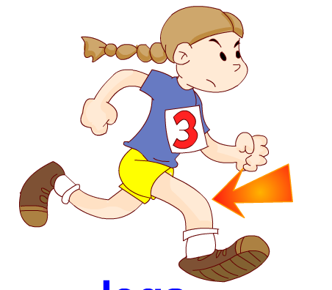
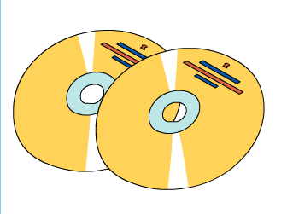
Ⅱ.听音，标号。用数字标出图片的先后顺序。（每题2分，共10分）
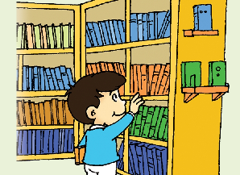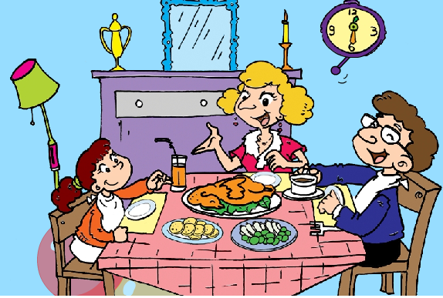
( ) ( ) ( ) ( ) ( )
Ⅲ. 听问句，选答句。将正确答案序号填在括号内。（每题1分，共6分）
( ) 1. A . A ticket B. A bus C. A bag
( ) 2. A. She is eating. B. She had fish and chips. C. She had dinner .
( ) 3. A. No, I won’t. B. No, I don’t. C. No, I didn’t.
( ) 4. A. No, thanks. B. Of course, I won’t. C. Yes, I will.
( ) 5. A. Yesterday. B. 4 pm. C. At six o’clock.
( ) 6. A. He’s reading a book. B. She is reading a book. C. She will read a book
Ⅳ.听短文，判断正(T)误(F)。（每题1分，共6分）
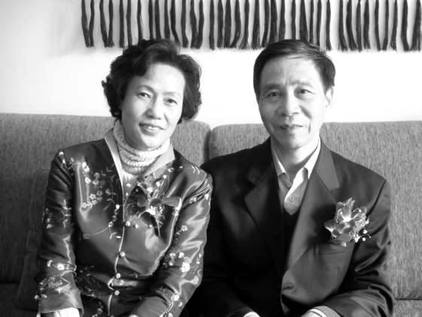
( )1. My mother is a teacher .
( )2. She goes to work at five o’clock every morning.
( )3. My father is an actor now.
( )4. He goes to work at 7:30 every morning.
( )5. I am a girl.
( )6. It’s a photo of my parents.
笔试部分（共六大题70分）
Ⅴ.根据语境提示，用词汇的适当形式完成下列句子。（每题1分，共10分）
1. Chinese people __________(建造) the Great Wall .
2. There are four ________（季节）in a year .
3. The schoolbag is ______________(轻的). I can carry it on my back.
4. Beijing is a very important __________(地方 ) in China.
5. I ___________（遇见）my classmates at the gate yesterday.
6. I like reading the books , they are very ______________（有趣的）.
7. My bag is ___________(黑色的). I carry it on my __________(背部)..
8. Daming ___________( 画) a f lower on a piece of paper, and then he painted it.
9. .My grandpa is __________(钓鱼) now.
Ⅵ.单项选择。（每题1.5分，共15分）
( ) 1. I sent you books . Did you like_____?
A. it B. they C. them
( ) 2. We took a short helicopter ride ______ Stonehenge.
A. to B. over C. on
( ) 3. – What can you do in winter? -- I can _______ ．
A．swim B．fly a kite C．go skating
( ) 4. ______ Amy like English food?
A. Do B. Does C. Is
( ) 5. ---Is this your dress , Amy? ---No, _______is pink.
A. my B. mine C. me
( ) 6.--- How will we get there? ---By car. ________will take three hours.
A. They B. We C. It
( ) 7. She ________TV on Sundays.
A. watched B. is watching C. watches
( ) 8. A bird _____ swim, but it ______ fly very high.
A. can, can’t B. can’t, can C. can’t, can’t
( ) 9. _________my parents.
A．This is B. That is C．They are
( ) 10. The men wore _____ clothes.
A．women B．womans’s C．women’s
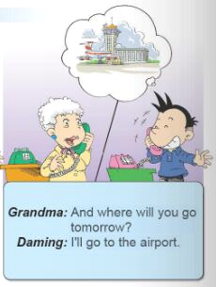
Ⅶ.句子理解。（共15分）
- Grandma: _____________________________________?

Daming: I’ll go to the airport.
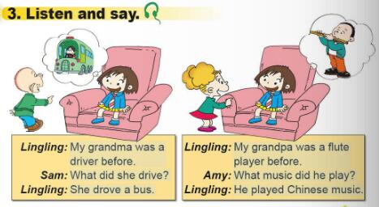
- Daming: Will you help me?

Fangfang: Of course ____________________.
- My grandpa was ______________________ before.
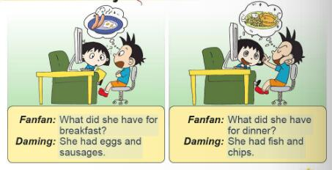
- Fanfan : What did she have for breakfast?

Daming : _______________________________.

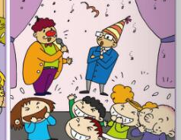
- Last week, we went to _______________________.
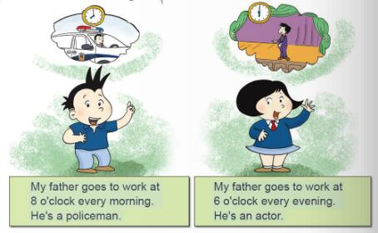
- My father _________________________at 6 o’clock every evening.
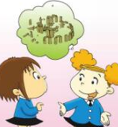
- Lingling : What will we see there?

Amy : ________________________________.

- Amy : _____________________the Harry Potter DVDs?

Librarian: Sorry, we haven’t got the DVDs.

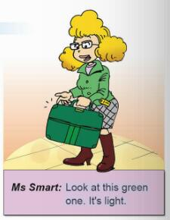
- Grandma : I sent you a maths game.______________get it?

Daming : Yes, Grandma.
- Look at this bag. ___________________________.

Ⅷ.情景交际。根据内容，从方框中选择正确选项，将其序号写在横线上。（每题2分，共10分）
Mother: Amy, ______________
Amy: Yes, Mum.
A. I’ll go to the park.
B. Are you ready for your picnic tomorrow?
C. Have a good time!
D. What did you put in your bag?
E. When will you leave tomorrow ?
. H .And then her friends are going tio go home. e will be home at seven o’clock. E. Is he very busy?
Mother:__________________
Amy: A bottle of water, some food,
my sun glasses and my books.
Mother:And where will you go tomorrow?
Amy: __________________
Mother :.__________________
Amy: At six o’clock in the morning.
Mother: __________________
Amy: Thank you.
Ⅸ.阅读理解。（共15分）

A. 阅读短文，判断正误。正确的写“T”，错误的写“F”。 （每题2分，共10分）
Last Saturday, John and his parents had a picnic at a place called Stonehenge. Then John had a very big surprise. His father said, “Now we will see Stonehenge from the air.” He pointed to the sky. John laughed. He thought it was a joke.“The stones are big.But from the sky they will look small,”his mother said.
Then they went and saw a helicopter!They took a helicopter ride over Stonehenge! It was amazing. John took photos with his camera.
( ) 1. John and his parents had a picnic last Sunday.
( ) 2. John’s mother had a big surprise.
( ) 3. They saw Stonehenge from the air.
( )4. John and his parents took a helicopter ride over Stonehenge.
( )5.John didn’t take any photos.
B组选择最佳答案。（每题1分，共5分）
There are four seasons in a year. Each season has three months.
The first season is spring. The three months are March（3月）, April and May（5月）. It’s warm in spring. We can see the baby ducks. There are beautiful flowers on the trees.
The second season is summer. The three months are June（6月）, July and August. The weather is very hot and it often rains. We can go swimming.
The third season is autumn. The three months are September（9月）, October(10月) and November. It’s cool. The leaves fall from the trees. We can play with them.
I like winter. It is very cold. Sometimes it snows. We can go skiing and make a snowman.
( ) 1. There are _____ months in each season. A. four B.three C.two
( ) 2. The______ season is autumn. A.first B.second C. third
( ) 3. December（12月）, January（1月） and February （2月）are in ______.
A. spring B.summer C. autumn D. winter
( ) 4. It’s very _____in summer. A. cool B.cold C. warm D.hot
( ) 5.We can____in spring. A. go swimming B. go skiing C. see the baby ducks
Ⅹ.书面表达。（5分）
亲爱的同学们，请给你在美国的朋友大明写一封信，同他一起分享你的一次快乐之旅吧！
内容提示：1. Where did you go? 2. When did you go there?
3. How did you go there? 4. What did you do (eat/drink/ see /visit…)?
5. How did you feel?

要求：1、要点齐全，表达准确，语句通顺，书写规范，可适当发挥；
2、词数40词左右。

Dear ___________,
__________________________________________________________________
__________________________________________________________________
__________________________________________________________________
__________________________________________________________________
__________________________________________________________________
From,
_____________

五年级英语听力题签
※注意：每道听力试题读二遍。时间控制在15分钟以内。

Ⅰ.听音，找出句子中含有的单词，将序号写在前面的括号内。
- She had sandwiches.
2. Lingling , your bag is broken.
3. Susan likes Chinese history.
4. It will take us three hours to get there .
5. Maybe you can find the answer.
6. The bag has got two small wheels.
7. Last summer I went to Mount Tai. I climbed the mountain.
8. She was a driver before.
Ⅱ.听音，标号。用数字标出图片的先后顺序。
1. My legs are long. I run with my legs.
2. She’s writing a letter to Amy.
3. I’ve got some CDs. I watched them last week.
4. Families usually have lunch together on Sundays.
5. If you like reading.You can borrow books in the library.

Ⅲ. 听问句，选答句。将正确答案序号填在括号内。
1. What did she drive?
2. What did she have for dinner?
3. Did you take your passport?
4. Will you help me ?
5. What time will you get up in the morning?
6. What is she doing?

Ⅳ.听短文，判断正(T)误(F)。
Look at the picture. They are my parents. My mother is a driver now. She dives bus. She works hard. She goes to work at 5 o’clock every morning. My father is an actor. He’s very busy. He goes to work at8:30 every morning. He was a teacher before. And I am a girl. I am 4.
听力部分到此结束！

五年级英语参考答案及评分标准
听力部分(30)
I. (1×8=8 分) C A A C ACBC
II. (2×5=10分) 5 4 3 2 1
III. (1×6＝6分) BBCCCB
IV. (1×6＝6分) F T T F T T

笔试部分(70分)
V、(1×10＝10分) (每词一分，没变化扣减0.5分)
1. built 2.seasons 3.light 4.place 5. met
6. interesting 7. black, back 8. drew 9. fishing
VI、(10×1.5＝15分) CBCBB / CC B C C
VII、(1.5×10＝15分)
1.Where will you go? 2. I will. 3.a flute player
4.She had eggs and sausages 5. a children’s theatre
6. goes to work 7. We will see lots of big stones. 8. Have you got
9. Did you 10. It’s light.

VIII、(2×5＝10分) BDAEC
IX、A.(2×5＝10分) F F T T F
B.(1×5＝5分) BCDDC

X、（5分）略

备注：卷面满分为100分。（听力30分，笔试70分。）
优秀：90---100
良好：80---89
及格：60---79
不及格：0---59

