小长山小学2016—2017学年度第二学期期末质量检测
四年级 英语 完成时间：60分钟
学校
班级
姓名
听力部分（共四大题，40分）
Ⅰ. 听音选词。请选出你所听到的单词。（每题2分，共10分）
( ) 1. A. cheap B. cheese C. country
( ) 2. A. glass B. grass C. game
( ) 3. A. machine B. message C. museum
( ) 4. A. shout B. special C. surprise
( ) 5. A. best B. rest C. west

Ⅱ. 听音标号。用数字标出图片的先后顺序。（每题2分，共10分）
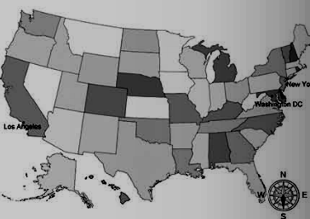
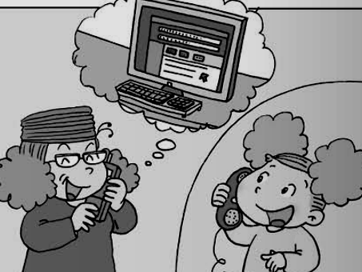
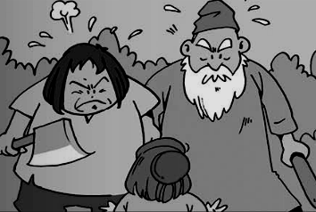
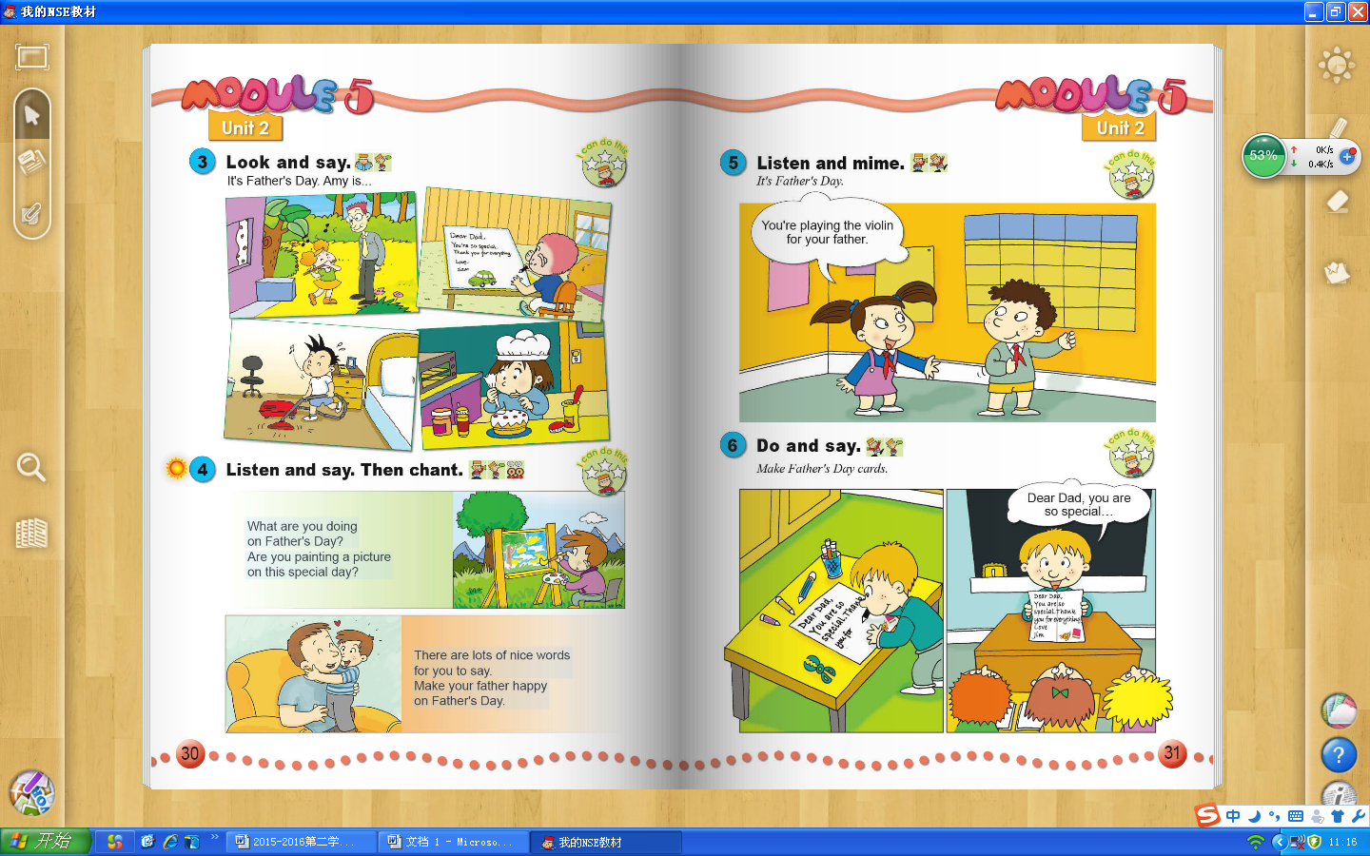


( ) ( ) ( ) ( ) ( )

Ⅲ. 听音选句。把正确的选项填在前面的括号内。（每题2分，共10分）
( )1.A. Don’t play computer games here. B. Don’t play ball games here.
( )2.A. The dress costs 180 yuan. B. The dress costs 118 yuan.
( )3.A.We’re having a party. B. We’re going to have a party.
( )4.A. Let’s have fun this Sunday. B. Let’s have fun this Saturday.
( )5.A. Look! Here is a map of Australia. B. Look! Here is a photo of Australia.

Ⅳ. 听短文判断正误。正确的写T, 错误的写F。（每题2分，共10分）
( )1. The postcard is for Daming.
( )2. Lingling is in London now.
( )3. Lingling will see Big Ben and some restaurants.
( )4. English food is not very nice.
( )5. Lingling is having a good time in the UK.

笔试部分（共六大题，60分）
Ⅴ.单项填空。（每题1分，共10分）
( )1. It’s very hot. _________ the window, please!
A. Open B. Opened C. Opening
( )2. A: Do you like this car? B: No, it’s _________ .
A. beautiful B. expensive C. perfect
( )3. This pen _______ nineteen yuan.
A. cost B. costs C. costing
( )4. Look! The boy looks ______ his father.
A. after B. like C. at
( )5. __________ live in Australia.
A. Pandas B. Koala C. Kangaroos
( )6. Beijing is the capital. It’s in the___________ of China.
A. west B. south C. north
( )7. I went to a _________ yesterday and listened to Chinese music.
A. concert B. cinema C. museum
( )8. We will _________ there at ten o’clock.
A. are B. be C. were
( )9. It was Amy’s birthday. She _________ a big birthday cake.
A. eat B. ate C. eating
( )10. --Happy Mother’s Day! A present for you.
--__________! Thank you.
A. What a surprise B. What a day C. That’s a great idea
Ⅵ. 根据所给语境，补全句子。（共15分）
A. 根据汉语提示，结合语境，填入所缺单词。（每题2分，共10分）
1. Look at this machine. It _________ (放) the bags in the box.
2. The man has got many ___________ (绵羊)on his farm.
3. There are twelve ____________ (月)in a year.
4. Tom is English, but he likes Chinese music very __________ (非常).
5. A: What’s the _________ (时间) now? B: It’s half past seven.
B. 根据语境，选择恰当的单词, 将其序号填写在横线上。（每题1分，共5分）
- reports B. stick C. make D. fantastic E. cut

Daming, Lingling, Sam and Amy are going to _________ an English newspaper about their school. Daming will draw the pictures. Amy will write the _____ . Sam will __________the paper. Lingling will the newspaper together. Their English newspaper is ___ .

Ⅶ. 情景反应。（每题2分，共10分）
( )1. What’s happening? A. Yes, please.
( )2. Where did you go yesterday? B. At 6 o’clock.
( )3. When did she play in the concert? C. She’s playing the violin.
( )4. Do you want to listen to music? D. I went to the shop.
( )5. What time do you get up every morning? E. Last month.

Ⅷ. 情景交际。选择答案的序号填写在横线上。(每题2分，共10分)
A. What about you? B. Where will you go this summer?
C. He lives in the north of Dalian. D. Yes, I will.
E. Why do you go to Australia?
Daming: _______________________
Amy: I will go back to the UK. And I’ll visit Australia with my mum.
Daming: ________________________
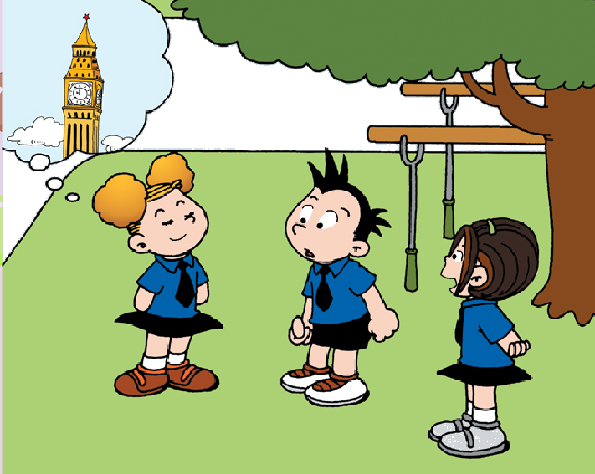
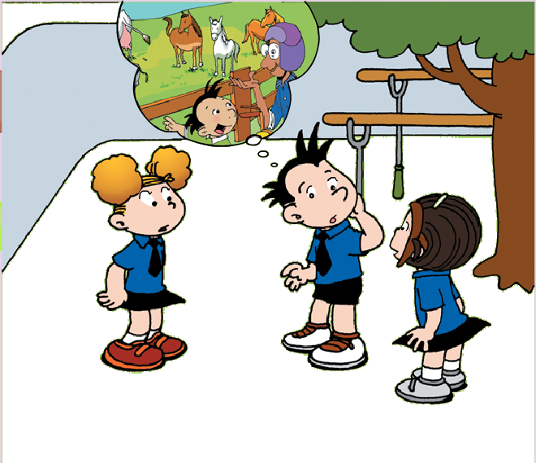
Amy: Because I like Australian animals. ___________________________
Daming: Maybe I’ll visit my grandpa’s farm.
Amy: Where does your grandpa live?
Daming: __________________________.
Amy: Will you send me a postcard?
Daming: ______________________.

Ⅸ. 短文阅读,判断正(T)误(F)。（每题2分，共10分）
Look! There are four koalas in the tree. This is a family, father koala, mother koala and two baby koalas. They’re my favourite animals. One day, the koalas are sleeping in the tree. But when(当……时候)the father koala and mother koala get up, the baby koalas are not sleeping. Where are they? What are they doing? Father koala says, “Maybe they’re swimming.” Mother koala says, “Maybe they’re climbing(爬) trees. Let’s go and have a look.” “ Oh, no! They’re fighting(打仗). Stop!!!!” Father and mother koalas shout.
( )1. How many children are there in the family? There are ____________.
A. four B. two C. three
( )2. Where are the koalas? They’re ___________.
A. on the tree B. in the sea C. in the tree
( )3. The baby koalas are ____when the father koala and mother koala get up.
A. sleeping B. swimming C. fighting
( )4. _________are my favourite animals.
A. Koalas B. Kangaroos C. Pandas
( )5. Father and mother koalas shout, “Don’t ___________!”
A. stop B. fight C. climb

Ⅹ.想一想，写一写。(共5分）
同学们，暑假即将到来，请你用英语写一个暑假计划，让自己度过一个愉快而又意义的假期吧。
要求：内容完整，语言顺畅，字迹工整，正确使用大小写和标点符号；
提示词：Dalian/ Beijing/ the US/ the UK...
go swimming, fly a kite, visit the zoo, read books, go to the park...
This summer, I will go to ______________. I will ____________________________.
I will ___________________________. _____________________________________.
I will be happy.

四年级英语听力题签
注意：每道听力试题读两遍，听力时间控制在15分钟内。
Ⅰ. 听音选词。请选出你所听到的单词。
1. Look! This country is the US.
2. Don’t walk on the grass.
3. I am going to visit some museums.
4. It’s a surprise party for our mothers.
5. North and south, let’s have a rest.

Ⅱ. 听音标号。用数字标出图片的先后顺序。
1. It’s Father’s Day. He’s writing a message to his father.
2. They are talking about computers.
3. I’ll send you a postcard from London.
4. The people were angry with this boy.
5. New York is in the east of the US.

Ⅲ. 听音选句。把正确的选项填在前面的括号内。
1. Don’t play ball games here.
2. The dress costs one hundred eighty yuan.
3. We’re having a party.
4. Let’s have fun this Saturday.
5. Look! Here is a map of Australia.

Ⅳ. 听短文判断正误。正确的写T, 错误的写F。
Dear Daming,
I’m having a great time in the UK. Tomorrow, I’m going to visit London. I’ll see Big Ben and some museums. We’re going to eat in an English restaurant. English food is very nice. I like it very much. Have a good holiday!
Love
Lingling

听力部分到此结束！

四年级英语答案及评分标准：
听力部分（40分）
Ⅰ、(2×5＝10分) CBCCB
Ⅱ、(2×5＝10分) 2----4----1----5----3
Ⅲ、(2×5＝10分) BAABA
Ⅳ、(2×5＝10分) T F F F T

笔试部分（60分）
Ⅴ、(1×10＝10分) ABBBC CABBA
Ⅵ、(2×5＝10分)
- 1. puts 2. sheep 3. months 4. much 5. time
（注意 ：其中画有“_”黑体的部分如果没有形式的变化将各扣1分， 其余单词必须完全拼写准确方可得2分。）
- CAEBD
Ⅶ、(2×5＝10分) CDEAB
Ⅷ、(2×5＝10分) BEACD
Ⅸ、(2×5＝10分) BCCAB
Ⅹ、(5分) 答案略。
请自行把握评分标准,做到心中有数。
一等：4----5分（主题鲜明，表述恰当，语言结构准确。）
二等：3分（主题较为鲜明，表述较为恰当，语言结构较为准确。）
三等：0-----2分（主题朦胧，语言表述不清，错词乱句，信息模糊。）

备注：卷面满分为100分。（听力40分，笔试60分。）
优秀：90---100
良好：80---89
及格：60---79
不及格：0---59

2017年7月10日

