新标准英语一起十一册
Revision of Module 4教学设计
大长山中心小学 傅海华
〔语言功能〕介绍节日
〔语言结构〕一般现在时
〔教学目标〕
1. 语言知识目标：a. 复习词汇：Thanksgiving, nearly, the Spring Festival, sure, December, light
复习目标语句：What do you do on Thanksgiving?
We always have a big, special dinner.
We say thank you for our food, family and friends.
Can you tell me about Christmas?
b. 复习并阅读运用一般现在时描述的与节日相关的语篇。
2. 语言技能目标: a. 能听懂对节日进行的简单的英语描述；
b. 能在读懂短文的基础上，运用一般现在时对节日进行描述和问答；
c. 掌握并运用目标语句和词汇书写简单的关于节日话题的小练笔。
3. 情感态度目标：比较、了解中西方节日的差异。
〔教学重、难点〕
重点: 能掌握一般现在时态，名词复数的变化，时间前介词用法。
难点：能正确运用一般现在时描述中西方节日的主要特征。
〔学生分析〕
一般现在时态，名词复数，时间前介词用法不是非常难的语法现象，但是经常被学生们忽视。作为即将升入初中的六年级的学生，牢固掌握小学阶段涉及的语法现象，有利于他们以后更好的学习。本课以学生感兴趣的节日为话题，使用影音文件，力图给学生创造出，既生动有趣又真实贴切的情景，使学生在有兴趣学习的同时，还可以从情景中领会掌握语法现象，从而能介绍自己喜欢的节日。
〔教学准备〕
PPT课件， task paper，奖励图片
〔教学过程〕
Step 1、Revision and lead in
1. Greetings.
2. Warmer: Free talk
T：Today I take some pictures for you. Let’s look what are they about?
S: They are about festivals . (板书)
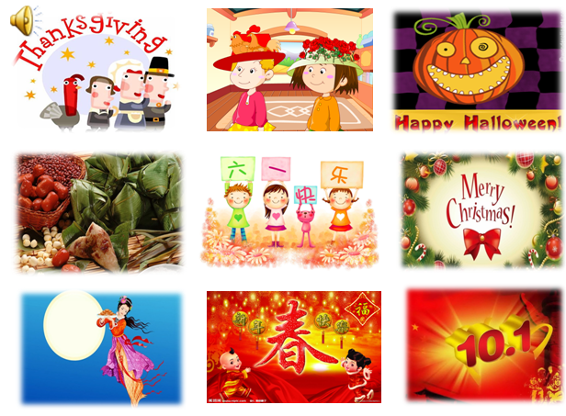

T: My favourite festival is the Spring Festival. What’s your favourite festival?
S: My favourite festival is ……
T: When is it?/ What do you eat?/ What do you do?
S: It’s in …/ We eat…/ We…
3. Lead in
T: Today our task is to review Module4 and introduce your favourite festival. We’ll have two groups. One is group “T”, the other is group “C”.（说明评价机制，奖励感恩节食物，圣诞礼物。）
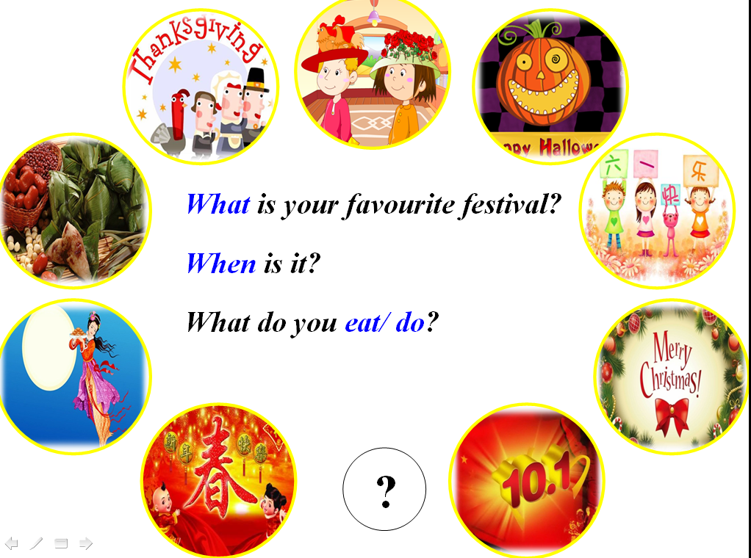
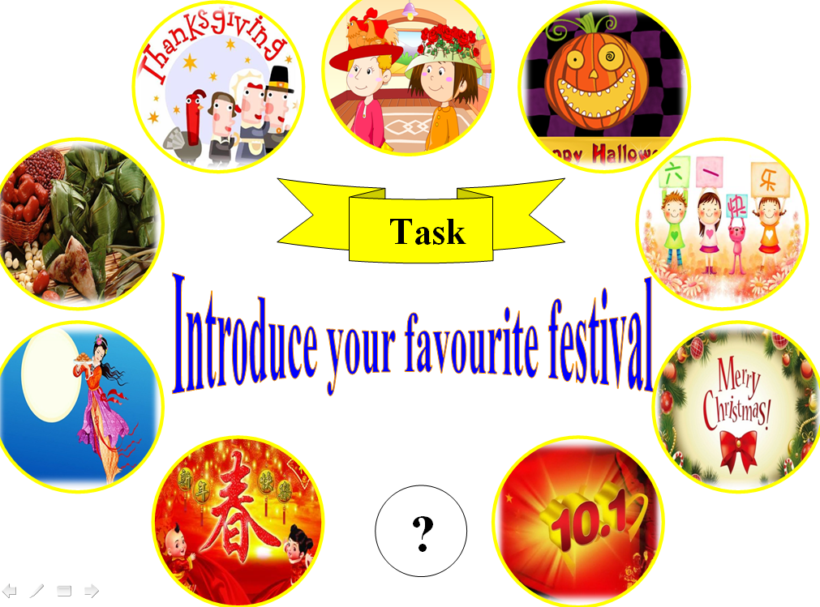

Step 2、Revision
1. Review the Topic 1: Thanksgiving
T: First, let’s look at an important festival in the US. What is it?(Show the picture of the text)
S: Thanksgiving.
(1) Read M4U1 and answer the Qs.
T: Here are three questions for you. Read the text and find the answers.
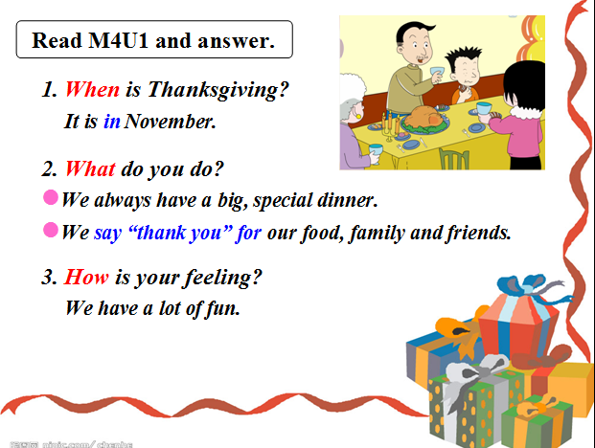

(2) Talk about Thanksgiving.
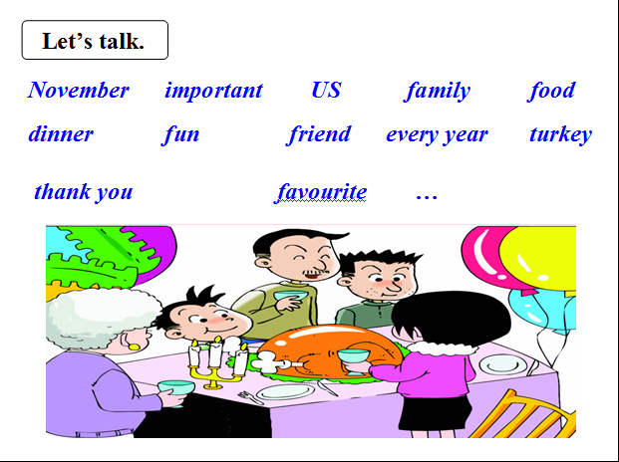

2. Review the Topic 2: Christmas
T: Do you like riddles? Ss: Yes.
T: Here’s a riddle about the festival. Read and guess what is it?
S: It’s Christmas.

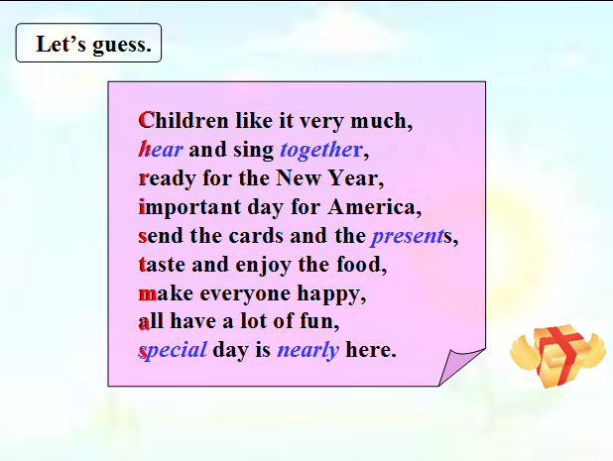

(1) Students try to ask the questions about Christmas.
(2) Read M4U2 and answer the Qs.
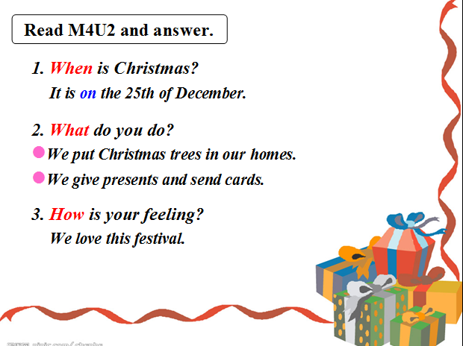

(3) Guess the colour labels and try to say more sentences.
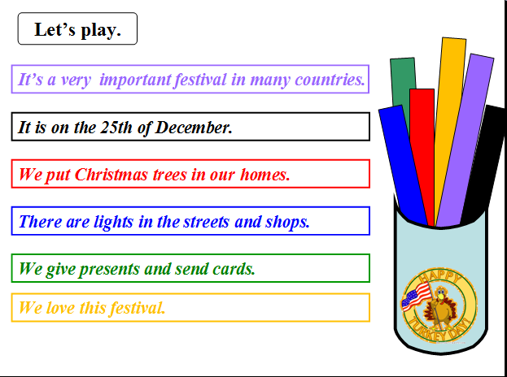

3. Compare with Christmas and Thanksgiving.
(1) 介绍节日的基本表达结构。
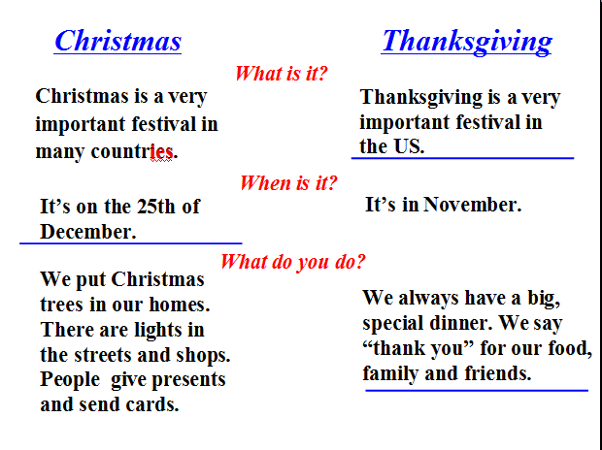

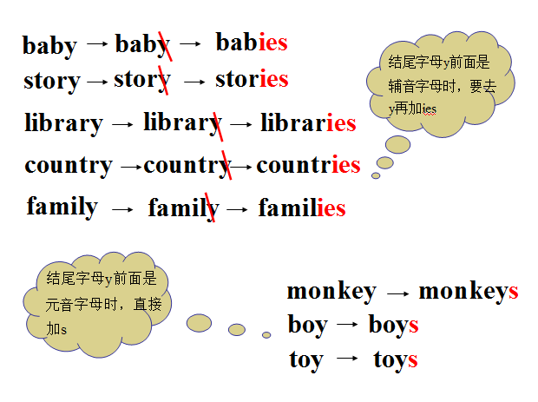
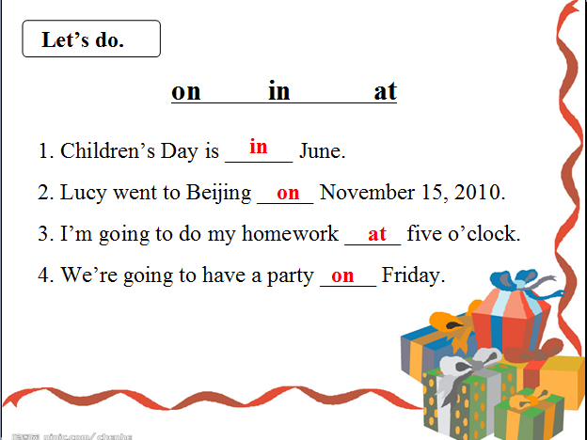
(2) 总结名词复数的变化规则，时间前介词用法练习。
Step 3、Practice
1. Guessing game. S: Is it (the)… T: Yes, it is./ No, it isn’t.
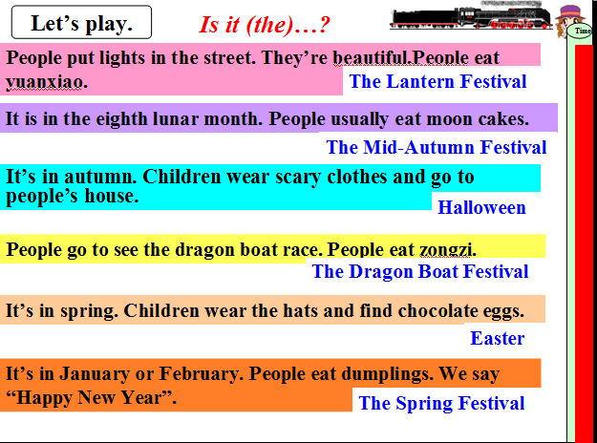

2. Have a reading.
T: Our friend Lingling wrote a letter about her favourite festival. Let’s read.(题单Task 1)
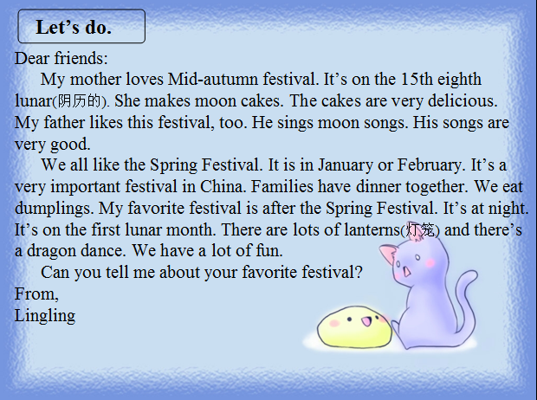

Step 4、Task completion
1. Talk show: talk about festivals you like.
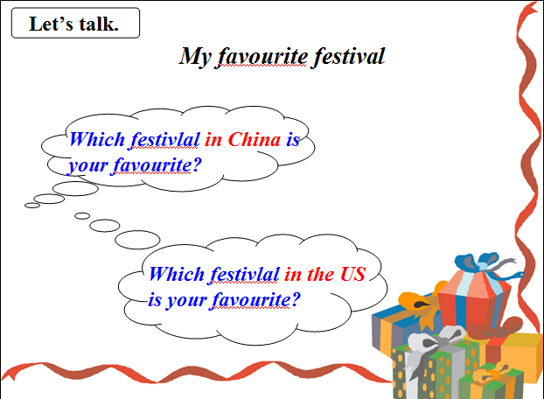
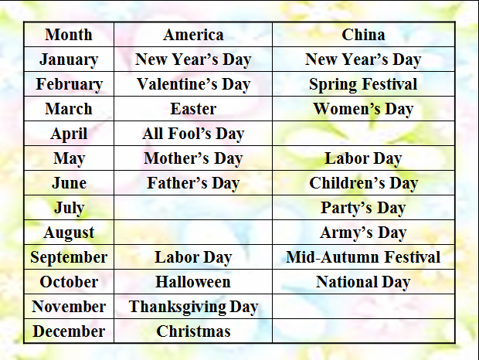
T: Children, do you remember today’s task? Let’s talk about your favourite festival.
- Writing: My favourite festival.
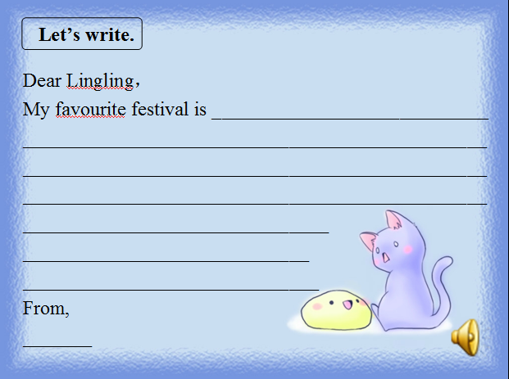
- T: Write a letter to Lingling about your favourite festival.

Step 5、Summary and homework
1. Sum up: What have we learnt today?
T: We learnt Thanksgiving and Christmas. And we can describe our favourite festival.
T: Look, which group is the winner?
2. Homework: 套餐A: Finish a letter to Lingling. 套餐B: 背诵M4课文
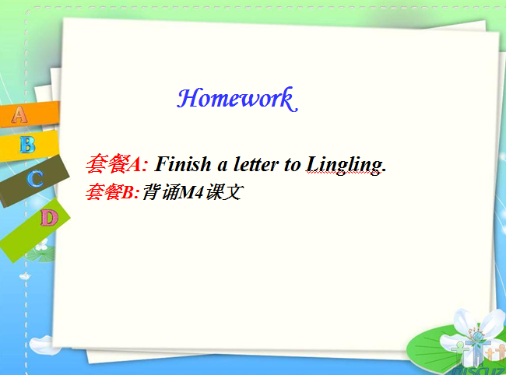

〔板书设计〕
Revision of Module 4
Festivals | Thanksgiving | Christmas
When | In November | On the 25th of December
What | have a big, special dinner | put Christmas trees
What | Say “thank you”for | give presents
What | Say “thank you”for | send cards
How | fun/ love/…
(Group T:感恩节食物) (Group C:圣诞节礼物)

Revision of Module4
Name:___________

Task 1: Read and choose.
Dear friends:
My mother loves Mid-autumn festival. It’s on the 15th eighth lunar(阴历的). She makes moon cakes. The cakes are very delicious. My father likes this festival, too. He sings moon songs. His songs are very good.
We all like the Spring Festival. It is in January or February. It’s a very important festival in China. Families have dinner together. We eat dumplings. My favorite festival is after the Spring Festival. It’s at night. It’s on the first lunar month. There are lots of lanterns(灯笼) and there’s a dragon dance. We have a lot of fun.
Can you tell me about your favorite festival?
From,
Lingling
( )1. How many festivals are there in the letter? _________.
A. Two B. Three C. Four
( )2. Lingling’s father likes _____________. And he sing songs on that day.
- The Mid- Autumn Festival B. The Spring Festival C. The Dragon Boat Festival
( )3. The Spring festival is ___________.
A. in January B. on the first lunar month C. in January or February
( )4. People can eat _________ at the Spring Festival.
A. moon cakes B. dumplings C. zongzi
( )5.Lingling’s favourite festival is ___________.
A. The Mid- Autumn Festival B. The Spring Festival C. The Lantern Festival

Task 2: Writing
Dear Lingling，
My favourite festival is _______________________________________________
__________________________________________________________________
__________________________________________________________________
__________________________________________________________________
__________________________________________________________________
__________________________________________________________________
__________________________________________________________________
From,
_______

