教学设计：
一年级起点第十二 册（NSE）Module 6
Unit 1 It was Daming’s birthday yesterday.
小长山小学 马晓丽
【教材分析】]
语言功能：讨论礼物。
教学目标：
- 语言知识目标：全体学生能运用：I was Daming’s birthday yesterday.全体学生能理解home, earth,space,travel, interested, be interested in, spaceship, surprised, made,全体学生能运用：home,travel,interested, made,部分学生能运用earth,space,travel, be interested in, spaceship, surprised.
b.语言技能目标：能够听懂、会说并认读本模块句型，能运用所学语言谈论礼物。
c.情感态度目标：乐于感知并积极尝试使用英语。
教学重、难点：
重点：单词home,travel,interested, made,
功能句I was Daming’s birthday yesterday.
Yesterday Simon’s mum bought him a book.
It was a book about space travel.
Simon’s mum was interested in the book, too.
难点：熟练运用一般过去式。
[教学准备]
CD-ROM, word cards, ppt.
【教学过程】

Step1. Warm-up and lead-in
- Greetings
- Now let’s watch some pictures. Are you interested in them? What did you see? Some aliens.Yes? Now let’s watch a CD-ROM about these two aliens and try to answer some questions.(Play the CD-ROM)
- Look! 3 questions. First complete the questions. Then try to answer.
（Teach: earth.; Explain: Welcome home! ）
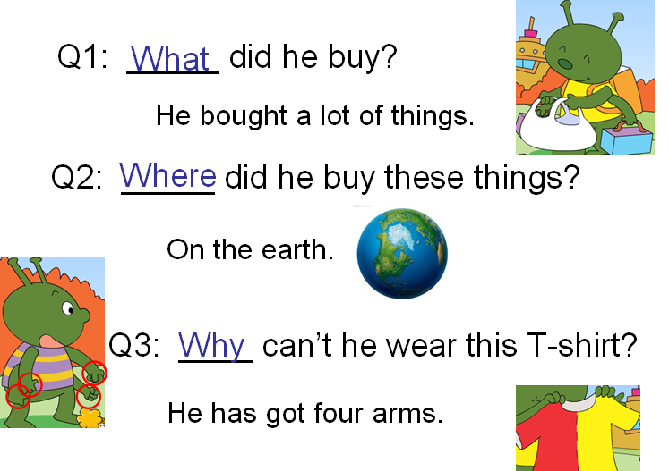
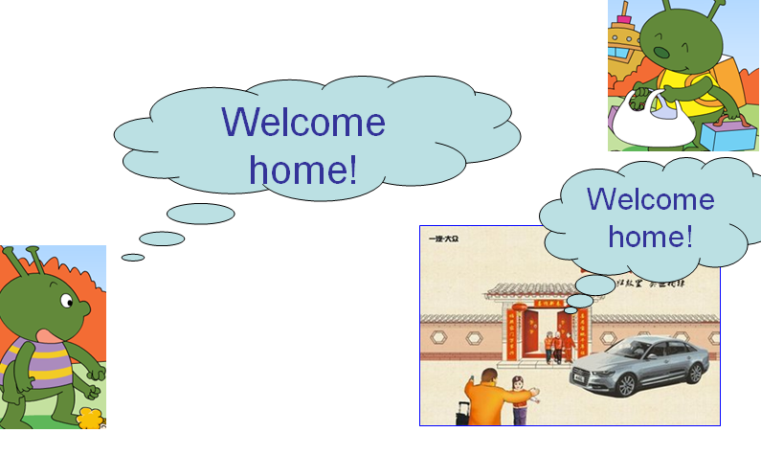

- Let’s listen and imitate!
- They’re aliens. They also give and get presents. How about us? We give presents to others and get presents, too. Yes? Now let’s think over! When do we get and send presents? ( Christmas, Spring Festival, Thanksgiving, Children’s Day, birthday) We get or send presents on some special days or festivals. Mostly on birthday. Right?

Step 2 Task presentation
So today we’re going to talk about birthday presents. What presents you got last time? Clear? How to talk about? Now let’s learn M6U1 It was Daming’s birthday yesterday. 板书 read it together!
Step 3. Text learning
- It was Daming’s birthday yesterday. What presents did he get? Just guess! Maybe he got…
Look! one of the presents is a book. Two questions. Read ! (Who bought the book for Daming? ) right. And what’s the book about? Let’s watch the CD-ROM and see. Ok?
Who bought a book for Daming? (Simon’s mum bought a book for Daming. )Right. Here “bought”, its orriginal form is –buy. Yes. Buy sth for sb equal to buy sb sth, so also we can say—Simon’s mum bought Daming a book.
What’s the book about?( It’s about space travel. Right.，space, travel, space travel)
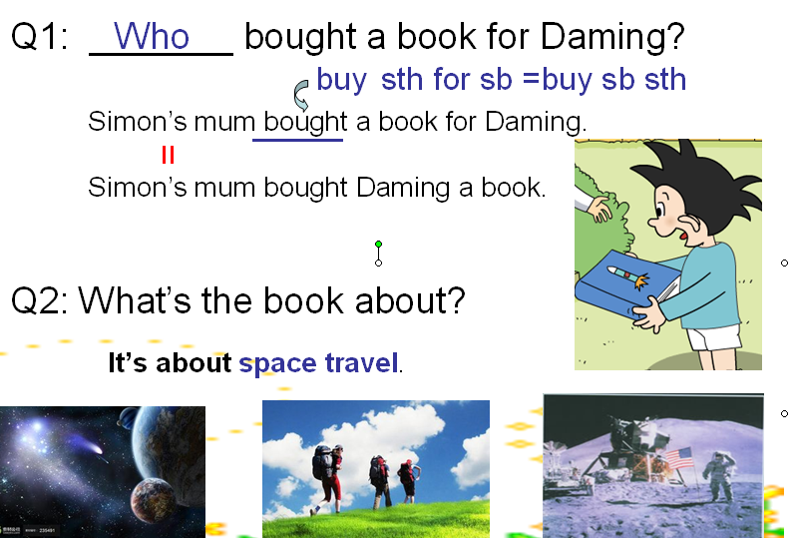

Does Daming like this book? Yes. Because he is interested in space travel. Use it to describe these pictures. What’s this? –interesting. Pay attention here. The subject is sth. Clear? Do it ,can you?
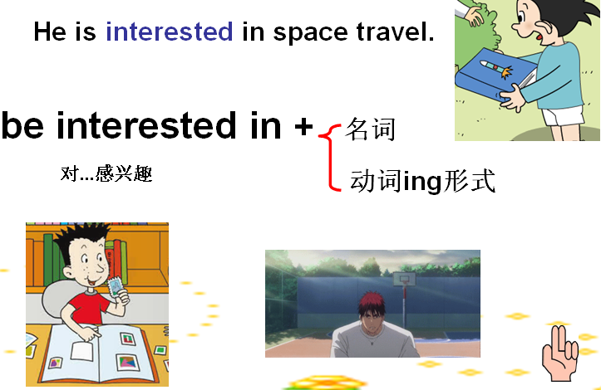
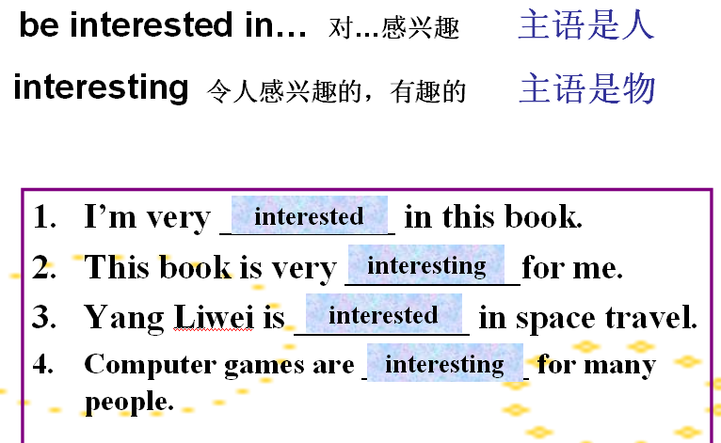

- Let’s watch the CD-ROM again, and answer another two questions. Read it .
Was Simon interested in the book,too? (Yes, he was. ) What did Daming do? (Daming asked Simon to read the book with him.) Pay attetion here. Ask sb to do sth eg. The art teacher asked Adam to draw a picture yesterday. Later I will tell you to retell the text. Are you clear? Read it! (Daming asked Simon to read the book with him. )So they read together. Yes?
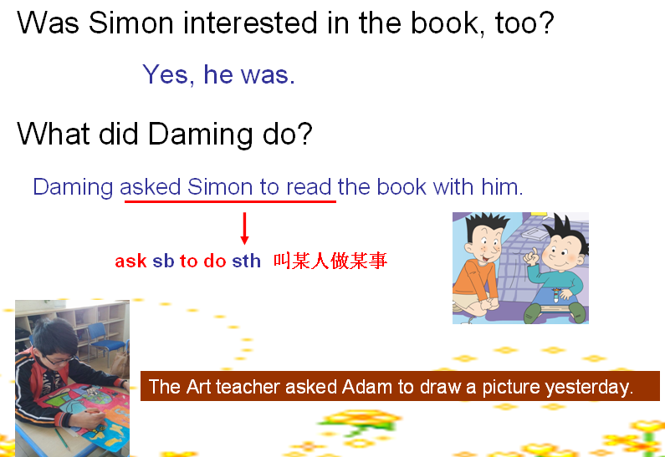

- read the last two paragraphs by yourselves and look for the answers. First let’s read the questions. Together!
Pen or pencil in your hands, read and underline the answers, and then talk about in groups.
First one can you? (in the book , they saw many pictures of spaceships from China, Russia and the US.) Right! Say after me. 贴spaceship 贴另一个， spaceships. What’s this? –space, this?—ship, it’s—spaceship. they saw spaceships from-(--China, ---Russia,---the US. )
Simon was surprised to see spaceships from China. Look! He is surprised. She is surprised. China sent people into space too. But Simon didn’t know. So he was very surprised.
What did Daming and Simon make? They made a paper spaceship. Here, made is the past form of make , yes? Do it, first one. Another one?
Was Simon’s mum happy? –yes, she was. Why? Why was she happy? Because Daming and Simon gave the spaceship to her. Yes? Here gave, its orriginal form is give , give sth to sb equal to give sb sth. So , also we can say—Daming and Simon gave her the spaceship.

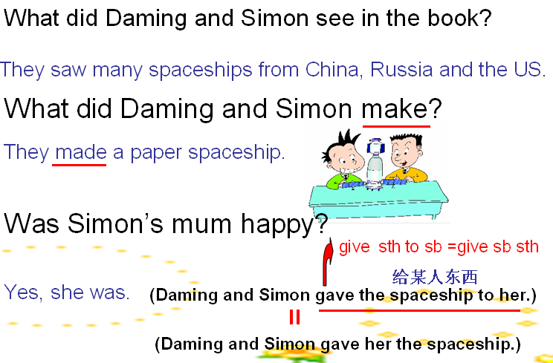

Why did Daming give the spaceship to Simon’s mum? –because Daming thanked her for the birthday present. Exerllent! Here thank sb for sth or doing sth. Look Sunny borrowed the ruler from Linda. Read it! Mark helped John pick up the books. Read!

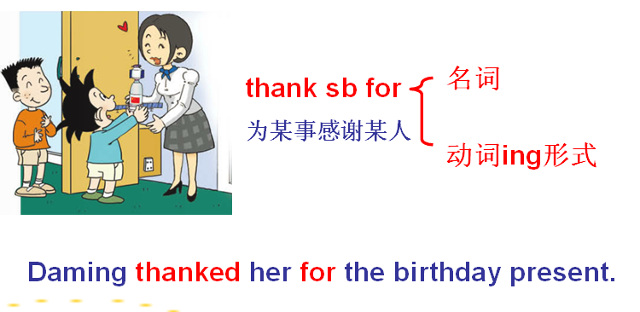

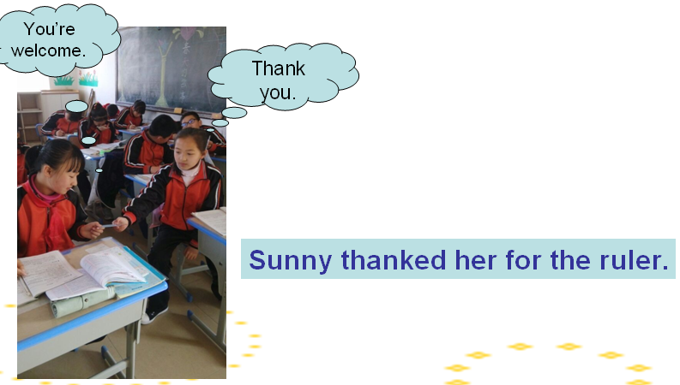

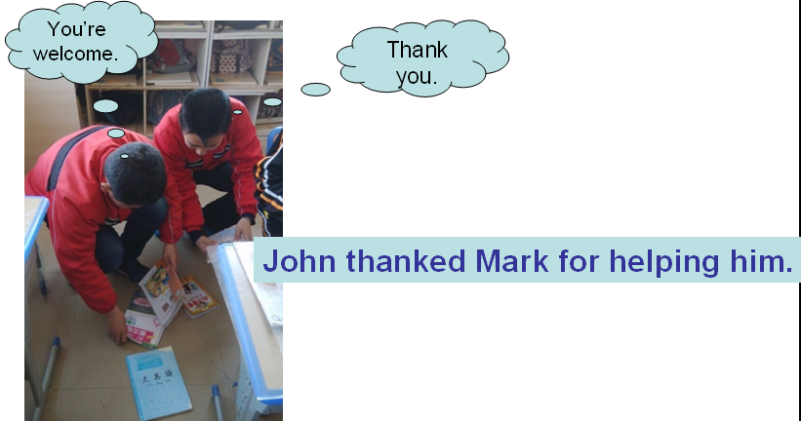

- this time, let’s listen and imitate.

- Fill in the blanks.
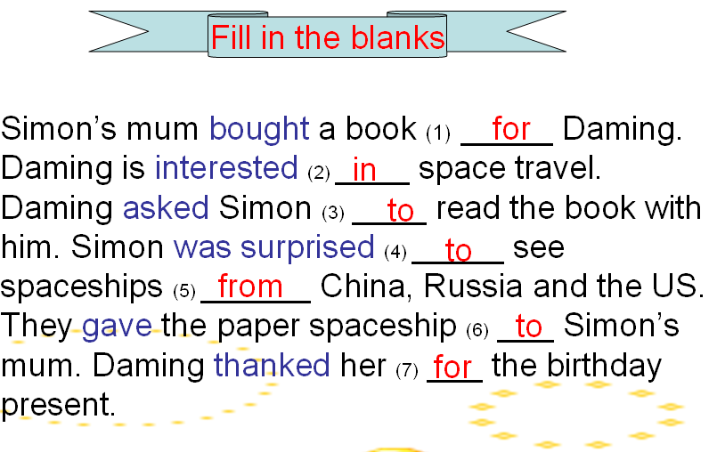

- Daming got many presents. can you retell the text according to this information map? Who can try? I can help you.
Now you can retell in groups , also you can just read in groups.

Step 4. practise
- Practise 4
- Close your books. Listen what can you hear? Talk about it this way. Can you?

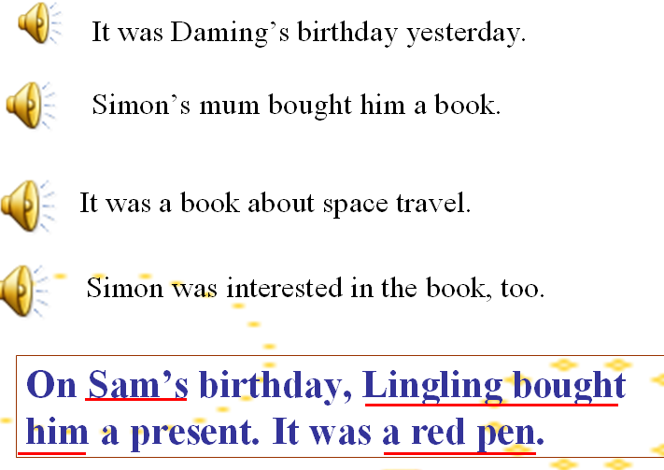

Step 5. Task completion
Boys and girls , do you still remember the task today? Talk about the birthday presents we got last time, right? First let me make an example……now talk about your birthday presents. Every group has got an information map. First discuss how to finish it in groups and then talk about together.
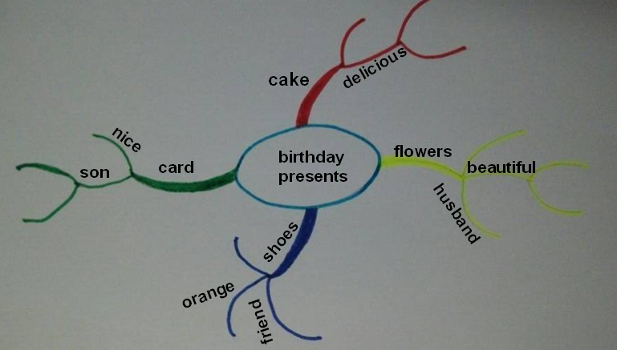

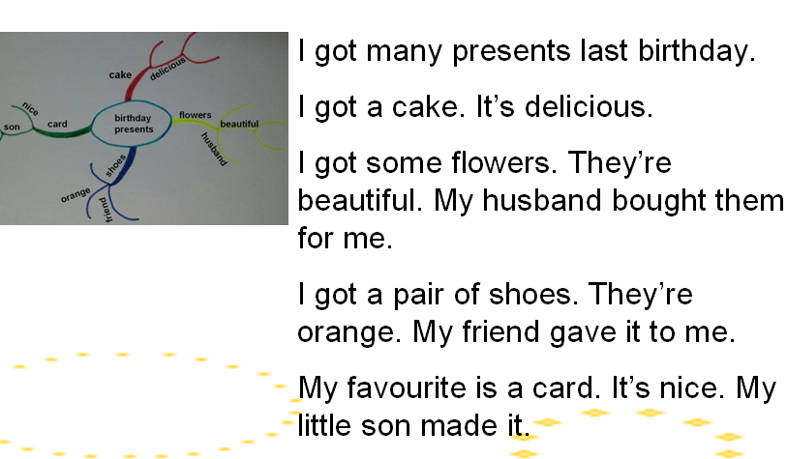

Now choose your favourite present to write about. You can write according to this.
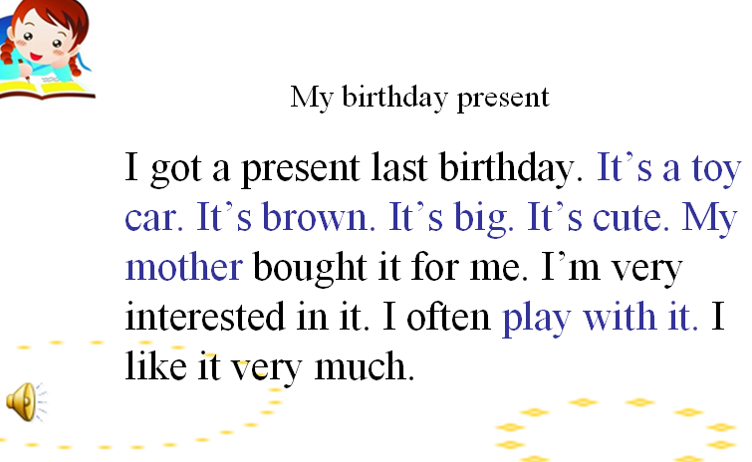

Step 6. Summary and homework
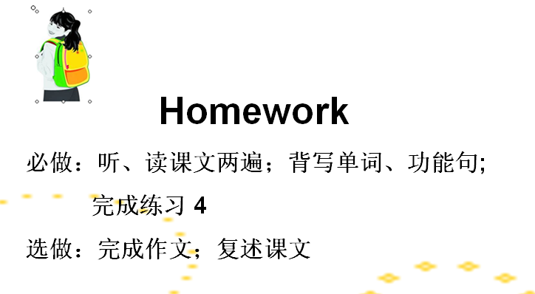

板书：
