2014—2015学年度第一学期阶段质量检测
四 年 级 英 语
听力部分（共五大题，40分）
Ⅰ. 听音，圈出你所听到的单词。（每题1分，共8分）
1、A. trip B. top C. took
2、A . mountain B. minute C. mouse
3、A. cooked B. cleaned C. climbed
4、A .see B. saw C. sweater
5、A .raining B. ride C. running
6、A .Maths B. watch C. wash
7、A .picture B. printed C. paint
8、A .was B. were C. wide

Ⅱ.听音标号。用数字标出图片的先后顺序。（每题1.5分，共12分）
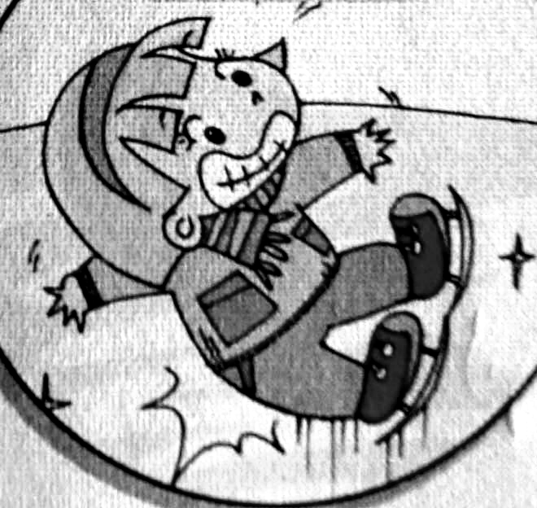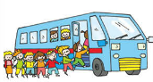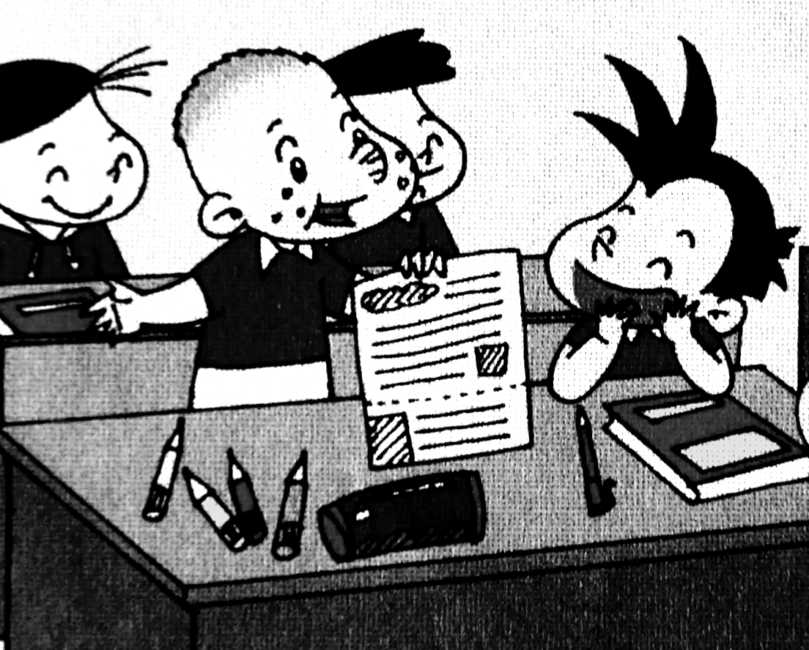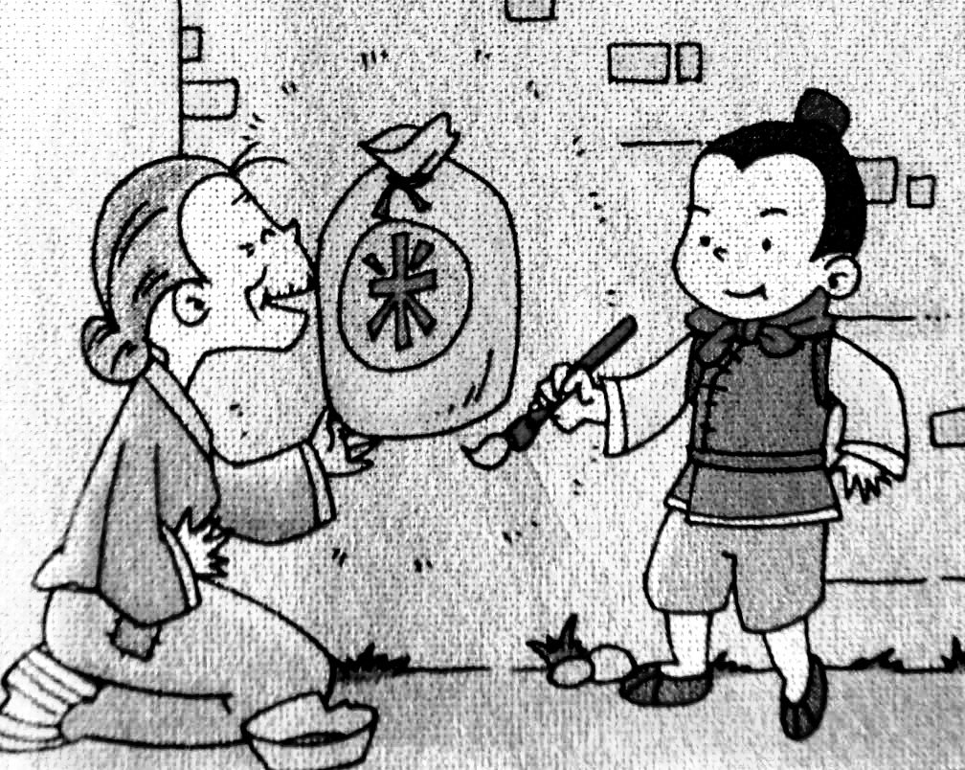

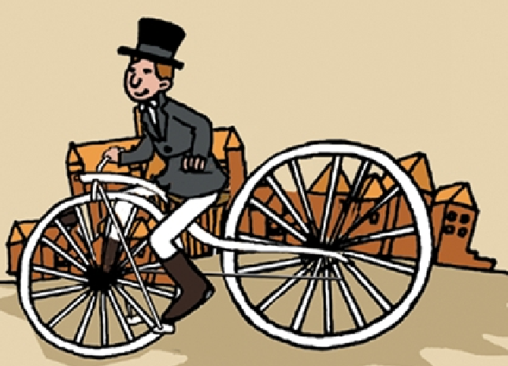
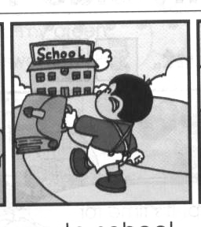
( ) ( ) ( ) ( )

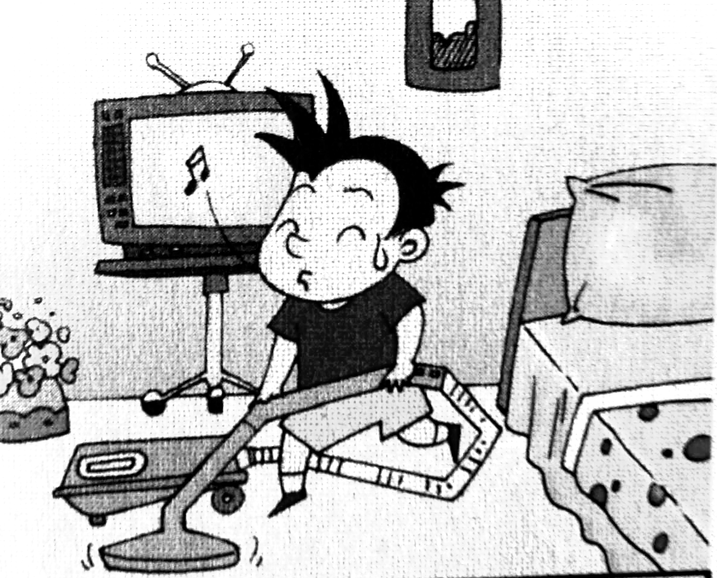
( ) ( ) ( ) ( )
Ⅲ. 听音判断。在正确选项前的括号内打“√”。（每题1分，共8分）
1、（ ）Zara has got a black, long hair . （ ）Zara has got a black, short hair .
2、（ ）Go to bed early every day. （ ）Get up early every day .
3、（ ）I fell off my bike. （ ）I went for a bike ride .
4、（ ）What did they play? （ ）When did they come?
5、（ ）What is Mr. Smart doing? （ ）What did Mr. Smart do?
6、（ ）Lingling didn’t walk to school . （ ）Lingling walks to school.
7、（ ）She usually gets up at half past six. （ ）She didn’t get up at half past six.
8、（ ）Chinese people invented printing. （ ）Chinese people invented paper.

Ⅳ、听问句，选择正确的答句。（每题1分，共6分）
( )1、A. She’s reading a letter. B. She learned English.
( )2、A. Yes, she did. B. Yes, she does.
( )3、A. They invented paper. B. They invented the bicycle.
( )4、A. He went to the Great Wall. B. He ate apples.
( )5、A. She lives in London. B. Yes, she does.
( )6、A. It’s from London. B. No, it isn’t.

Ⅴ、听音填词，补全短文。（每题1分，共6分）
Do you want to be ?Eat vegetables .
Drink lots of or .Do a lot.

笔试部分（共五大题，60分）
Ⅵ. 单项填空。将正确答案的序号填写在前面的括号里。（每题1分，共15分）
( ) 1. This letter is _______ Lucy. A. from B. of C. on
( ) 2. My trousers ____ dirty, so I washed them. A. were B. was C. are
( ) 3. Where ____ your mother work? She worked in a shop.
A. do B. does C. did
( ) 4.Yesterday Maomao didn’t ____ to school. She ___ to the park.
A. go… went B. went…went C. go…goes
( ) 5. Fruit healthy,vegetables healthy.
A.is/is B.are/are C.are/is D.is/are
( ) 6. At first,I over.And I didn’t over again.
A. fall/fall B. fell/fell C. fell/fall
( ) 7. the Doctor’s. A.In B.in C.At D.at
( ) 8. You will a competition. A.win B.won
( ) 9. Yesterday we went a bike ride . A .to B. on C. for
( ) 10. Who is ? A .cry B. crying C. cried
( ) 11. _____ Saturday we go to swim. A. In B. At C. On
( ) 12. The key was your bag.
A.to B.in C.on
( ) 13. What did you do yesterday? I ___________.
A. watch TV B. play football C. stayed at home
( ) 14. You had fish breakfast yesterday.
A.to B.for C.of
( ) 15. Always wash your hands you eat and you go to the toilet.
A.before/after B.after/before

Ⅶ. 词语运用(共12小题，共15分)
A. 选择方框中词语填空，使句子通顺连贯。（每题1分，共6分）
took , only , said, angry , away , help,

The bad man was .The magic paintbrush didn’t him.
It helped Ma Liang.So he Ma Liang .”I want a big ship” the bad man”You paint it”.

B. 根据提示，用词汇的适当形式完成下列句子。（每题1.5分，共9分）
1. Look at the man （在……旁边） the bicycle.
2.The other man （在……中间）the two cars.
3. It didn’t （变成） （金子） .
4. Always wash your hands （在……之前）you eat
and （在……之后）you go to the toilet.

Ⅷ. 句子理解。（共2大题，计15分）
A. 找出相对应的答句，将序号填入题前括号内。（每题1分，共6分）
( ) 1. What’s the matter? A. No, it didn’t.
( ) 2. What did they do yesterday? B. I’m reading a letter.
( ) 3. Where did you go yesterday? C. They climbed the mountain.
( ) 4. Did the paintbrush make gold? D. I hurt my knees.
( ) 5. How many biscuits did you eat? E. I went to the cinema.
( ) 6. What are you doing? F. I ate thirty biscuits.
B. 根据图文提示，完成下列句子。（1.2.4.5每题2分，第3题1分,共9分）
1. ---Where do you live? （China）
---__________________________________ .
2. ---What happened to you?
---__________________________________ . (head)
3. Sam his bike. 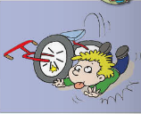
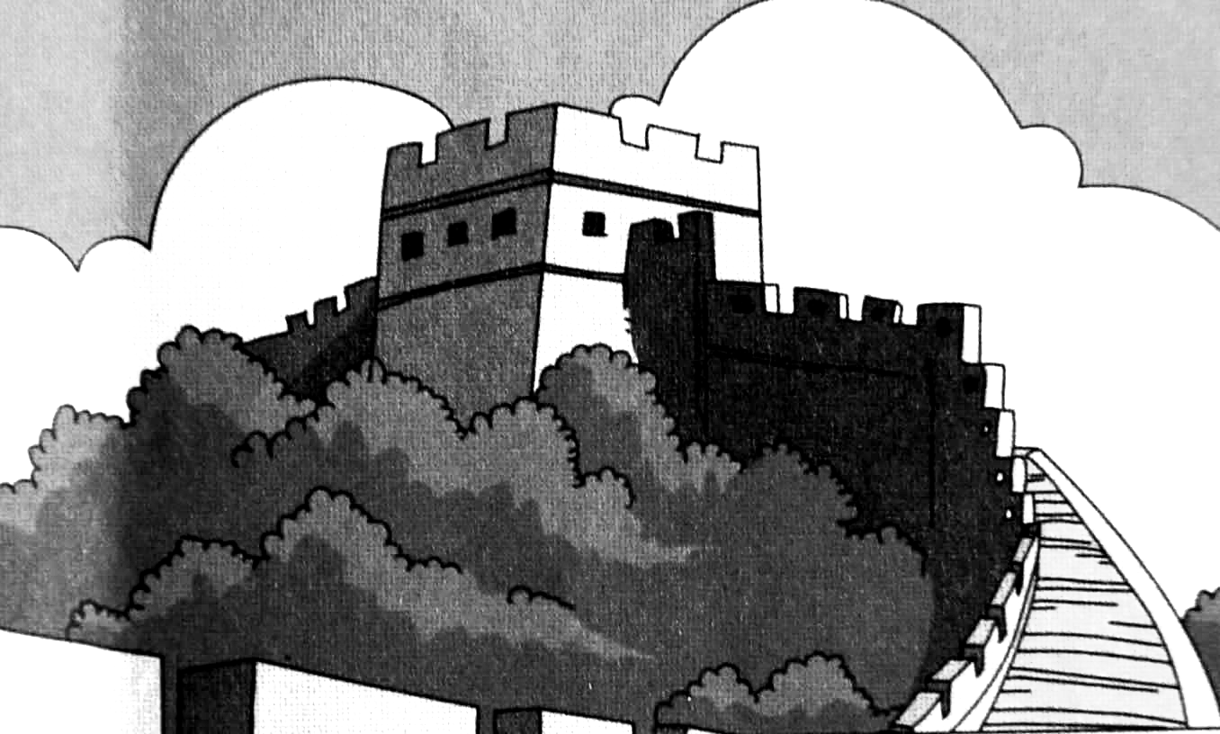
4. Where did you go last summer?
We _____________________________. (SanYa)
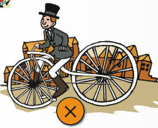

5.Chinese people ______________ _______________

Ⅸ. 情景交际。选择答案的序号填写在空格处。(每题2分，共10分)
A. Did you go to the hospital? B. bumped my head.
C. What happened to you? D. Yes, I fell off my bike.
E. I went for a bike ride.

Lily：Hi, Tom, ________________________.
Tom: I hurt my knees and .
Lily: What did you do yesterday?
Tom: ________________________.
Lily: Did you fall?
Tom: .
Lily: .
Tom: Yes ,I did.
Ⅹ. 短文阅读,判断正（T）、误（F）。（每题1分，共5分）
My name is Lili.This week,I sit in the middle（中间）of the classroom.Feifei is in front of me.Xiaoyong is beside me.Lingling is beside me,too.Last week,I was in front of Feifei.Feifei was between Xiaoyong and me.Lingling was beside me.
( ) 1. Lili sits in front of the classroom this week.
( ) 2. This week,Feifei is in front of Lili.
( ) 3. Xiaoyong is beside Lili this week.
( ) 4. Last week,Lili was in front of Feifei.
( ) 5. Lingling was beside Lili last week.

