二年级英语期末检测

听力部分
学 校
班 级
姓 名
- 听音标号。（5分）
walk park autumn eat plane
( ) ( ) ( ) ( ) ( )
二、听一听，连一连。（12分）
1. 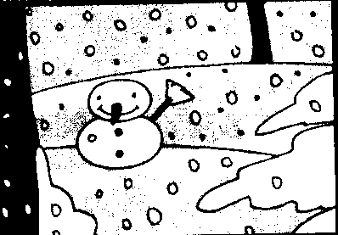 It's warm.

2. 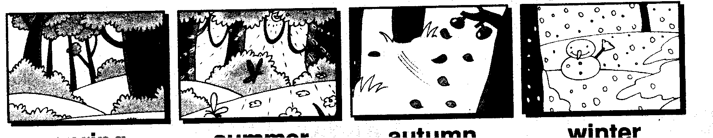 It's cold..

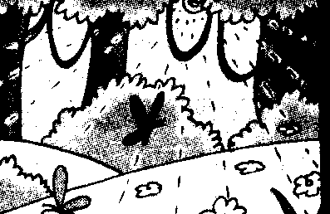 It's cool .

4. 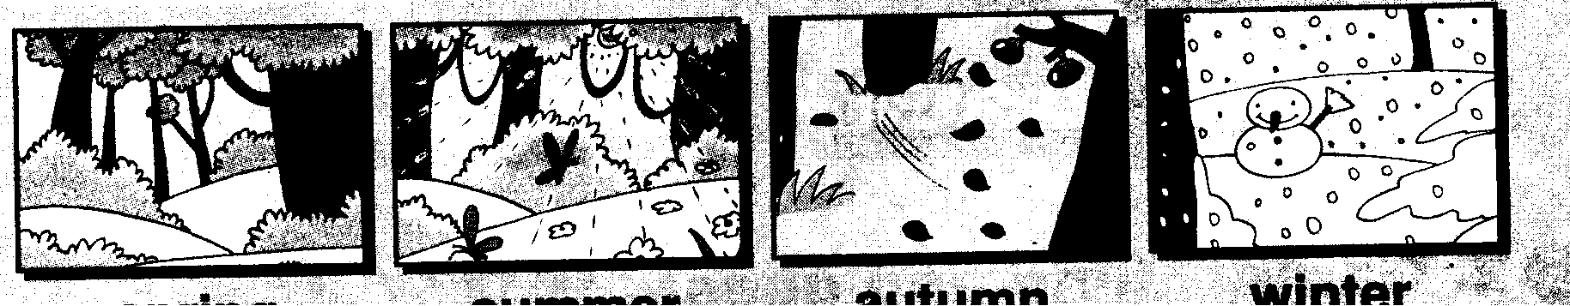 It's hot .

三、认真听，请为他们选出正确的交通工具，并将单词其圈出来。（12分）

1. I go to school by bus / car .
2. I go to work by train / bike .
3. She goes to school by plane / ship.
4. My father goes to work by bike / bus.
5.Amy goes to the zoo by taxi / bus
6.I walk / work to the farm.
四、请为下面的各个季节找到其相应应穿的衣服并用线连接起来。（8分）
1. spring We wear T-shirts . 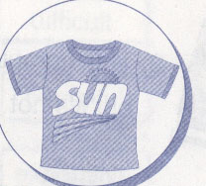
2. summer We wear jackets . 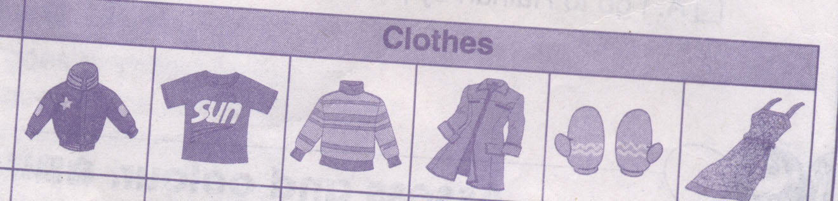
3. autumn We wear coats and gloves . 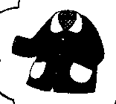
4. winter We wear sweaters . 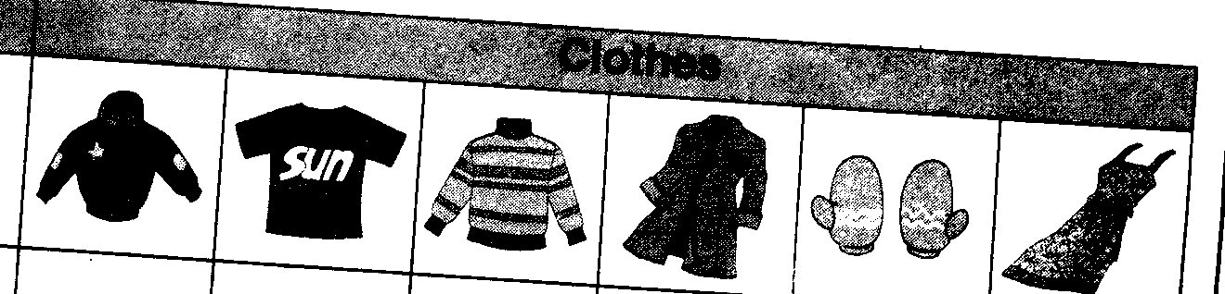

笔试部分

一、按要求规范背写Aa——Zz。（26分）

- 将左右两边的单词连接起来使其组成一个短语。（10分）
go to holiday listen to books

at the work play CDs

have weekend read football

on flute watch home

play the lunch go TV

三、选择，请将正确的答案前的序号写在前面的括号内。（12分）

( ) 1) We ______ wear jackets.
A not B doesn't C don't
( ) 2) . I like summer .it’s________.
A warm B hot C cold
( ) 3) I go ______ train .
A by B on C for

( ) 4) I play football _____ 7 o'clock _____ the afternoon.
A at , at B at , in C in , in

( ) 5) It _______ autumn .
A is B a C does

( ) 6) ______ he go to school by car ?
A Do B Is C Does

四、请为下面的问句找到合适的答句，并连接起来。（10分）
1) Where do you live ? I play football.

2) Doe she like football? Yes , she does .

3) What do you do at the weekend ? I live in Dalian .

4) Where do you play ping-pong ? I walk to school .

5) How do you go to school ? At the park

五、按下列单词的首字在字母表中的位置为它们排序。（5分）
jug art teddy rabbit vase
( ) ( ) ( ) ( ) ( )

听力答案：
一、听音标号。（5分）
Park autumn eat walk plane

二、听一听，连一连。（12分）
1.In spring , it's warm.
2.In autumn ,it's cool.
3.In summer , it's hot .
4.In winter , it's cold .
三、认真听，请为他们选出正确的交通工具，并将其圈出来。（12分）
1.I go to school by bus
2.I go to work by train
3.She goes to school by plane
4,My father goes t o walk by bike.
5.Amy goes to the zoo by taxi
6.I walk to the farm.

四、请为下面的各个季节找到其相应应穿的衣服并用线连接起来。（8分）
1.It’s spring , We wear jackets .
2 It’s summer We wear T-shirts .
3.It’s autumn , . We wear sweaters .
4. It’s winter , We wear coats and gloves .
装 订 线 内 不 得 答 题
装 订 线 内 不 得 答 题

