大长山小学2014~2015学年度第一学期期末检测
学 校
班 级
姓 名
三年级 英语 完成时间：60分钟
题号 | 听力部分 |  |  |  |  | 笔试部分 |  |  |  |  |  |  | 总分
题号 | Ⅰ | Ⅱ | Ⅲ | Ⅳ | Ⅴ | Ⅵ | Ⅶ | Ⅷ | Ⅸ | Ⅹ | Ⅺ | Ⅻ | 总分
得分
听力部分（50分）
Ⅰ、听音,选出你所听到的单词，将其序号填入括号内（10分）
（ ）1. A. food B. feed （ ）2. A. cake B. lake
（ ）3. A .easy B. sea （ ）4. A. paper B. people
（ ）5. A. bread B. bring （ ）6. A. worry B. sorry
（ ）7. A. fly B. cry （ ）8. A. pear B. peach
（ ）9. A. cough B. careful （ ）10. A. wash B. water
Ⅱ、听音,根据所听顺序用数字(1,2,3,4,5)给下列图片排序（10分）
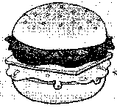
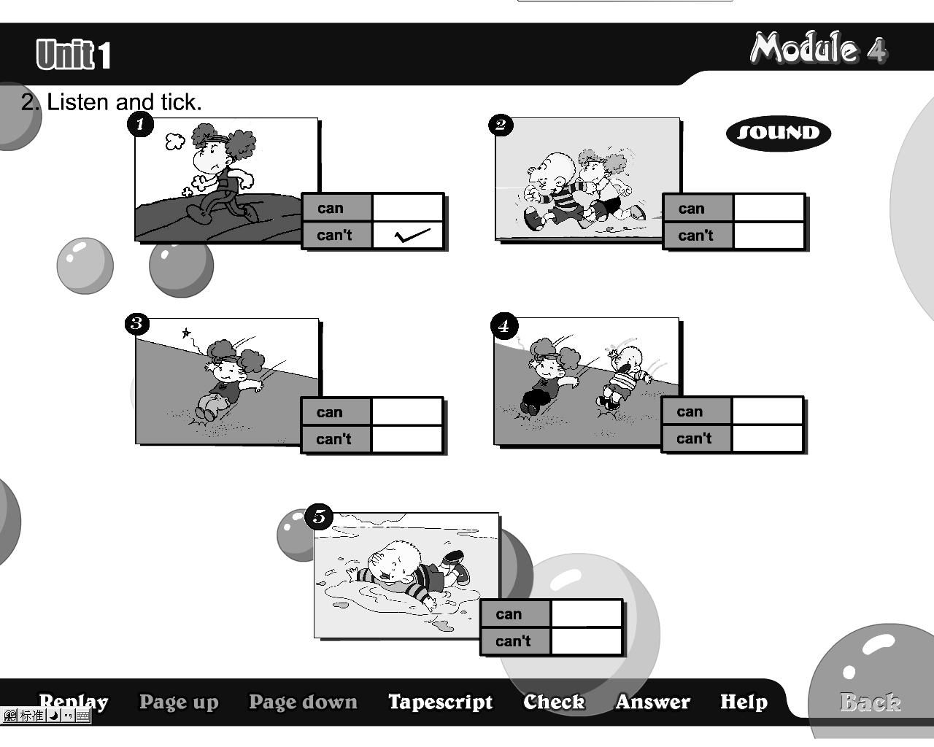
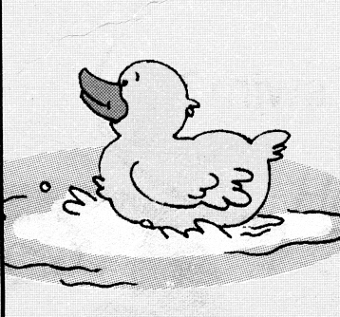
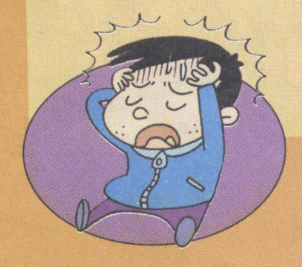
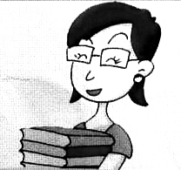

( ) ( ) ( ) ( ) ( )
Ⅲ、听对话，画笑脸(can)和哭脸(can’t) （10分）
1. have a drink
2. have an ice cream
3. have a cake
4. go to the shop
5. watch TV

Ⅳ、选出你所听到的句子，并把序号写在题前的括号内（10分）
( )1. A. Do you use chopsticks in the UK?
B. We use chopsticks in China.
( )2. A. They are dragon boats. B. They are boats.
( )3. A. What are you going to be？
B. What are you going to do?
( )4. A. What are these? B. What are those?
( )5. A. He’s reading. B. She’s working.
Ⅴ、听音，用数字(1,2,3,4,5)给句子重新排序（10分）
（ ） Sam can jump far. He’s going to do long jump.
（ ） No, she isn’t. She’s going to do high jump on Sports Day.
（ ） It’s going to be Sports Day on Friday.
（ ） Daming is going to run a race. He can run fast.
（ ） Is Amy going to do long jump，too?

笔试部分（50分）
Ⅵ、请按顺序规范默写26个大小写英文字母（5分）

Ⅶ、请根据所给语境写出正确的单词（10分）
1. It’s _________(容易的) for us to use a knife and fork.
2. You can’t run fast. You are _________(慢的).
3. She likes film. She is going to be a __________(明星).
4. Sam is ill. He’s got a ___________(感冒).
5. We’re going to ________ (参观) the zoo.
Ⅷ、选择，将正确的答案序号写在题前的括号内（5分）
( )1. I am eating noodles. It's ________ fast food.
A. Chinese B. English C. China
( )2. Amy is _____ the flute.
A. playing B. play C. plays
( )3. I can jump far, _______I can’t jump high.
A. and B. but C. to
( )4. Can I play _____ your football?
A. with B. in C. of
( )5. She _____ got a new dress.
A. have B. is C. has
Ⅸ、根据语境，选择恰当的单词填写在横线上（10分）
Saturday, winner, lovely, clever, quiet
1. Look at the toys. They are _________.
2. Don’t worry. You are a __________ boy.
3. On _________, we’re going to see a film.
4. Please be ________! Mum is working.
5. Ha! I’m the __________. I can jump far.
Ⅹ、根据问句选答句， 把正确的序号写在题前的括号内（10分）
( )1. Is this Sam’s book? A. No, I’m not.
( )2. What are you doing? B. Yes, please.
( )3. Can I come in? C. I’m watering flowers.
( )4. Have you got a test today? D. Yes, it is.
( )5. Are you going to Hong Kong? E. Yes, I have.
Ⅺ、连词成句（5分）
1．a/ fork/ we/ knife/ and/ use/(.)
________________________________________________
2. naughty/ are/ very/ these/ ducks/(!)
________________________________________________
3. going/ be/ a/ driver/ I/ am/ to/ (.)
________________________________________________
4. stomach ache/ a/ you/ got/ have/(?)
_________________________________________
5. shirt/ is/ Amy’s/ this/(.)
________________________________________________
Ⅻ、阅读理解，正确的写T，错误的写F（5）
I’m a girl. My name is Wang Mei. I’m nine. I have many friends. I like them. My friend Li Ming can run fast and jump far. Zhang Dong can play football and basketball, but he can’t swim. Chen Hua can play the drums, but she can’t play the flute. My friends Jiang Ling and Guo Qiang can run a race. I can sing and dance. How happy we are!
（ ）1. Wang Mei is nine.
( ) 2. Wang Mei have many friends.
( ) 3. Li Ming can’t run fast.
( ) 4. Chen Hua can play the flute.
( ) 5. Wang Mei can sing and dance.

三年级英语听力题签：
注意：每道听力试题读二遍，听力时间控制在25分钟内。
Ⅰ、听音,选出你所听到的单词，将其序号填入括号内。
1. Let’s feed the ducks !
2. We’re making a cake for mum and dad.
3. I’m going to swim in the sea.
4. People row on this lake.
5. You can’t bring toys to school.
6. Don’t worry! You can read all the books now.
7. I can see a bird. It can fly.
8. I’ve got a peach.
9. Be careful!
10. I can wash my shorts and shoes.
Ⅱ、听音,根据所听顺序用数字(1,2,3,4,5)给下列图片排序。
1. What are you eating? I’m eating a hamburger.
2. Oh! Amy, I can’t jump far.
3. The duck can swim.
4. Have you got a headache? Yes, I have.
5. I’m going to be a teacher.
Ⅲ、听对话，画笑脸(can)和哭脸(can’t)。
1、Amy: Mum, can I have a drink, please?
Mum: Yes, Here you are.

2、Amy: Can I have an ice cream?
Mum: No, you can’t. Look, no ice cream.

3、Amy: Can I have a cake?
Mum: Yes, you can.
Amy: Thanks, mum.

4、Amy: Can I go to the shop?
Mum: No, you can’t go out. You’re ill.

5、Amy: Can I watch TV?
Mum: Yes, you can.
Ⅳ、选出你所听到的句子，并把序号写在题前的括号内。
1. Do you use chopsticks in the UK?
2. They are dragon boats.
3. What are you going to do?
4. What are those?
5. She’s working.
Ⅴ、听音，用数字(1,2,3,4,5)给句子重新排序。
1. It’s going to be Sports Day on Friday.
2. Daming is going to run a race. He can run fast.
3. Sam can jump far. He’s going to do long jump.
4. Is Amy going to do long jump，too?
5. No, she isn’t. She’s going to do high jump on Sports Day.

听力部分到此结束！

三年级英语答案及评分标准：
听力部分
Ⅰ、(1×10＝10分) B A B B B A A B B A
Ⅱ、(2×5＝10分) 5--- 4 ---3--- 1 ---2

Ⅲ、(2×5＝10分) 1. 2. 3. 4. 5.

Ⅳ、(2×5＝10分) A A B B B
Ⅴ、(2×5＝10分) 3—5—1—2—4

笔试部分
Ⅵ、(5分) 略
（备注：要求一律用手写体规范书写26个大小写英文字母，如果个别字母没变体就算错误，4个或4个以内字母合计0.5分，共52个字母合计5分，扣完为止！）
Ⅶ、(2×5＝10分)
easy , slow , star , cold , visit
Ⅷ、（1×5＝5分）A A B A C
Ⅸ、（2×5＝10分）lovely, clever, Saturday, quiet, winner
（黑色粗体加下划线没变形扣1分）
Ⅹ、（2×5＝10分）D C B E A
Ⅺ、（1×5＝5分）略
Ⅻ、（1×5＝5分）T T F F T
2015年1月7日

