小学英语四年级测试卷（2014）
学 校
班 级
姓 名
题号 | 一 | 二 | 三 | 四 | 五 | 六 | 七 | 八 | 九
得分
考试时间：40分钟

听力部分（42’）
Ⅰ、听句子，圈出你所听到的单词或短语。（10’）
1、went want
2、 thirty hungry
3、bought buy
4、 fell over fell off
5、fell on fell off

Ⅱ、按照正确的顺序排一排。(12’)（用1、2、3、4、5、6数字）
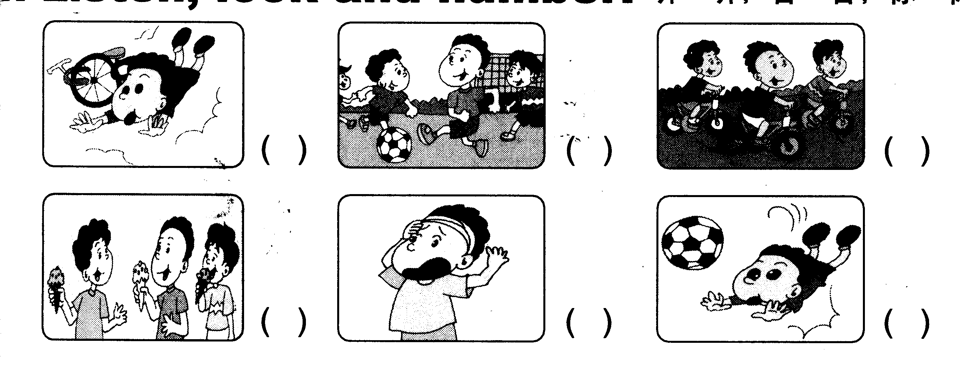

Ⅲ、听句子，选择句子。(10’)
( )1.A. He fell off his bike.
B. He fall off his bike.
( )2.A. I went to the Great Wall.
B. I want to the Great Wall.
( )3.A. She gets up at seven clock.
B. I get up at six clock.
( )4.A. I came last Sunday.
B. I came last Wednesday.
( )5.A. I saw lots of mountains.
B. I ate lots of candies.

IV. 听短文排序。（10’）
( ) We had a good time.
( ) I fell over, but it didn’t hurt.
( ) The ice was very cold.
( ) I was able to skate.
( ) I wore warm clothes.

笔试部分(58’)

Ⅴ、根据提示写出单词，使句子表达准确。（10’）
- What did you _______(演奏)yesterday?
- What_________(发生)to you? I____（割）my finger?
- Some English children_______ ____(来到)China last week.
- Did you _______(弄坏)your toy?
- The bad man _____ Ma Liang ______.(带走)

Ⅵ、选择正确的答案。(10’)
( )1.Yesterday_____National Day.
A. was B. is C. were
( )2. Last year she____the competition,
- wins B. won C. win
( )3.did they come___the music competition?
A. for B. at C. to
( )4. He can play____and she can play_____.
- the footbale,the flute B. football,flute C. football, the flute
( )5. I______go out.I stayed at home.
A. did B. didn’t C. am not
( )6. What____he do last Monday?
A. does B. is C. did
( )7. Ma Liang painted the food _______ the magic paintbrush.
A. and B. for C. with
( )8. We went______a bike ride.
A. to B. for C. four
( )9. Sam put the watermelon______his bike.
A. to B. off C. on
( )10. Tom is _____.
A. cried B. cry C. crying

Ⅶ、选择合适的词填空。(18’)
1. What did you_______? I ________some sweets.(buy/bought)
2. What’s the matter? I _______my head.(bump/bumped)
3. Tom usually ______football in the afternoon.(played/plays)
4. Where did you go? I _________go out.(don’t/didn’t)
5. Where does your friend live? My friend _____in England.(live/lives)
6. Do some ______ every day.(exercises/exercise)

Ⅷ、根据答句，选词填空(10’)

Who What Where When

1._______ did your mother come back?
—— She came last Monday.
2._______ did Tingting go last winter?
——She went to America.
3.________ did you play?
—— I played the flute.
4.________ invented paper and printing?
—— Chinese people.

Ⅸ、阅读理解,判断T或F。(10’)
Hi, I’m Tim. Yesterday was my birthday. I went to the park with my mum. I saw my friend, Tom. We played football together(一起).then we went home. I ate some birthday cakes. I was very happy.

1. Yesterday was Tim’s birthday.( )
2. Tom is Tim’s friend.( )
3. They played basketball together.( )
4. Tom ate some birthday cakes.（ ）
5. Tim had a good time.( )

四年级测试听力题签
- 听句子圈出你所听到的单词或短语。
1、Yesterday,Sam and Daming went for a bike ride.
2、They were very hungry and thirsty.
3、So they bought a watermelon.
4、Then Sam fell off his bike.
5-And Daming fell on the watermelon。
二、按照正确的顺序排一排
1．We played football.
2． I fell over and hurt my knee.
3. We were thirsty and bought some ice creams.
4. We went for a bike fide.
5. I fell off my bike.
6. My head was hurt.

三、听句子，选择正确的答句。
1、He fell off his bike
2. I went to the Great Wall.
3.She gets up at seven clock.
4. I came last Wednesday.
5. I ate lots of candies.
四、听短文排序。
Yester we went for a school trip. We went skating. I wore warm clothes. And the ice was very cold. First I fell over. But it didn’t hurt. I never stop. Then I was able to skate. I was very happy. And we had a very good time.

