广小五年级英语下册期末试题
第一部分 听力
Ⅰ、 听音，选择听到的内容，将标号填入题前括号内。(共5分，每小题1分)
（ ）1 A . Last night. B . Last year
（ ）2 A .I met her. B . I will meet her.
（ ）3 A.Here’s a letter for Daming. B.Here’s a letter from Daming.
（ ）4 A . I went to the Great Wall. B. I will go to the Great Wall .
（ ）5 A.I go there to buy sheep. B.I go there by ship.

Ⅱ、 听音，选择正确的答案。(共10分，每小题2分)
( ) 1 A. Yes, it is B. No, it isn’t.
( ) 2 A.He is going to the park. B.He is going to the zoo.
( ) 3 A.Yes, she can. B.No, she can’t.
( ) 4 A. Three pencils. B.Five pencils.
( ) 5 A. It’s blue. B.It’s red.

Ⅲ、 听音, 填入所缺单词。(共5分，每小题1分)
1. My grandma was a ______________ before.
2. My favourite ____________is spring.
3. Chinese people ____________the Great Wall.
4. The men wore women’s _______________ .
5. I___________a dragon on a piece of paper.

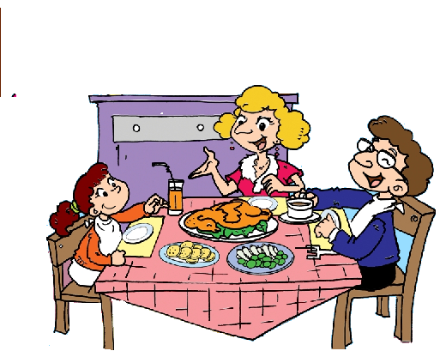
Ⅳ.听短文，判断正误。正确写“T”, 错误写“F”。(共10分，每小题2分)
（ ）1. English people usually have breakfast at half past six.
（ ）2. Dinner is usually at seven o’clock.
（ ）3. English families usually eat dinner together on Sundays.
（ ）4. They eat chicken ,potatoes and vegetables for lunch on Sundays.
（ ）5. Many people eat fish on Fridays.
第二部分 笔试
Ⅴ、 单项选择。(共10分，每小题1分)
( )1. I went there _____ bus.
A.in B.by C.at
( ) 2.Tell me something _____ your sister.
A.about B.for C.at
( ) 3.Sam ____Daming a present last week.
A.gave B.giving C.gives
( ) 4.___ you ready for your trip?
A.Are B.Do C.Will
( ) 5.We go to school ____ 7 :50.
A.in B.for C.at
( )6. In winter, it’s cold. We can wear____and gloves.
A. dress B. coats C. shorts
( )7. A: What did you have for lunch yesterday? B: I ______ noodles.
A. was B. had C. have
( )8. A: ____ did your uncle work? B: He worked in a shop.
A. Where B. When C. What
( )9. You ___ talk to your friends in the library.
A. won’t B. don’t C. can’t
( )10. What ______ your grandpa before?
A. was B. is C. were

VI. 用方块中所给单词或短语的适当形式填空。(共10分，每小题2分)
in a circle return in an office chocolate send
1. Some stones are ____________. And some are on top of others.
2. Her mother works______________.
3. I ______ you American ___________. Did you eat them?
4.Please __________the books in a month, please!
Ⅶ.找出相对应的答句，将序号填入题前括号内。（每题1分，共5分）
( ) 1. Do you like Chinese food, Amy? A. I’ll go to Beijing.
( ) 2. What will you do this summer? B. He has got a computer in his room.
( ) 3. What has he got in his room? C. She played Chinese music.
( ) 4. What music did your mother play? D. No. I didn’t.
( ) 5. Did you read This is London? E. Yes. It’s delicious.
ⅥII. 连词成句。(共10分，每小题2分)
1 put, in, bag, your, What, did, you,
______________________________________________
2 The, women’s, men, wore, clothes,
______________________________________________
3 I，got, have , in, English, letters, two,
______________________________________________
4 sent, you, I, a, game, Maths
______________________________________________
5 use, You, can, a computer.
______________________________________________
IX. 阅读短文,根据短文内容判断正（T）误（F）。(共20分，每小题2分)
- 选择正确的答案
Mary went to the park yesterday. On the way, she saw an old woman who wanted to cross the road. Mary went to her and helped her go cross the road. The old women said,“Thank you!”Mary smiled and said,“You are welcome.”In the park, Mary met her old friend Betty. They haven’t seen each other for one year. They came out the park together and went to the coffee shop. They talked for the whole afternoon. They Talked about the time when they were in the primary school. They were happy. They decided to meet each other once a week. Then Mary said goodbye to Betty. She went home at 5 o’clock.“It was a happy day，”Mary wrote on her dairy book.
( ) 1.Mary is a policewoman.
( ) 2.Her old friend is an old woman.
( ) 3.Mary went home alone.
( ) 4.Betty helped the old woman crossing road.
( ) 5. Mary and Betty were in the same school before.
B.选择正确的答案。
Yesterday Lucy was very sad, because her cat was in the tree. She called it again and again, but it couldn't get down. Peter was a good boy. He came there and asked Lucy, "What's wrong with you?" Lucy said, "Mimi can't get down from the tree. It's afraid. Look, it's there." "Don't worry, I can help you.” said Peter. Then he climbed up the tree. Mimi saw him and jumped down from the tree and ran away. Lucy was happy and ran after her cat. What about Peter? He was sad! Because he didn't know how to get down!
( ) 1. Lucy was yesterday. A. happy B. sad C. bored
( ) 2. Where was her cat? A. On the tree. B. In the tree. C. Under the tree.
( ) 3. Peter was a boy. A. good B. clever C. bad
( ) 4. Could Mimi jump down from tree?
A. No, it couldn't. B. Yes, it could. C. Yes, it couldn't.
( ) 5. Peter could help others, but he couldn't help himself. Yes or No?
A. Yes. B. No.
Ⅹ.书面表达。（本题共5分）
以Amy的名义给Sam发一封电子邮件，告诉他你暑假的打算。30词左右。
问题提示：Where will you go? How will you get there? What will you see/do there?
Dear Sam,
_______________________________________________________________________________________________________________________________________________________________________________________________________________________________________
From,
_______________________________________________________________________________________________________________________________________________________________________________________________________________________________________

