小学英语四年级（下）期末测试卷 [2014.6]
听力部分(30分)
Ⅰ. 听音，排序。将单词的序号写在横线上。
（本题共10小题，每小题1分，共10分）
A. thousand B. shout C. south D. silence E. sun
1.________ 2.________ 3.________4.________5.________
A. leaves B. language C. lie D. laugh E. wolf
1.________ 2.________ 3.________4.________5.________
Ⅱ. 听音，在正确的图片下打√。
（本题共4小题，每小题2.5分，共10分）
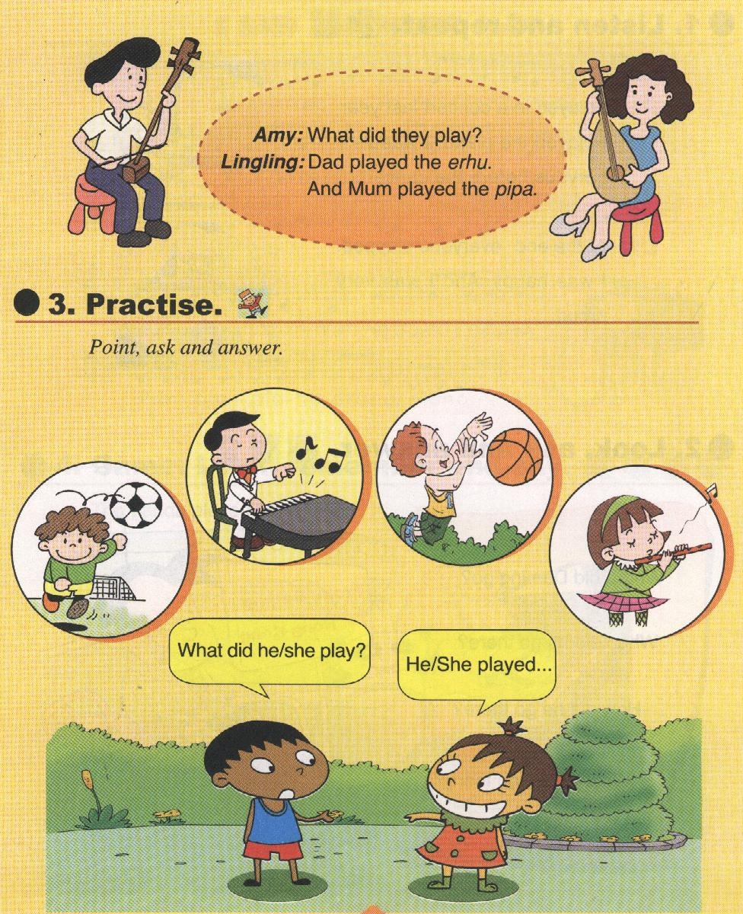
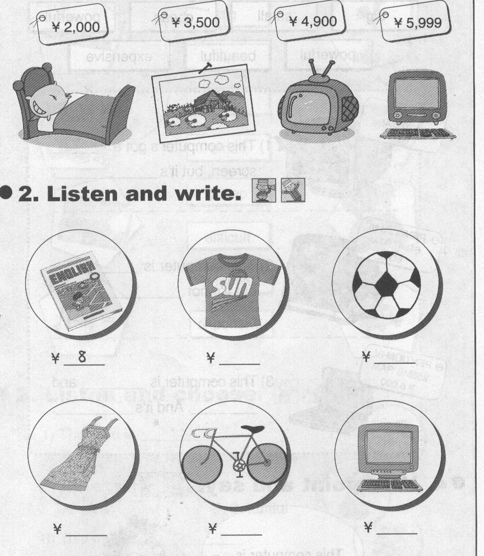
1 2
￥5999
￥4900

( ) ( ) ( ) ( )
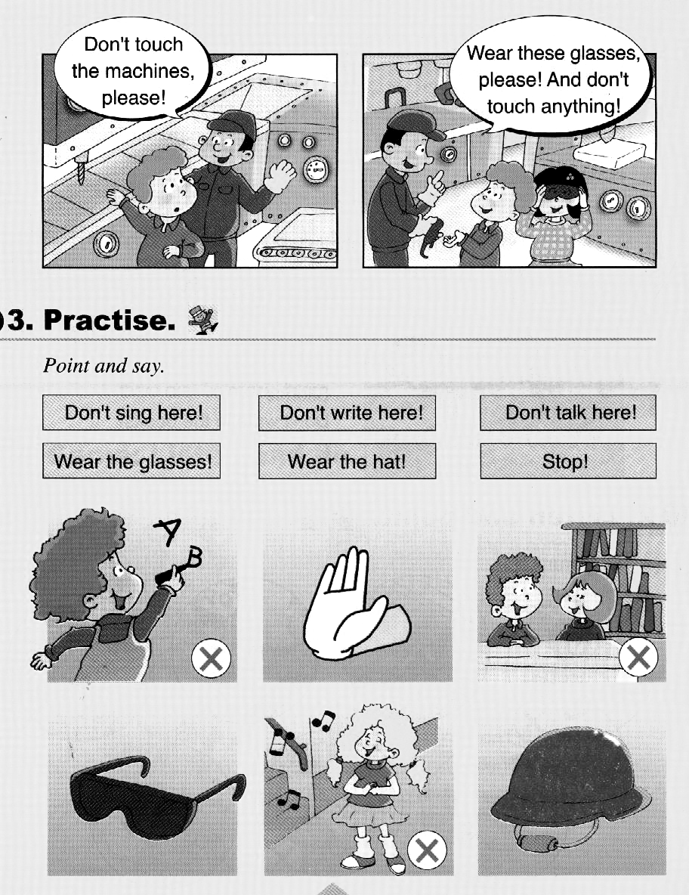
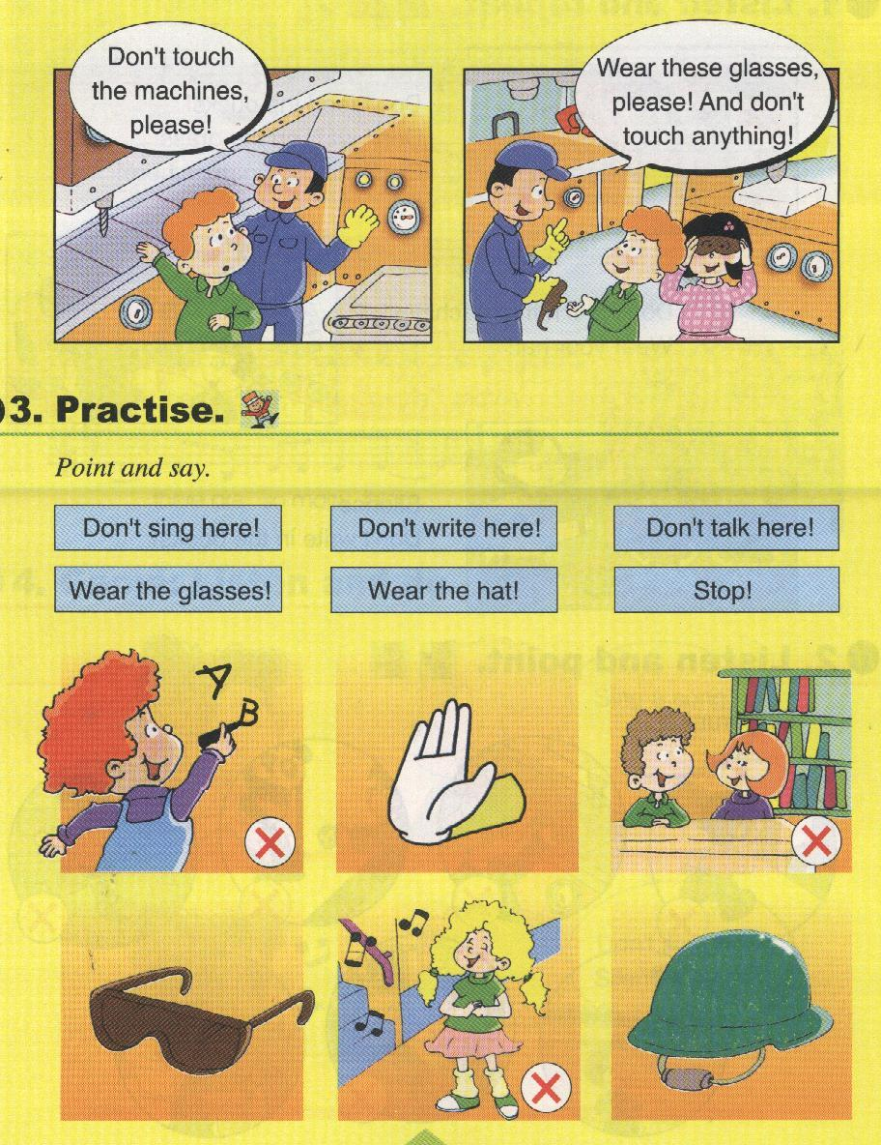
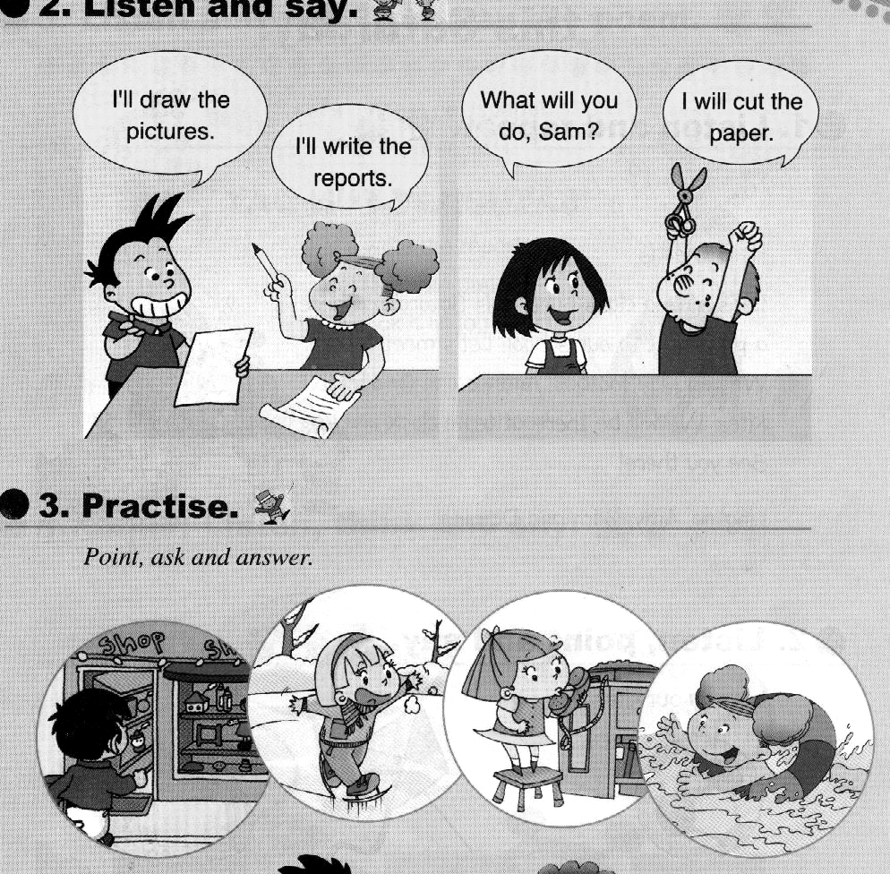
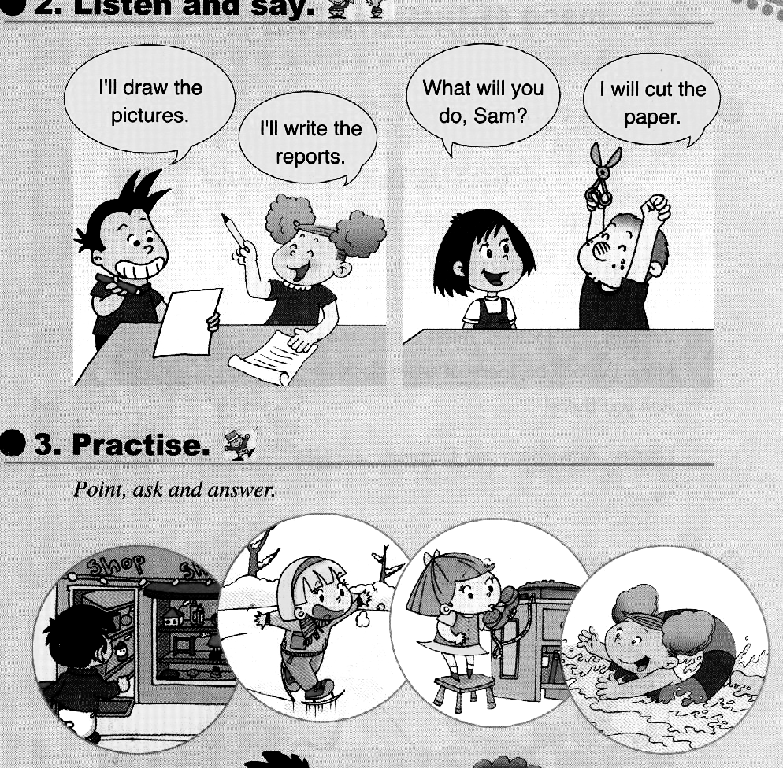
3 4

( ) ( ) ( ) ( )
Ⅲ.听音，根据问句选答句，将其序号填在括号里。
（本题共5小题，每小题2分，共10分）
( )1. A. I will cut the paper. B. I played the erhu.
( )2. A. You’re singing. B. We’re having a party.
( )3. A. It’s in the east. B. It’s in the west.
( )4. A. Yes, he did. B. No, he wasn’t.
( )5. A. Because they’re cute. B. Because I love Australian animals.
笔答部分 （70分）
Ⅰ.默写26个英文字母，并圈出五个元音字母。（18分）

Ⅱ.选择填空，将序号填在括号里。（共10小题，每题1分，共10分）
( ) 1. He’s _____ flowers..
A. paint B. paints C. painting
( ) 2. What_______ you do tomorrow?
A. do B. are C. will
( ) 3. Dad ________the erhu in a concert.
A. play B. played C. playing
( ) 4. This pen _______ one thousand eight hundred yuan.
A. cost B. costs C. costing
( ) 5. This planet is near ______ the sun.
A. from B. to C. away
( ) 6. Canada is ________ the north of America.
A. to B. in C. at
( ) 7. Pipa looks______ a guitar.
A. after B. at C. like
( ) 8. It’s ________ today.
A. mothers’ day B. Mother’s Day C. Mothers’Day
( ) 9.The capital of America is ________.
A. New York B. Washington,D.C. C. Los Angeles
( ) 10.________ live in Australia.
A. Pandas B. Koala C. Kangaroos

Ⅲ.根据句意，选择正确的词语填空。
（本题共5小题，每小题1分，共5分）
end proud clapped concert nervous

Last year, I played the piano in a ________. I was very ________ before the concert. At the__________ everyone _________. I was happy and I was very _________.
Ⅳ.根据所给的汉语意思，写出正确的单词。
（本题共5小题，每小题2分，共10分）
1.Why do you like______________？(澳大利亚)
2. This computer is ____________(便宜).
3. The little boy_______________(照看)sheep.
4. Don’t touch the_____________(机器)
5. Mexico is to the _____________(南方)of America.
Ⅴ.根据所给的问句选出相应的答句，将序号写在前面的括号里。
（本题共5小题，每小题2分，共10分）
( ) 1. Where’s New York? A. She played the pipa.
( ) 2. Where will he go? B. It’s in the east of America.
( ) 3. What did she play? C. I’m having a party.
( ) 4. What are you doing? D. He’ll go to England.
( ) 5. Why do you love cats? E. Because they are very cute..
Ⅵ. 连词成句。（本题共6小题，每小题2分，共12分）
1．go / going/ i/ to/ am/ London/ to
____________________________________.
2. Australian/ I / animals/ love/ because
___________________________________________.
3. the/ feed/ ducks/ Don’t
______________________________________!
4. a/ I/ you/ postcard/ will/ send
____________________________________________.
5. have/ this/ let’s/ a/ party/ Saturday/class
_____________________________________________!
6．draw/will/ the/i/ pictures
______________________________________________.

Ⅶ.阅读理解。判断正误，对的打√错的打x。
（本题共5小题，每小题1分，共5分）
It’s Mother’s Day today. The children are very happy. Amy is playing the piano. Tom is singing a song. Sam is playing the drums. Daming is drawing a picture for his mother. And what’s Lingling doing? Oh, she’s playing the violin.
( ) 1. Today is Teacher’s Day.
( ) 2. Lingling is playing the piano.
( ) 3. Daming is drawing a picture for his father.
( ) 4. All the children are happy today.
( ) 5. Sam is singing a song.

小学英语四年级（下）期末测试卷
听力原文
Ⅰ. 听音，排序。将单词的序号写在横线上。
（本题共10小题，每小题1分，共10分）
1. south 2. silence 3 thousand 4. shout 5. sun
1. wolf 2. laugh 3. lie 4. leaves 5. language
Ⅱ. 听音，在正确的图片下打√。
（本题共4小题，每小题2.5分，共10分）
1. This TV costs four thousand nine hundred yuan.
2. He’s playing the piano.
3. Don’t write here!
4. I will cut the paper.
Ⅲ.听音，根据问句选答句，将其序号填在括号里。
（本题共5小题，每小题2分，共10分）
1. What will you do?
2. What are you doing?
3. Where is Los Angeles?
4. Did your brother play football?
5．Why do you like Australia?

