2013—2014学年度第二学期学业质量检测试卷
六 年 级 英 语
（ 本试卷共6页，满分100分。答卷时间：60分钟 ）
题号 | 听力部分 |  |  |  | 笔试部分 |  |  |  |  |  | 总分 | 书写
题号 | Ⅰ | Ⅱ | Ⅲ | Ⅳ | Ⅴ | Ⅵ | Ⅶ | Ⅷ | Ⅸ | Ⅹ
得分

听力部分（共四大题，30分）
Ⅰ.听音，找出句子中含有的单词，将序号写在前面的括号内。（每题1分，共8分）
C. soon
C.study
C. angry
C.proud
C. stairs
C. model
C.escaped
C. brought
B. sents
B. funny
B. hungry
B. around
B. someday
B. middle
B. excited
B. baseball
( ) 1. A. cents
( ) 2. A. sunny
( ) 3. A. heavy
( ) 4. A. arrive
( ) 5. A. sad
( ) 6. A. matter
( ) 7. A.interested
( ) 8. A. basketball

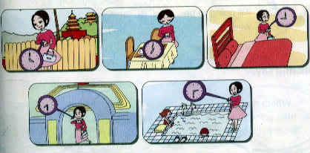
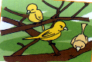
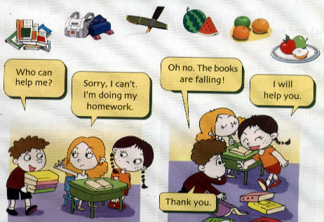
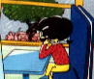
Ⅱ.听音，标号。用数字标出图片的先后顺序。（每题1分，共8分）

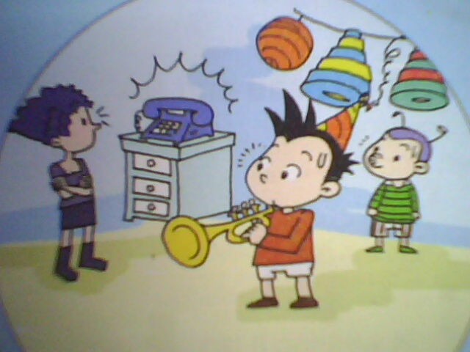
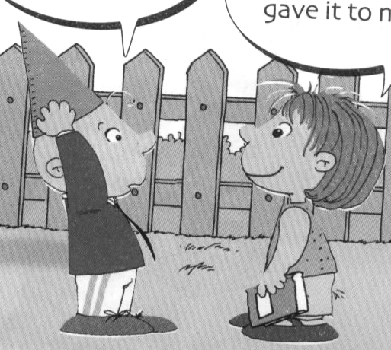
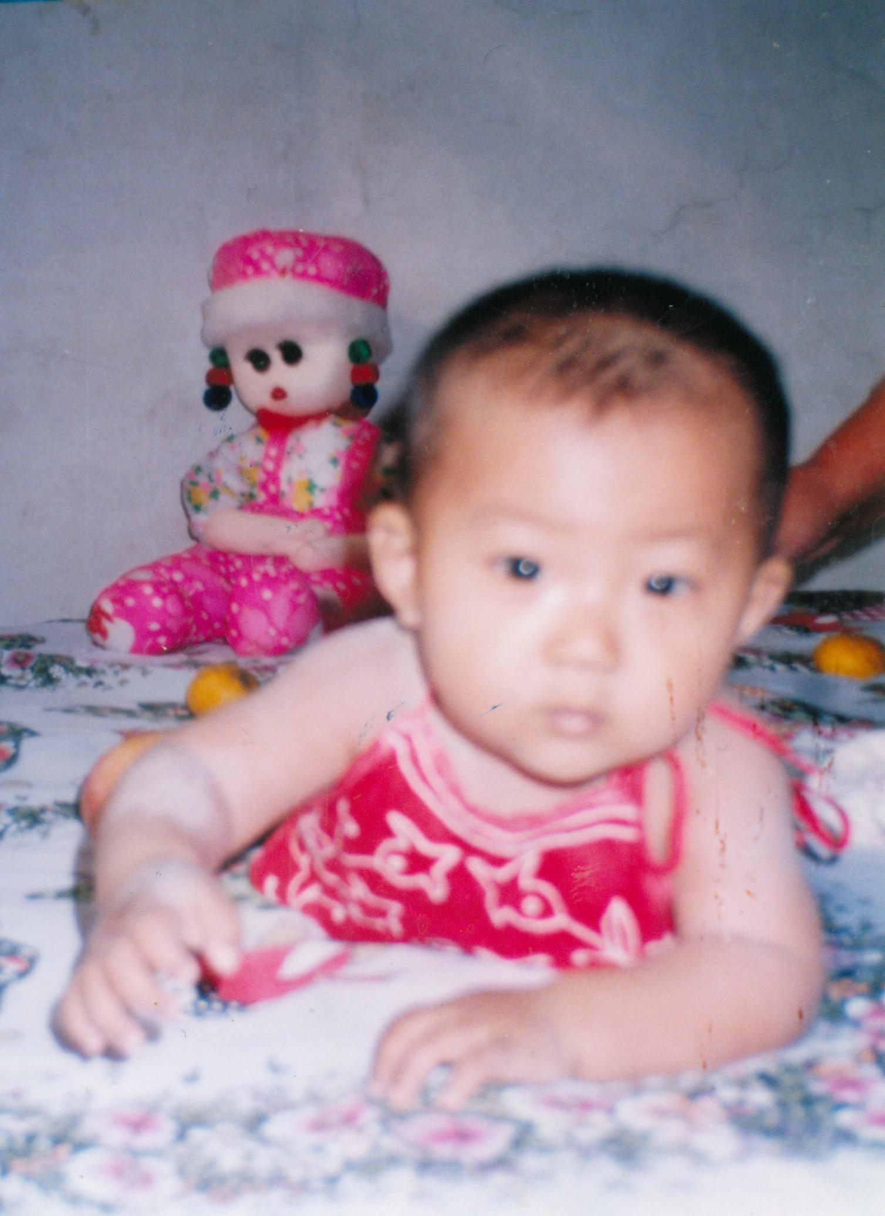

( ) ( ) ( ) ( )

( ) ( ) ( ) ( )
Ⅲ.听问句，选答句。将正确答案序号填在括号内。 （每题1分，共8分）
A. I took some photos.
B. I take some photos.
C. I’m taking some photos.

A. I want a football.
B.I want a hamburger.
C. I want a cola.

( ) 1. ( ) 2.

A. At half past six.
B. In the park.
C. I’m really excited.
A. Because I am happy. B. Because I am angry. C. Because I am ill.

( ) 3. ( ) 4.

( ) 5. ( ) 6.
A. He’s ten.
B. I’m ten.
C. It’s ten cents ,in all.

A. It’s going to snow in Daqing tomorrow.
B. It’s Monday.
C. It’s March 27th.

A. Eight hours.
B. One dollar.
C. Eight weeks.
( ) 7. ( ) 8.
A. You’re going to No.76 Middle School.
B. We’re going to No.76 Middle School.
C. We’re going to go this September.

Ⅳ.听短文，判断正误。正确打“√”, 错误打“×”。（每题1分，共6分）
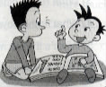
1. Simon and Daming read a book about Chinese food.
2. Their dad bought the book for him.
3. They made a model of Chinese spaceship.
4. The spaceship took a bird,a dog, a rabbit into space first.
5. The spaceship took Yang Liwei into space in 2003.
6. Yang Leiwei was the first man in space all over the world.

笔试部分（共六大题，70分）
Ⅴ.单项选择。将正确的序号填写在前面的括号里。（每题1分，共15分）
( ) 1.In Guangzhou,it’s going to __ _ tomorrow.
A.be rain B. rain C.raining
( ) 2. We were wet, hungry and angry ________ the ducks
A. at B. with C. to
( ) 3. He is eating dinner, _____ then the telephone rings.
A. and B. but C. or
( ) 4. My friend _____ a birthday present for me last Sunday.
A. buy B. buys C. bought
（ ）5. Lingling some cups for the baseball game.
A. bring B. brought C.brings
（ ）6.A:Who can help me? B: .
A.Sorry I can’t. B.Yes, I will. C.No,I won’t.
（ ）7. The hot dog good.
A.look B.looked C.looks
（ ）8.Why are you laughing? it is very funny.
A. And B.But C.Because
（ ）9. They are going to our sandwiches.
A.eating B.eat C.ate
（ ）10.ShenzhouV flew into space. Everyone was very .
A.angry B.excited C.sad
（ ）11. It is raining. I haven’t got umbrella, so I am .
A.wet B.naughty C.clever
（ ）12.He is playing the trumpet but then the telephone .
A. ring B.rings C.rang
( ) 13. There _______a big lake and there ________lots of ducks.
A.were…was B. are….are C. was…were
（ ）14.—Here’s your food.
A.Thank you. B.Enjoy your meal. C.It’s a nice day.
（ ）15.Helen said,“Blind people are people.”
A. deaf B.clever C. normal
Ⅵ.根据提示，用词汇的适当形式完成下列句子。（每题1分，共10分）
1、I’ve got lots of （录像带）about Chinese music.
2、They made a Chinese .（宇宙飞船）
3. There were lots of __________（鸭子） under the tree.
4. Look! The oranges are falling down the __________（楼梯）.
5. In this photo, the sun is .（照耀）
6. Helen Keller was __________（聋的）.So she couldn’t hear.
7. I went to the _______（超市）with my mother.
8 .Look! All the balloons (飞) away.
9. We are going to take a birthday （聚会）.
10. YangLiwei （渡过）about 21hours in space.

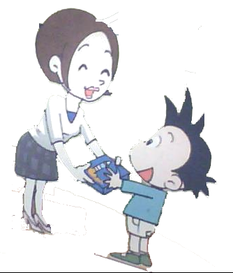
Ⅶ.句子理解。（共2大题，计15分）
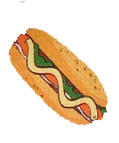
A.根据图文提示，写出句子。（每题2分，共10分）
1．A: ___________________? 2. A: ________________.
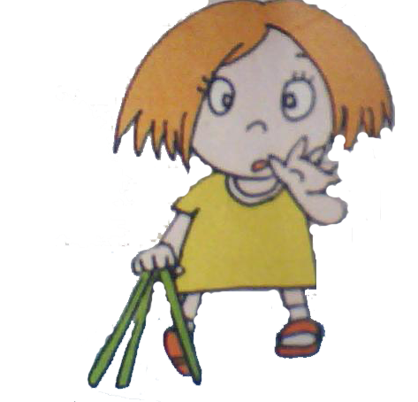
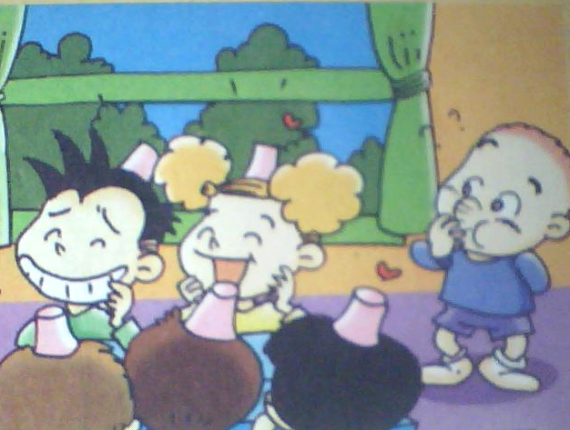
B:I want a hot dog, please. B: Thank you.
3. _________________. 4. ________________?
So she couldn’t see. Why are you laughing？
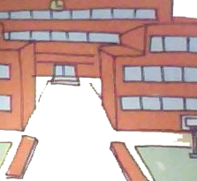
5．A: ________________________________?
B: Yes, I’m really excited.

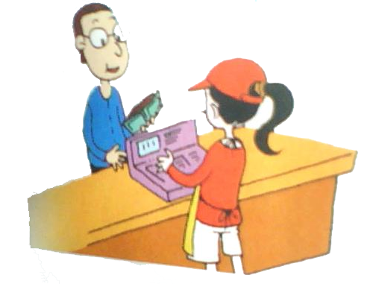
B.情景交际。从所给的选项中选择恰当的句子补全对话, 将答案序号写在横线上。（每题2分，共10分）

A. It’s ten dollars and twenty cents.
B. Yes, I want a hamburger, please.
C. How much is it?
D. Enjoy your meal.

Waitress: Hello! Can I help you ?
Daming: 1.______________
Waitress: And to drink?
Daming: A cola, please.
Waitress: So,a hamburger and a cola.
Daming: 3._______________
Waitress:4. .
Daming: Here’s the money.
Waitress: Thank you.5.______________

Ⅷ.完形填空。（每题2分，共10分）
Oh dear! I can’t 1 them all. Look 2 the eggs.And the apples are
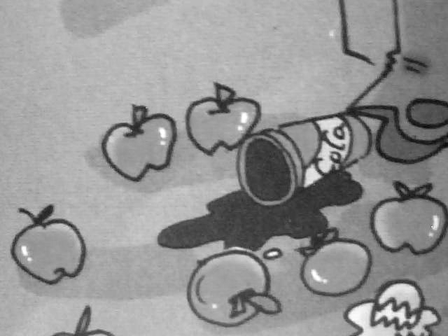
3 down the stairs. Now, the cola is falling ,too.
4 a mess! Who can help 5 ?
1.A．carry B.carried C.carrying
2. A. on B.in C.at
3. A.fell Bfalling C.falls
4. A.How B.What C.When
5. A.my B.I C.me

Ⅸ.阅读理解。（每题1分，共10分）
A. 阅读短文，判断正误。正确写“T”，错误写“F”。
I’m a Chinese boy. My name is Tongtong. I’m going to go to middle school this September. It’s No.4 Middle School. This school is near Longfeng Street. It’s a big school. There are about two thousand students at the school. I’ll go to my new school by bus. I’ll study Chinese , Maths , English, Geograph, History and Science at the school. Some of my friends will go to this school too. They’re Lili, Xiao Hua and Lanlan. We like our new school very much. We’ll study hard there.
( )1. The boy’s name is Dongdong.
( )2. He’s going to go to No.5 Middle School this September.
( )3. There are about two hundred middle school students at the school.
( )4. Some of Tongtong’s friends will go to No.4 Middle School too.
( )5. They won’t study hard at middle school.
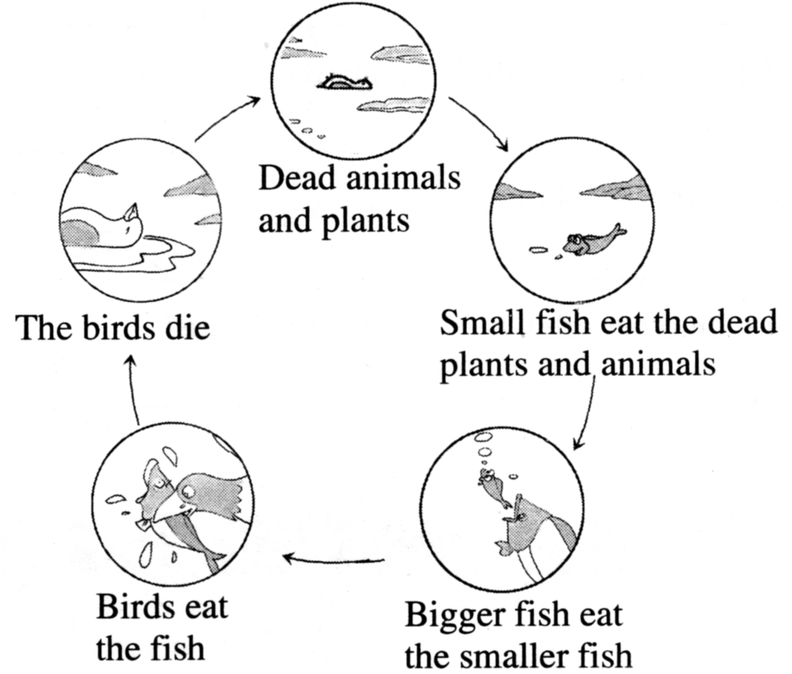
B. 阅读下列短文，根据图示选出正确答案。
Look at this food chain for the ocean（海洋）.
What do you think of it？Keep the balance of
nature（保持生态平衡）. One animal（动物）
eats another（另一种）animal or plant（植物）.
It is a balance. Don’t worry about（担心）it.

（ ）1. What is the food chain？
A. 生物圈 B. 食物链 C. 食谱
（ ）2.What do small fish eat？
A.Dead(死的)animals. B. Dead plants. C. A and B.
（ ）3.If（如果）we catch（抓）many smaller fish，bigger fish will（将） .
A. eat dead plants. B. eat bigger fish C. die
（ ）4.It is a that birds eat the fish and other animals eat the birds.
A. nature B. balance C. food
（ ）5.Do you know what will kill（杀死）the birds？ .
A. Plants. B. Dogs. C. Men

Ⅹ.书面表达。（本题共5分）
阅读表格中的信息，试着写出你对法国盲人少年Louis Braille（路易斯·布莱叶）的了解。书写规范，语句通顺，内容完整，不少于5句话。
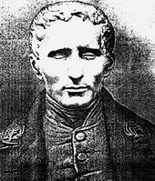
Name | Louis Braille | Became blind | 1812
Born | 1809 | At school for blind children | Learn to read and write
Country | France,  a small country village | Made the first letters in braille | 1824
________________________________________________________________ _ _
_________________________________________________________________ _
__________________________________________________________________
__________________________________________________________________
__________________________________________________________________
This is Louis Braille. He was born…

听力材料：
Ⅰ.听音，找出句子中含有的单词，将序号写在前面的括号内。
No.1 It’s going to rain soon.
No.2 We’re going to study hard at middle school.
No.3 This bag is very heavy, I can’t carry it.
No.4 They are walking around the lake.
No.5 The oranges are falling down the stairs.
No.6 Tne name of the model spaceship is ShenZhou.
No.7 The snake escaped from the zoo.
No.8 We’re going to have a baseball team.

Ⅱ.听音,标号。用数字标出图片的先后顺序。
No.1When I was a baby. I couldn’t walk.
No.2 In this photo,we’re having a picnic.
No.3 The girl is on the train. She is looking out of the window.
No.4 It is a sunny day. The birds are singing in the trees.
No.5 He is playing the trumpet ,but then the telephone rings.
No.6--Who gave this hat to you,SongTao?—Lanlan gave it to me.
No.7 Mum is going to go to the park at 9 o’clock.
No.8 The books are falling .I will help you.

Ⅲ.听问句，选答句。将正确答案序号填在括号内。
No.1 What did you do at the park last weekend?
No.2 What do you want to drink?
No.3 When are you going to have breakfast?
No.4 Why didn’t you drink the soup? It’s delicious
No.5 What’s the weather going to be like in Daqing tomorrow?
No.6How much is two hamburgers and one cola?
No.7 Which middle school are you going to go ?
No.8 How many hours did we spend at school?

Ⅳ. 听短文，判断正误。正确打“√”, 错误打“×”。
Simon and Daming read a book about space travel yesterday. Their dad bought the book for them. They are very interested in the book. The pictures in the book are good. In the book there are spaceships from Russia,China and America. Simon and Daming made a model of a Chinese spaceship. The name of it is Huaxia. First,it took a monkey ,a dog and a rabbit into space. Then ,in 2003 ,it flew into space with Yang Liwei. He was China’s first man in space.

