獐子岛镇中心小学三年级英语检测卷（2014.6）时间：40
学 校
班 级
姓 名
听力部分（40分）出卷人：宁时林
题号 | 1 | 2 | 3 | 4 | 5 | 6 | 7 | 8 | 9 | 总分
得分
一、听音选单词，将单词的序号写在前面的括号里。（每题1分）
( ) 1、 A. fifteen B. fifty ( ) 2、A. peach B. pear
( ) 3、 A. fast B. first ( ) 4、A. fun B. funny
( ) 5、 A. twenty B. twelve ( ) 6、A. round B. loud
( ) 7 、A. drum B. driver ( ) 8、A. writer B. wide
( ) 9 、A. say B. shy ( ) 10、A. them B. then



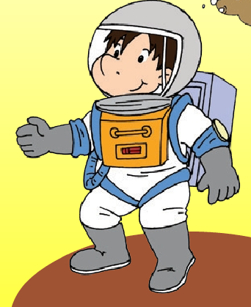
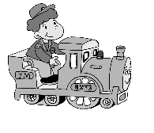
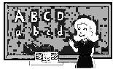
二、听音，用数字（1，2，3，4，5）为下列图片重新排序。（10分）
( ) ( ) ( ) ( ) ( )

三、选出你所听到的句子。（每题2分）
（）1.A.We’ll see lions and tigers.
B. We won’t see lions and tigers.
（）2.A.Maybe I’ll be an astronaut.
B. Maybe he’ll be a doctor.
（）3.A.Will we pick oranges?
B. Will they pick peaches?

（）4.A.She’s quite good at English.
B. She’s very good at English.
（）5.A.There are fifteen peaches on the tree.
B. There are thirteen peaches on the tree.

四、听句子，找出掉队的词，只写序号 。（每题2分）
( ) 1. What's ten plus eleven ?__________.
A. It's twenty B. It's twenty - two C. It's twenty- one
( ) 2.They are _____.
A. pears trees B. pear trees C. tree pear
( ) 3. She ______ tigers and lions .
A. doesn't like B. don't like C. like
( ) 4.______ he work hard ?
A. Are B. Is C. Does
( ) 5.Are you clever ?________.
A. Yes , I am. B. No, I am . C. Yes, I'm not .

笔答部分 (60分)
一、根据语境和中文提示将正确的单词写在横线上。（每空1分）
1. He is a bit ______________(安静的).
2. What’s ____________(十三) plus fourteen?
3. Daming works ____________(努力地).
4. I’m _________ (来自)China.
5. You will eat more ________ (梨)and ________(苹果).
6. There are ___________ (十六)___________(老虎)in the zoo.
7. ________(也许) we’ll go to the zoo.
8. I can run fast, _______(但是)I can’t jump far.
二、选择。（每空1分）
( ) 1. Amy is _____ shy .
A. a bit B. bit C. little
( ) 2. Will you go too? No, I _____.
A. willn't B. won't C. am not .
( ) 3.She's quite good ______English .
A. for B. in C. at
( ) 4. Wlill you play with ____ this weekend ?
A. me B. he C. she
( ) 5. Peaches _____ my favourite fruit .
A. is B. are C. at
( ) 6. I will see lots of _______in the countryside.
A. duck B. pigs C. tiger
( ) 7. This girl is helpful. She’s going to _______ you.
A. help B. helps C. helping
( ) 8.He ______in the countryside.
A. live B. lives C. lived
( ) 9. Look at the peaches ____ these trees !
A. in B. at C. on
( ) 10. He ‘ll be _____ astronaut .
A. a B. an C. the
三、情景交际。把序号填入前面括号内。10
（ ）1.Will they go to the bus station? A.I’ll be a worker.
( ) 2.How many peaches are there? B.No,we won’t.
( ) 3.I love apples very much. C.Yes,they will .
( ) 4.Will we pick pears? D.Me too.
( ) 5.What will you be in the future? E.There are fourteen.
四、连词成句。15
1.maybe film a I star be will.

2.you be will what the in future?

3.am going I to her help

4.ten fourteen plus what is ?

5.the River Thames very is long.

五．阅读短文，回答问题15
There is a nice girl in our class .She is thirteen years old .She's not tall and not short .She is a bit fat . She has two big blue eyes and a small nose . She likes yellow. But today she's wearing a red sweater . She has a litte black dog in her home .She and the dog are good friends.

( ) 1. The girl is_____.
A. 12 years old B. 13 years old C. 3 years old

( ) 2. The girl is _______.
A. tall B. short C. fat

( ) 3. The colour of her eyes is _______.
A. blue B. black C. green
( ) 4.Her good friend at home is ______.
A. a boy B. a dog C. a cat
( ) 5.What colour does she like? ______________.
A. Yellow B.red C.blue

三年级英语听力题签:
一、听音选单词，将单词的序号写在前面的括号里。（每题1分）
1. fifteen 2. peach 3. first 4. funny 5. twenty
6. loud 7. drum 8. wide 9. shy 10. them
二、听音，用数字（1，2，3，4，5）为下列图片重新排序。（10分）
1. He’ll be an astronaut. 2. He’ll be a train driver.
3. He’ll be a policeman. 4. He’ll be a doctor.
5. She’ll be a teacher.
三．听音选出你所听到的句子。
1.We won’t see lions and tigers.
2.Maybe I’ll be an astronaut.
3.Will they pick peaches?
4.She’s quite good at English.
5.There are thirteen peaches on the tree.
四、听句子，找出掉队的词，只写序号 16
1. What's ten plus eleven ?__ It's twenty- one
2.They are ___ pear trees __.
3. She doesn't like tigers and lions
4. Is he work hard ?
5.Are you clever ? Yes , I am.

