长海县2013~2014学年第一学期期末质量检测
小学四年级 英语 检测时间：80分钟
题  号 | 听力部分 |  |  |  |  | 笔试部分 |  |  |  |  | 总分
题  号 | Ⅰ | Ⅱ | Ⅲ | Ⅳ | Ⅴ | Ⅵ | Ⅶ | Ⅷ | Ⅸ | Ⅹ | 总分
得
分
听力部分（共五大题，40分）
Ⅰ.听音选词。在听到的单词序号上画圈。（每题1分，共8分）
2. | A. last | B. fast
4. | A. soon | B. said
6. | A. print | B. printing
8. | A. food | B. good
1. | A. American | B. America
3. | A. win | B. winner
5. | A. washed | B. watched
7. | A. gold | B. cold

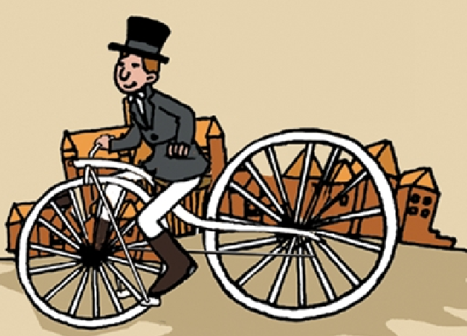

Ⅱ.听音标号。用数字在括号内标出图片的先后顺序。（每题1.5分，共12分）
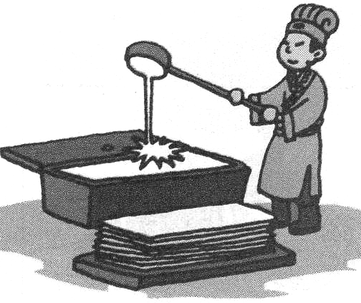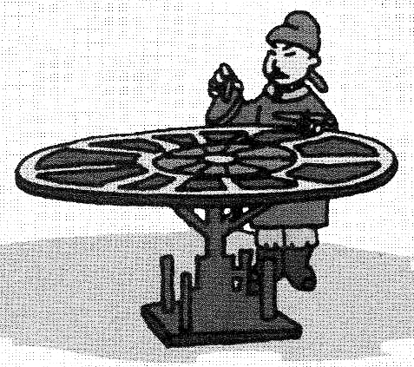
( ) ( ) ( ) ( )


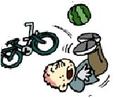

( ) ( ) ( ) ( )
Ⅲ.听音判断。在正确选项前的方框内打“√”。（每题1分，共8分）
1. 2.
A. I usually get up at 6 o’clock.
B. I didn’t get up at 6 o’clock.

A. Did you wash your toy?
B. Did you go to the Great Wall?

3. 4.
A. What can she play?
B. What did he play?

A. Yesterday was a special day.
B. Yesterday was National Day.

5. 6.
A. He’s got a fever.
B. She’s got a toothache.

A. Where did you go?
B. Where did you live?

7.
A. It was my birthday on Monday.
B. It was really fun.

A. The good boy helped his mum.
B. The bad man didn’t help people.

Ⅳ.听问句，选答句。将正确答案序号填在括号内。（每题1分，共6分）
A. Yes, she is.
B. Yes, he did.
A. No, I didn’t.
B. No, I don’t.
( ) 1. ( ) 2.
A. I saw tigers.
B. I went to the zoo.

( ) 3. ( ) 4.
A. Last week.
B. Tomorrow.

( ) 5. ( ) 6.
A. Yes, he does.
B. Yes, she did.
A. I read a letter.
B. She’s reading a letter.

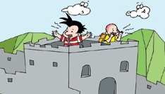
Ⅴ.听音填词，把短文补充完整。（每题1分，共6分）
Yesterday ①_ _ _ _a school trip. We② _ _ _ _ to the Great Wall. We climbed to the top. And we ③_ _ _ lots of mountains. We④ _ _ _ biscuits and apples. We ⑤_ _ _ _ _ _ dad a present. We⑥ _ _ _ a good time.
笔试部分（共五大题，60分）
Ⅵ.单项填空。将正确答案的序号填写在前面的括号里。（每题1分，共15分）
（ ）1. A: Happy birthday to you! B:______ A.OK! B. Thank you !
（ ）2. Thank you _______ your letter. A. for B. to
（ ）3. Yesterday I ______ my room. A. clean B. cleaned
（ ）4. Chinese people invented paper _____printing. A. and B. but
（ ）5. The children ran away. _____ I cried. A. so B. Then
（ ）6. It ______ warm yesterday. A. is B. was
（ ）7. Come _____ , please！ A. in B. of
（ ）8. Yesterday I _______ Grandma. A. phone B. phoned
（ ）9.There ______ an old man. A. were B. was
（ ）10. We were ______. So we bought a watermelon. A. thirsty B. dirty
（ ）11. I didn’t ________ football. A. play B.played
（ ）12. It didn’t make gold. It _____ a snake. A. make B. made
（ ）13. Wang Fei ______ a bad cold. He stayed at home.
A. has got B. have got
（ ）14. I ______ a new friend. A. has got B. have got
（ ）15.I am still nine. I will be ten ______ April. A. on B. in
Ⅶ.词语运用。根据提示，用词汇的适当形式完成下列句子。（每题1.5分，共15分）
1. Lucy lives in ___________.（伦敦）
2. We ________（穿）warm clothes yesterday.
3. I usually walk to school. She ________ (也)walks to school.
What happened to you?
I fell over/cut my finger.
4. The bad man was_________(生气的). He__________(带走)Ma Liang away.
5. Did you__________（弄坏）your toy?
6. Sam _________(放) the watermelon on his bike.
7. He __________ _________（从......上跌落）his bike yesterday.
8.This girl _________(赢得) a gold cup.

Ⅷ.句子理解。（共2大题，计15分）

A.看问句，找出相对应的答句，将序号填入题前括号内。（每题1分，共6分）
( )1. Did you see a scary thing? A. I finished my homework.
( )2. What did you do yesterday? B. Yes, I did.
( )3. What did she play? C. I hurt my knee.
( )4. Did Tom cry? D. Yes, he did.
( )5.What happened to you? E. She played the flute.

( )6.How many children were there? F. There were three.


B.看图，选择。在正确答案上画“——”。（每题1.5分，共9分）
1. 2. 2.
She painted a picture
/watched TV yesterday.

Chinese people invented /didn’t invent the computer.



3. 4.
The ice was very cold.
Lucy learnt to skate / swim.
She fell over/cut her finger and she cried.

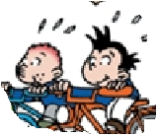
5. 6.
Yesterday Sam and I went for
a bus ride / a bike ride.

Ma Liang painted food for the old woman. The food was / wasn’t real.

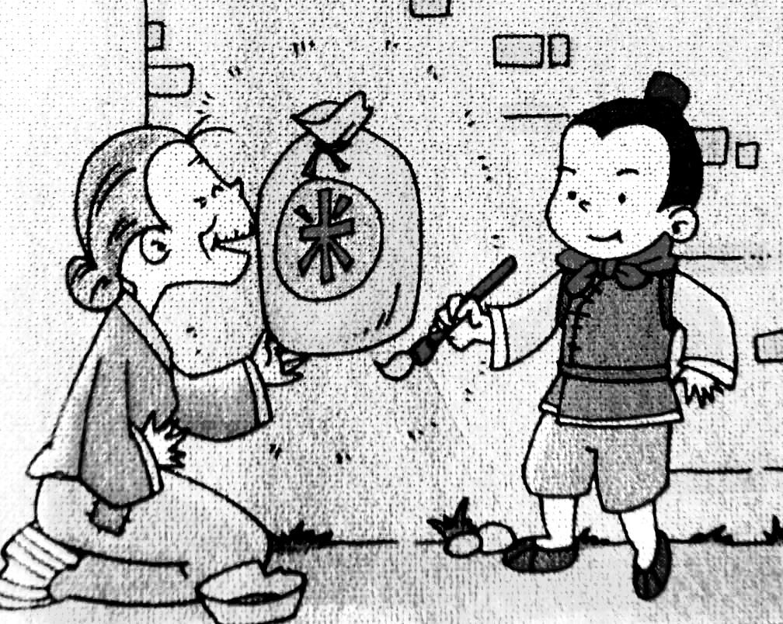

Ⅸ.情景交际。选择恰当答案的序号填写在横线上。(每题2分，共10分)
Doctor: What’s the matter?
Sam: I’ve got a stomach ache.①____________
Doctor: ②___________
Sam: I ate some bread, an ice cream, two eggs ③__________.
Doctor: Oh, you ate too much.④_____________
A. What did you eat this morning?
B. I feel (感觉)bad.
C. and five apples
D. Take this medicine, please.
E. You’re welcome.

Drink more water…and you’ll feel better soon.
Sam: All right. Thank you very much.
Doctor: ⑤__________

Ⅹ.图文阅读。根据信的内容和图片，选择最佳答案回答下列问题。将答案的序号写在题前括号内。（每题1分，共5分）
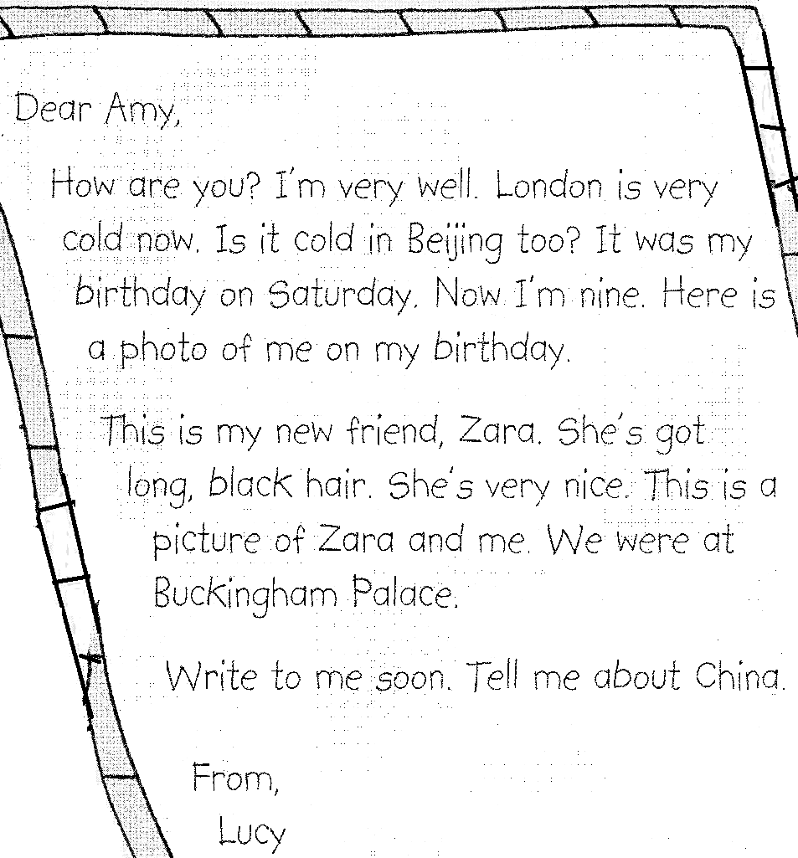
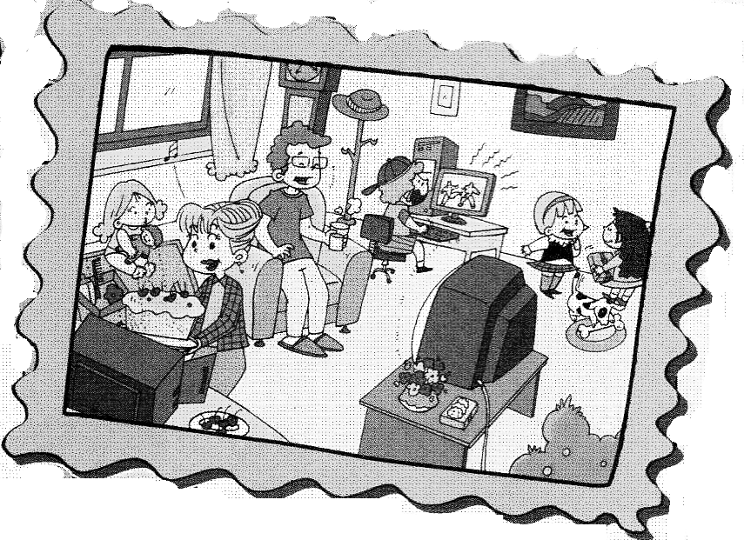

( ) 1. Is the letter from Amy? A. Yes, it is. B. No, it isn’t.
( ) 2.How is Lucy? A. Very well. B. Not good.
( ) 3.How old was Lucy last year? A. She was nine. B. She was eight.
( ) 4. Who is Lucy’s new friend？ A. Zara. B. Amy.
( ) 5. Where is Lucy now? A. She’s in Beijing. B. She’s in London.

四年级英语听力题签
注意：每道听力试题读二遍，听力时间控制在20分钟内。
I、听音选词。在听到的单词序号上画圈。
No.1 American No. 2 fast No.3 win No.4 soon
No.5 watched No.6 printing No. 7 gold No.8 food

II、听音标号。用数字在括号内标出图片的先后顺序。
1. Chinese people invented paper.
2. He had a paintbrush. It was magic.
3. Chinese people invented printing.
4. Englishman invented this bicycle in1839.
5. I saw a monster on the TV.
6. I fell off my bike.
7. He cut his finger.
8. I bumped my head.

III、听音判断。在正确选项前的方框内打“√”。
1. I usually get up at six o’clock.
2. Did you go to the Great Wall?
3. What did he play?
4. Yesterday was National Day.
5. He’s got a fever.
6. Where did you live?
7.It was my birthday on Monday.
8. The bad man didn’t help people.

IV、听问句，选答句。将正确答案序号填在括号内。
1. Did he play football?
2. Did you fall?
3. When did they come to China?
4. Where did you go yesterday?
5. Did she practise a lot?
6.What is she doing?

V、听音填词，把短文补充完整。
Yesterday was a school trip. We went to the Great Wall. We climbed to the top. And we saw lots of mountains. We ate biscuits and apples. We bought dad a present. We had a good time.

听力部分到此结束！

四年级英语参考答案及评分标准

Ⅰ.每题1分，共8分。
1. A 2. B 3. A 4. A 5.B 6.B 7. A 8.A
Ⅱ.每题1.5分，共12分。
1324 6857
Ⅲ.每题1分，共8分。
1. A 2. B 3. B 4. B 5. A 6. B 7. A 8 .B
Ⅳ.每题1分，共6分。
1. B 2. A 3.A 4. B 5. B 6. B
Ⅴ. 每题1分，共6分。
was went saw ate bought had（每词必须完全准确方能得1分)

Ⅵ.每题1分，共15分。
1. B 2. A 3.B 4. A 5. B 6. B 7. A 8.B 9. B 10. A
11. A 12. B 13. A 14. B 15.B
Ⅶ.每题1.5分，共15分。
1. London 2. wore 3.also 4. angry 5. took
6. break 7. put 8. fell off 9. won
(共10个词，画线黑体应注意：首字母大写“L” 是0.5分； 动词过去式如果没有变化，仍是动词原形，只能得0.5分；其它5词必须完全准确方能得1.5分。 )
Ⅷ.共2大题，计15分。
A、 每题1分，共6分。
1. B 2. A 3.E 4.D 5.C 6.F
B、每题1.5分，共9分。
1. painted a picture 2. didn’t invent 3. skate
4. fell over 5. a bike ride 6. was
Ⅸ.每题2分，共 10分。
B A C D E
Ⅹ.每题1分，共5分。
1. B 2. A 3. B 4. A 5. B

备注：卷面满分为100分。（听力40分，笔试60分。）
优秀：90---100
良好：80---89
及格：60---79
不及格：0---59

2014年1月8日

