新标准英语一起九册
Module4 Unit1 We’re going to sing and dance.教学设计
大长山小学 傅海华
一、教学目标与要求
1. 语言知识目标
掌握核心词 invitation， 短语tidy up,
掌握目标句: What are we going to do?
We’re going to have lunch together. We’re going to sing and dance.
Are you going to have a birthday cake? Yes, I am. / No, I’m not.
2. 语言技能目标
学会运用be going to谈论将来的计划、打算。
3. 情感态度目标
培养能够学生关心他人，积极表达自己的祝福。
4. 学习策略
学会倾听，积极思考，积极与他人合作，共同完成学习任务。
5．文化意识
学会制定自己的生日计划，了解英国请柬的写法。
二、教学重点及难点
1. 掌握要求听、说、读、写的单词、短语和句子，并加以运用。
2. 正确的使用将来时be going to 描述将要做的事情，注意be 动词的用法。
三、课前准备
点读笔，CD- ROM，课件，课堂检测题
四、学情分析
学生在三年级学习了一般将来时be going to和will的用法，而且本课的话题又是学生感兴趣的，在此基础上学习语篇，相对容易掌握。课上会重点关注组内互助合作和组间竞争情况。
StepⅠ. Warmer
1. Greeting: Teacher and students greet each other.
T: Class begins! S: Stand up. T: Sit down, please!
2. Play a meomory game.
T: Let’s play a meomory game.
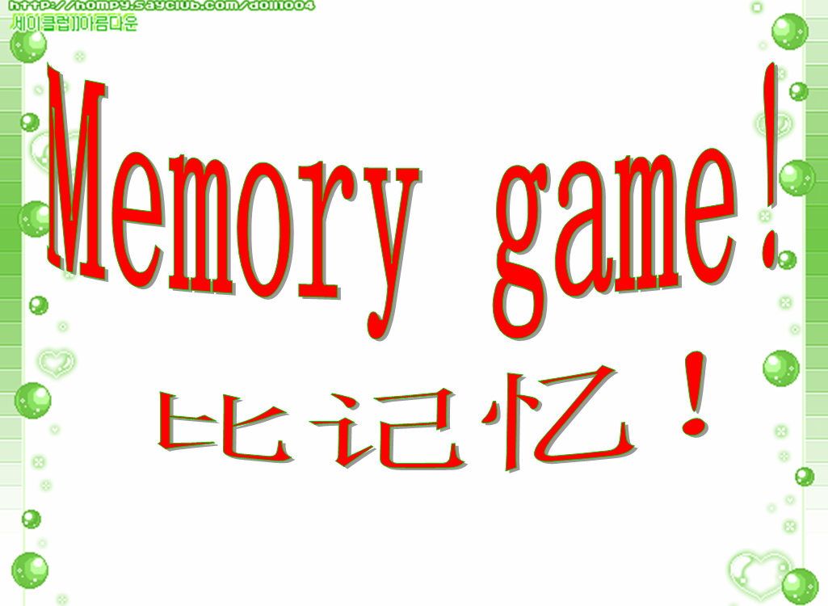
S: go swimming, watch TV, play basketball, play the flute, have a picnic…
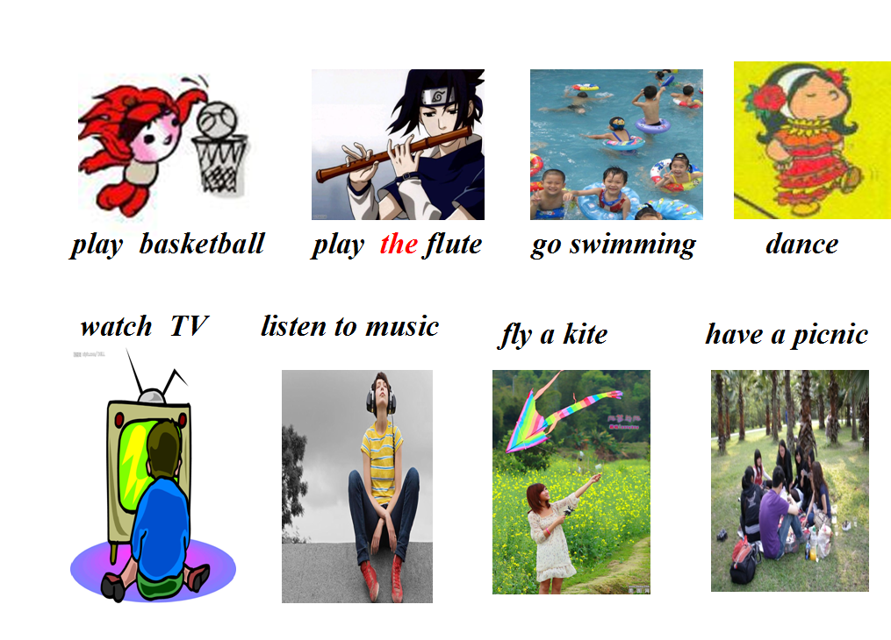
(猜动词短语)
StepⅡ. Presentation
1. Free talk
T: I’m going to have a party on Sunday.
Are you going to have a party? (板书)
S: Yes, I am.
No, I’m not. I’m going to watch TV/ do my homework…
T: Children, are you going to go to school on Sunday?
Ss: No, we aren’t.
T: Are you going to do your homework children?
Ss: Yes, we are. (补充板书，启发学生发现Are you…?的两种人称回答)
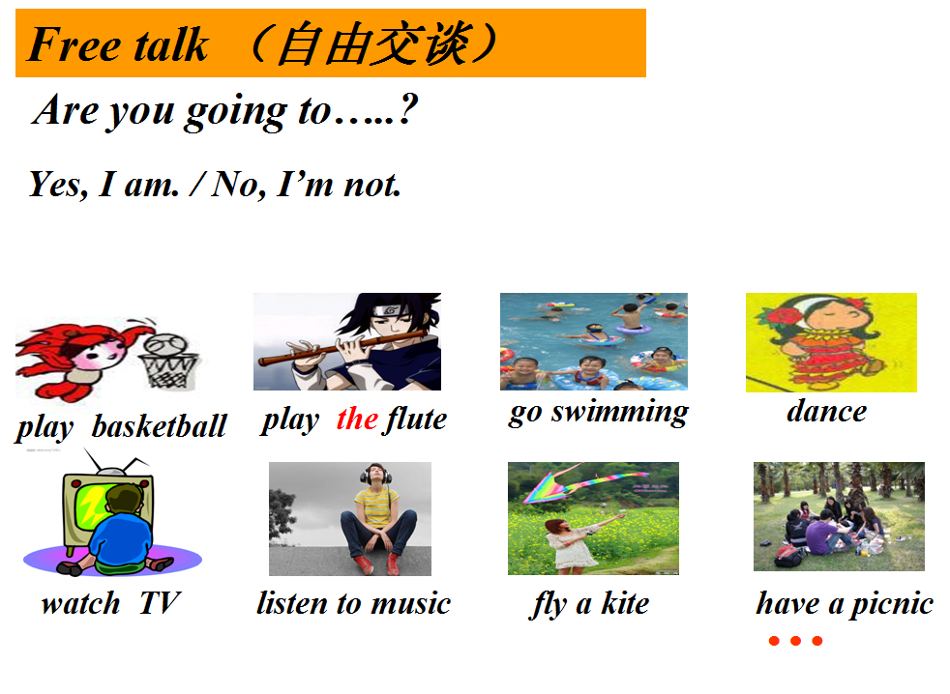

2. Introduce the text
T: Look! What’s this?
S: It’s an invitation.
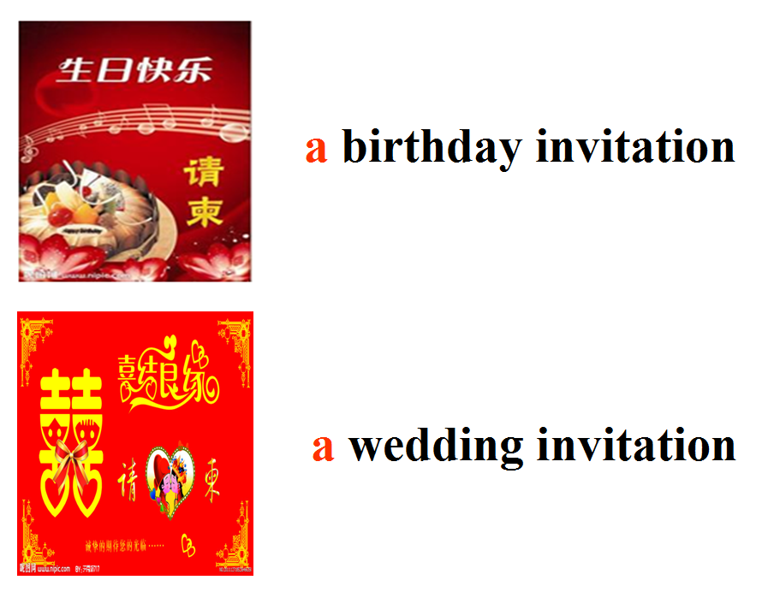
（分音节教授单词，a birthday invitation，a wedding invitation）
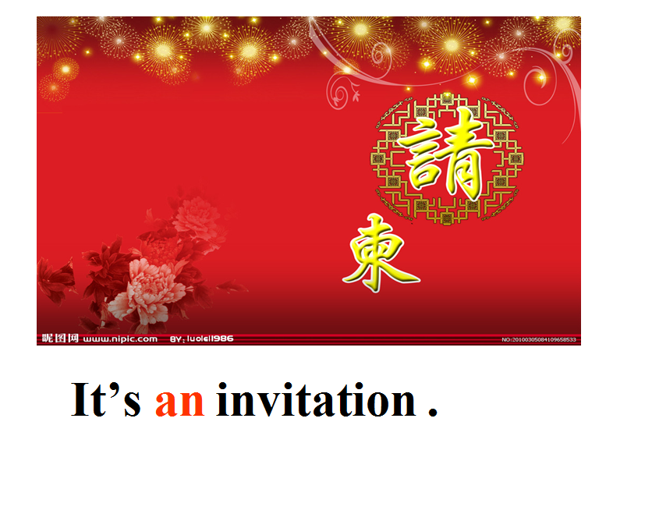

T: On Sunday, I’m going to have a birthday party. This is an invitation to my birthday party.（顺势在黑板右侧画一封请柬）

1
2
3
4
5

T: Are you going to come to my birthday party?
Ss: Yes!
T: Very good! Let’s have match between 5 groups. And if you can do a good job, I’m going to give you a letter.
（向学生说明评价机制，小组展开竞赛，表现好的，就会奖励一个单词，单词来源于M4U2请柬的内容，既激发了学生的竞争意识，也渗透了巩固课的请柬内容）
Step Ⅲ. Practice
1. Watch and answer
Q1: Who is going to have a birthday party?
Q2: How old is she going to be?
S: Amy is going to have a birthday party.
She is going to be 11.
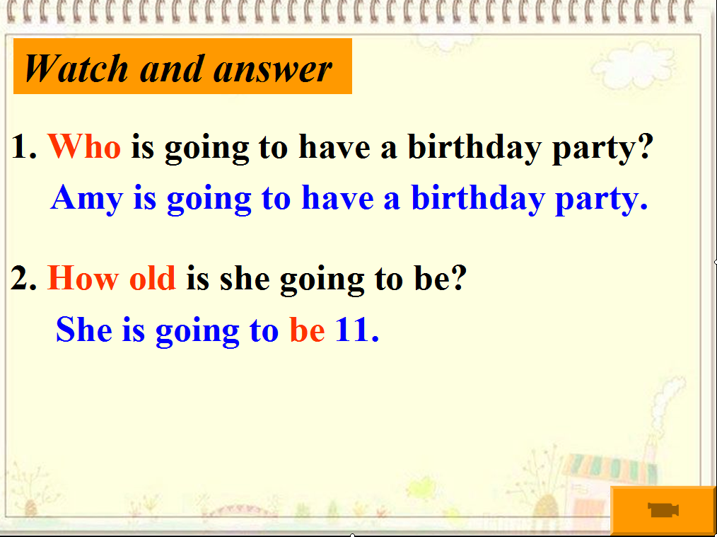

2. Listen and find the answer:What are we going to do, Amy?
T: Discuss in groups and try to read the answer.
S: We’re going to have lunch together.
We’re going to have a birthday cake.
We’re going to sing and dance.
We’re going to tidy up the room.
T: What can you find?
S: Be going to + 动词原形
(补充板书，认读短语，通过男女生读，小组读等不同形式的朗读，引导学生观察黑板句型特点：Be going to + 动词原形)
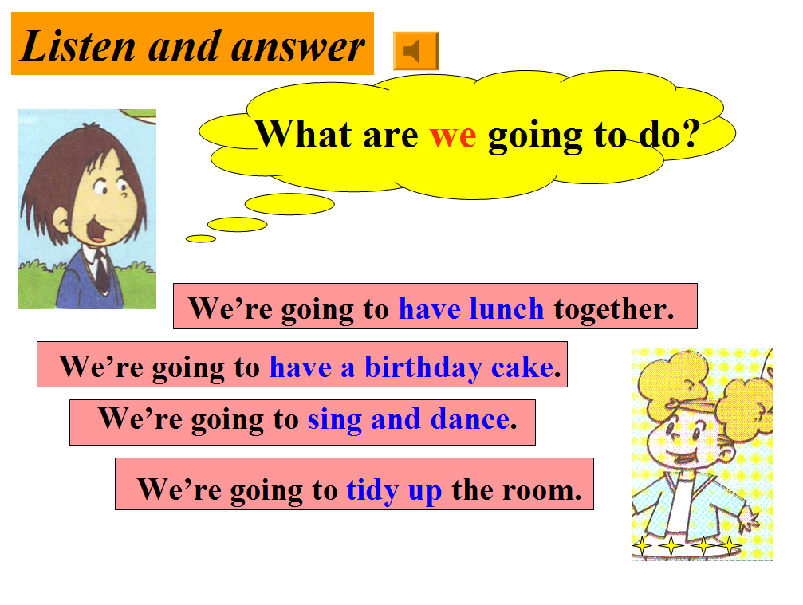

3. Pair work: Look and say.
T: What are they going to do at the party?
S: They’re going to sing and dance. （可以根据图片替换短语）
T: What is Amy going to do?
S: She is going to drink the water.
T: Who has another question?
S1: What is Lingling going to do?
S2: She is going to have a cake.
（操练本节课功能语句，变换人称。教师先做1组问句示范，其余全体学生问。在3和4幅图片时，注意第三人称问题及回答，师以图3为例，发散学生思维，培养学生提出和解决问题的能力）
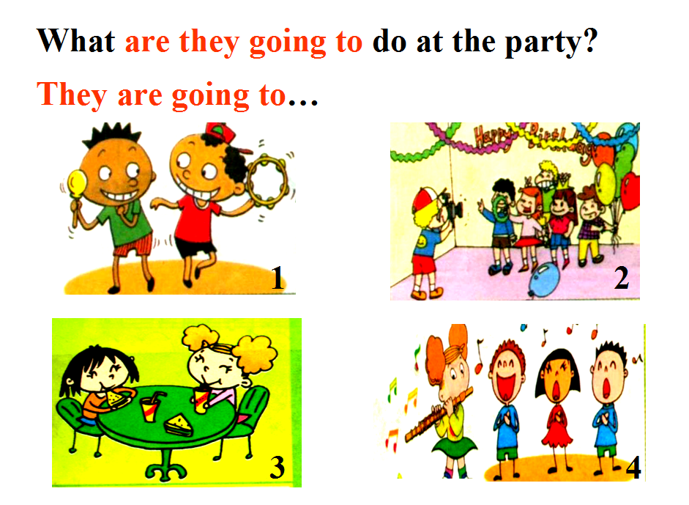

4. Exercise: Fill in the blanks. （be going to 与will都表示将来打算）
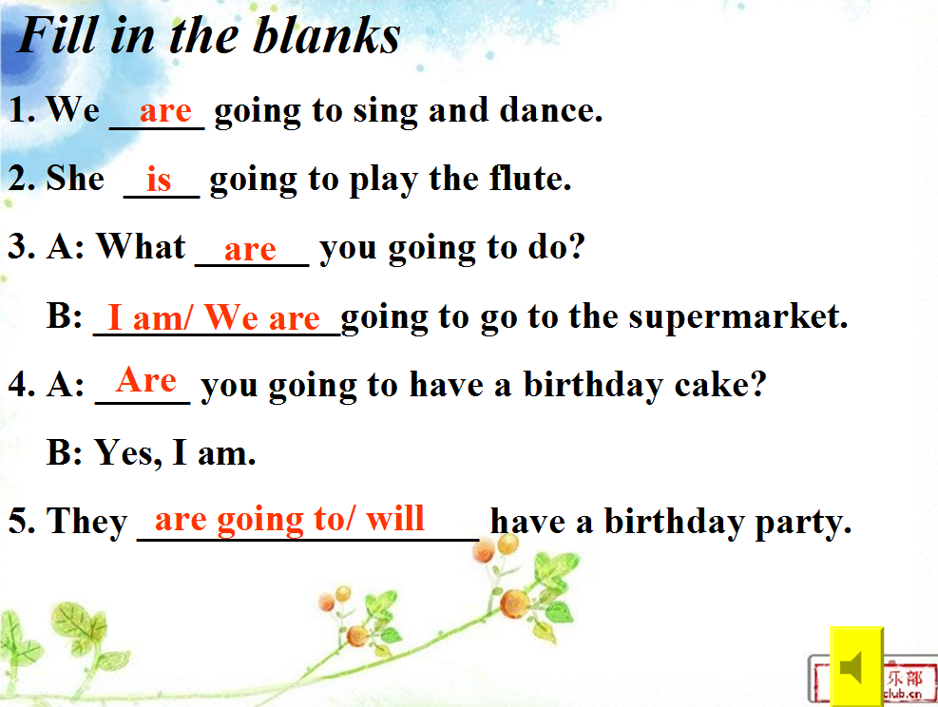

5. Listen and repeat.
6. Role play.（先组内自由练习对话，然后通过组内和组间形式表演）
Step Ⅳ. Production
1. Reading time.
T: Amy is going to have a birthday party. Let’s look.
（出示阅读，将M4U1的对话体语篇整合成短文问答，引导学生抓特殊疑问词，培养学生阅读技巧）
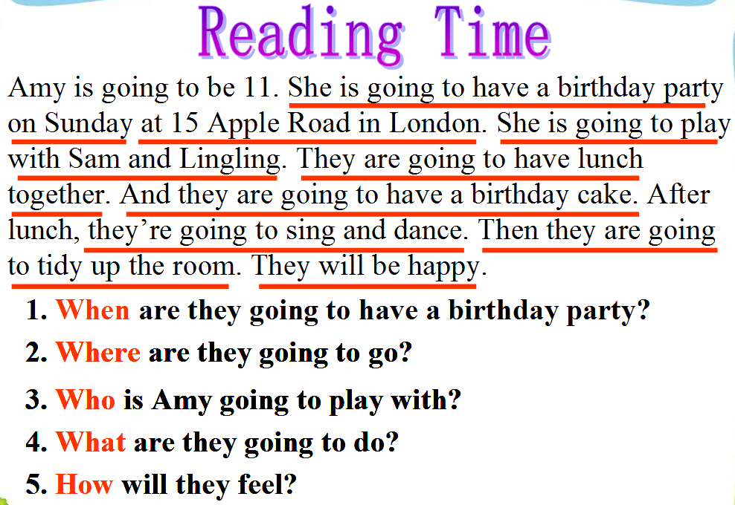

2. Talk Show
T: When are you going to go to the party?
S: on Sunday, in October/ this weekend…
T: Where are you going to go?
S: go to 11 East Road/ go to teacher’s home…
T: Who are you going to play with?
S: my friends/ my teacher…
T: What are you going to do?
S: have a birthday cake/ play football/ sing and dance/ fly a kite/ watch TV/ take photos…
T: How will you feel?
S: happy/ have a good time
(根据导入环节教师说要开生日派对，学生将要参加，逐条列出问题，并给出提示词，引导学生回答，最后选1-2个学生综合所有问题，完整展示周末计划)

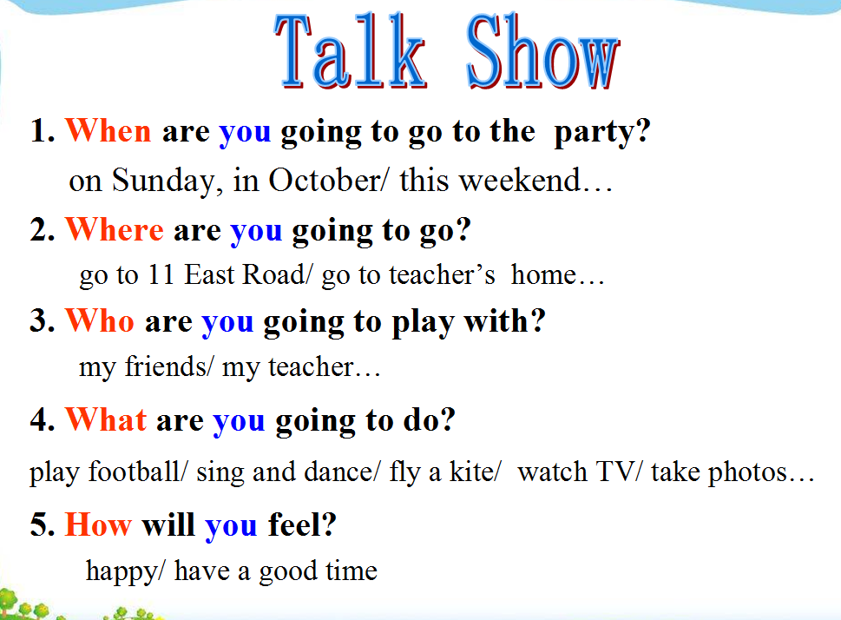

3. Writing: < My Plan>
( 课堂检测：学生书写。教师巡视，并给予指导，最后利用展台展示2-3篇习作)
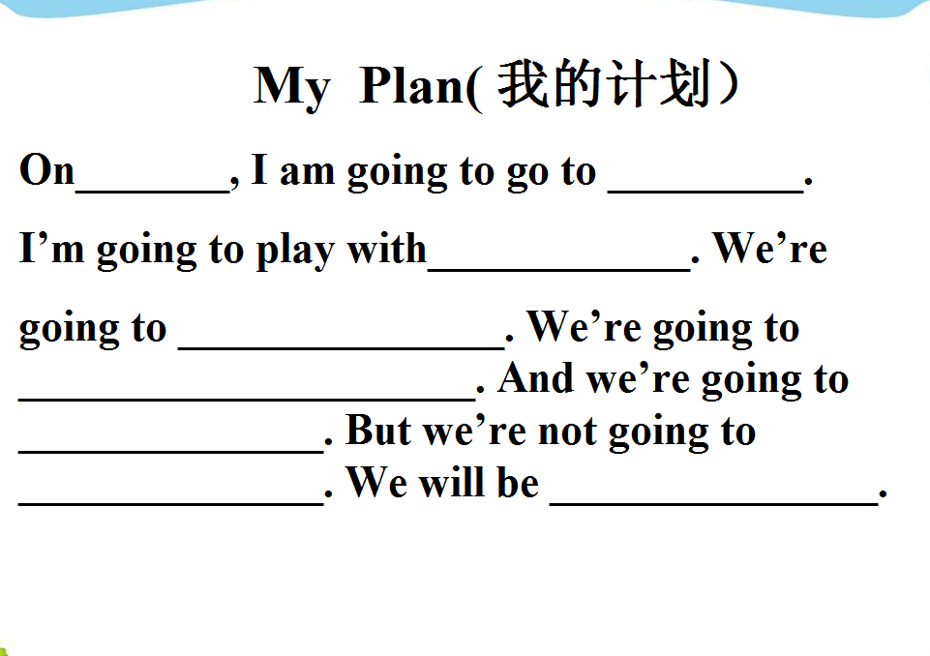

Step Ⅴ. Summary and Homework
1. Sum up: What have we learnt today?
谈论将来打算或计划的基本表达结构：be going to +动词原形
T: Who is the winner today?
Ss: Group5.
T: Yes. Next class we’ll learn how to write an invitation. And we’ll finish this invitation together.
( 将U1和U2的课文用本课的评价机制有效地结合起来，贯穿整个模块)
2. Homework:
