《Did you break your toy ? 》教学设计

小长山中心小学
吴巧丽

《Did you break your toy ? 》教学设计
课题：Module 7 Unit 1 Did you break your toy ?
教学目的：1、Grasp the words : break 、cry 、 monster
Grasp the sentences: Did you break your toy ? Yes, I did . No, I didn’t.
2、Can read the text, act the text out and ask and answer use the sentences.
3、Improve their study interesting .
重点：the words : break cry monster
The sentences ：Did you ……？Yes , I did . No, I didn’t.
难点：Can use the sentences to ask and answer .
关键：More interesting activities .
教具：cards ; recorder ; PPT
教学过程:
Step 1: Warm up
- Greeting .
- Review some words :
watch TV play football read a book go swimming
clean the room go to school go swimming paint a picture
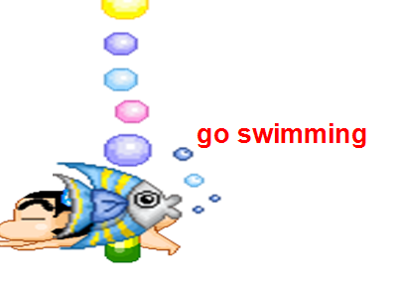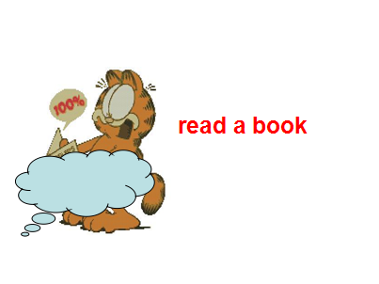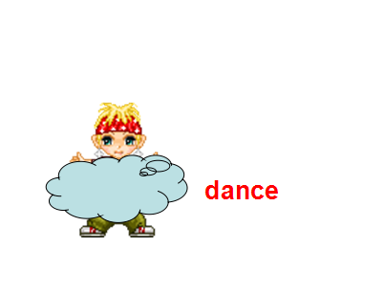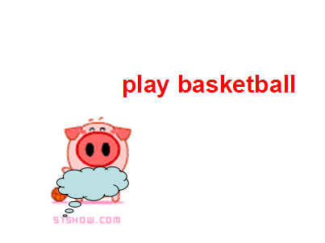
- Ask and answer
T: Did you read a book ? S: Yes , I did .
T: Did you go swimming ? S: No , I didn’t .
Ask and answer to let the children know how to answer the questions .
Step 2 : Presentation :
Show the pictures. Look! Who is he？ Yes , he is little Tom. （教师播放哭声） Listen！ What’s the matter of Tom？ Tom is crying. Learn “cry” .Read the word of “cry， crying”.
Do you know why did Tom cry? Let’s have a look what happened to Ms Smart ,Sam and Amy .And how did they take care of Tom.
Let’s listen to the dialogue.

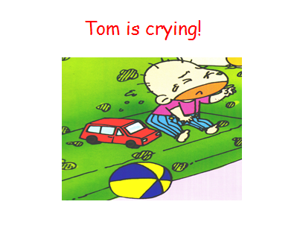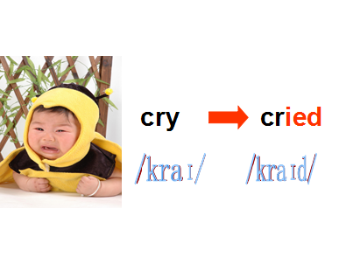
Step 3: Text learning :
- Listen to the tape .
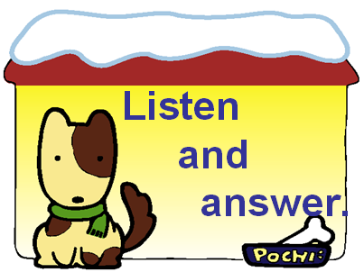
- Listen again and answer the questions:
What did mum ask ?
What did Sam ask ?
What did Amy ask ?
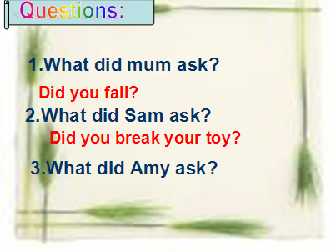
- Listen and underline the new words :
break cry monster
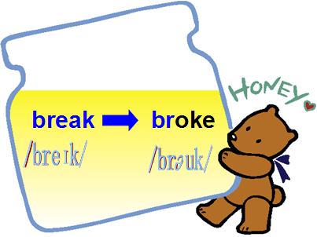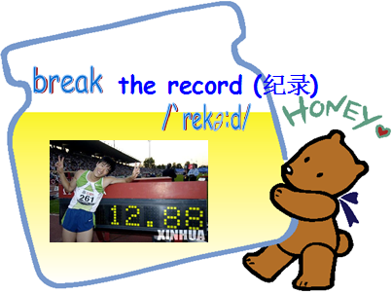
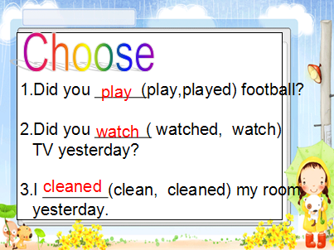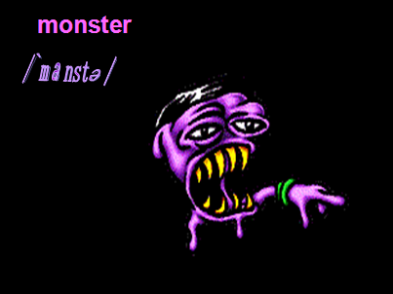
- Teach the words by some ways .
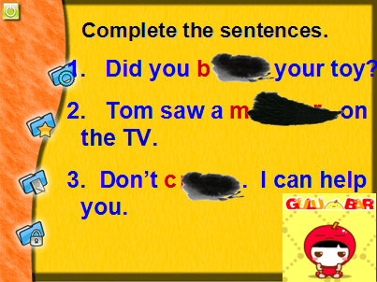
- Listen and repeat .
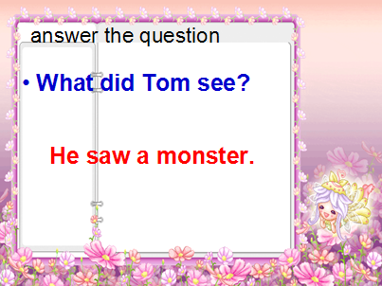
- Read after teacher .
- Read by oneself .
Step 4 Practise :
- Act the text out .
- Play a guessing game :
S1 ：Did you …… ？ S2 : Yes , I did ./ No , I didn’t .
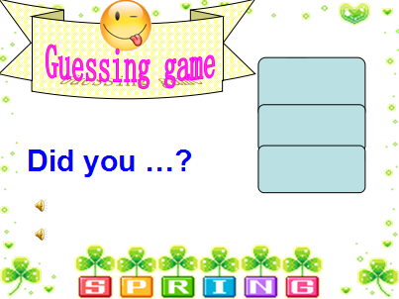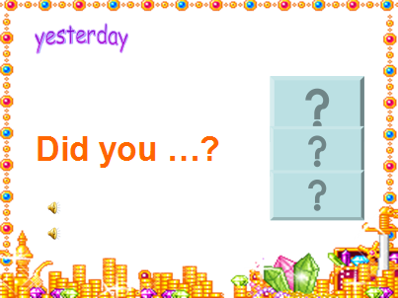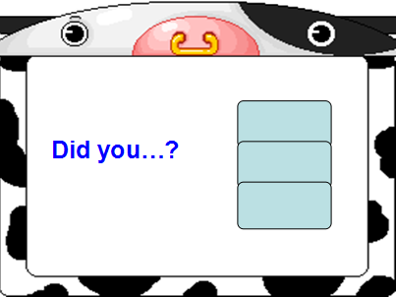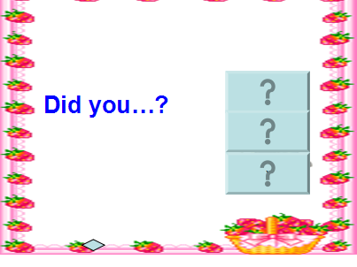
- Ask and answer in groups.
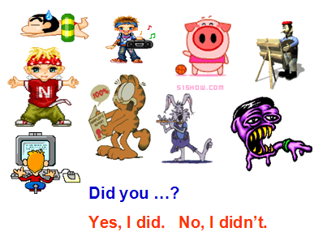
4. Practice.
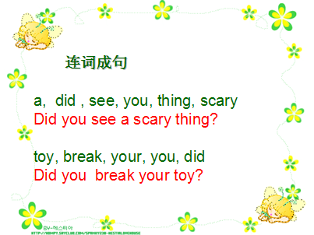
- 拓展：Show the picture, then ask and answer:
Did he/she/Amy ...? Yes, he/she did. No, she/he didn’t.
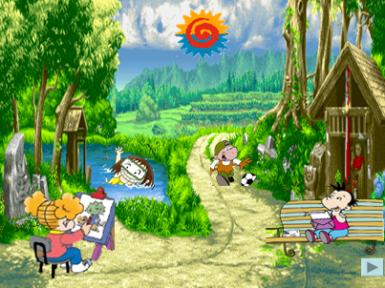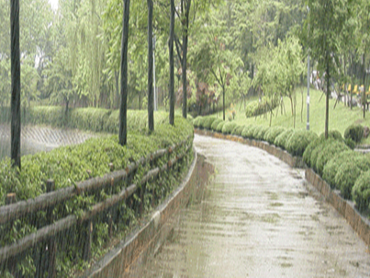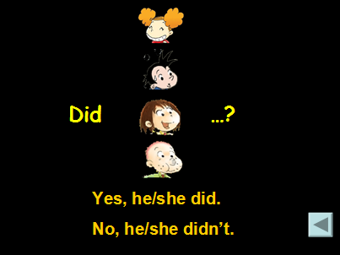
Step 5 Summary and homework :
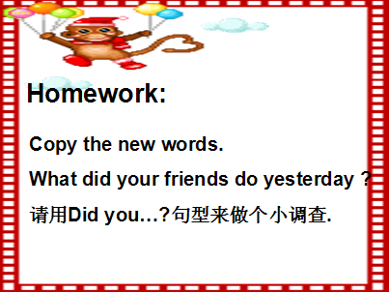

板书设计：
fall ?
Did you break your toy ?
see a scary thing ?

