新标准英语一起五册
Module9 Unit1 I’m going to do long jump.教学设计
大长山中心小学 傅海华
Step1. Warming up
1. Greeting
2. Warm: Say a chant and do the actions:
Swim, swim, swim, I’m going to swim.
Jump, jump, jump, I’m going to jump.
Run, run, run, I’m going to run.
Do them please on Sports Day!
T: I like sports. Do you like sports? Ss: Yes.
T: I like swimming. Which sports do you like?
S: I like……
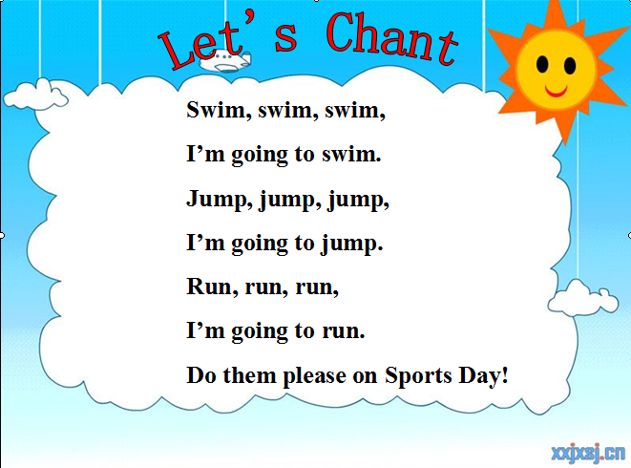

Step2. Presentation
1. Show, ask and answer
T: Oh, here is a good news. Sports Day is coming.（教授单词，强调大小写）
On Sports Day, I’m going to swim. What are you going to do on Sports Day?
S: On Sports Day, I’m going to……（play ping pong, run, ride a bike, play football……）

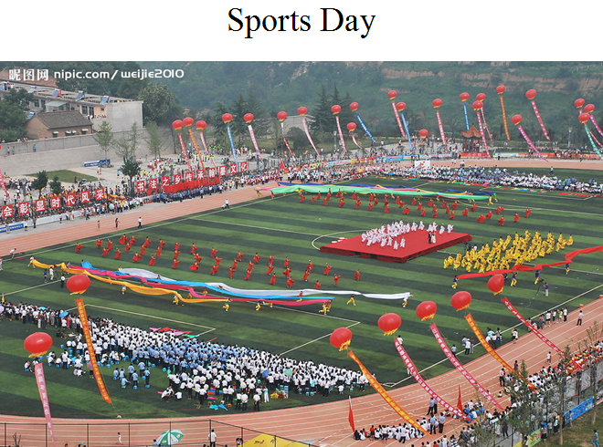
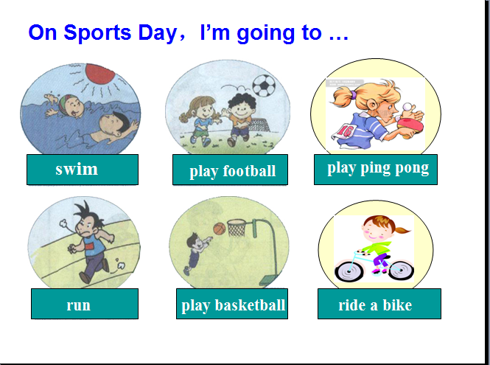

2. T: Now, please open your books, let’s learn M9U1. Let’s look what are our friends going to do?（板题）
Step3. Practice
1. Listen, point and circle“going to”
1) Let the Ss listen and circle by themselves.
2) Let them discuss their answers in groups.（小组合作1: 4人组）
3) Check in groups.
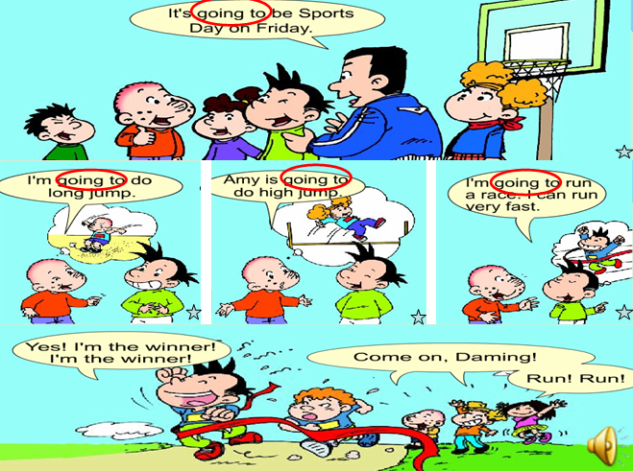
4) Read the sentences after the T.

2. Watch and answer:
Q1: What are you going to do, Sam?
Q2: What are you going to do, Daming?
Q3: What is Amy going to do?
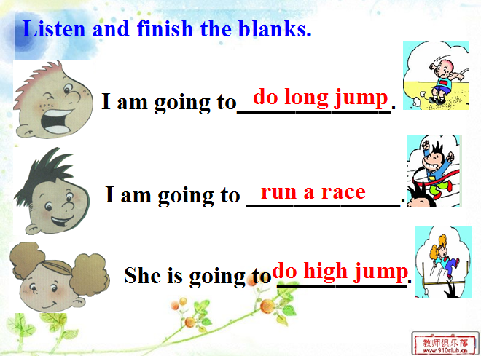
1) Let the Ss listen and match fill in the blanks.
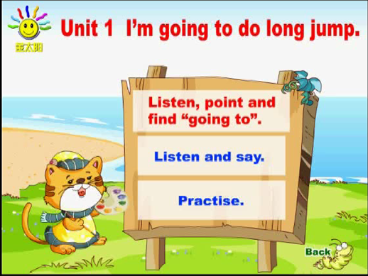
2) Teach the new words“long jump, race, run a race, high jump”
a. T: Who can jump far? （选两名学生）Let’s say“1，2，go”
Ss: 1，2，go!
T: Who can jump far?
Ss: S1 can jump far.
T: So S1 can do long jump. （选两名学生）Let’s say“Come on! Run run！”
b. T: Now who can run fast?
Ss: Come on! Run run！
T: Who is the winner?
S1: I’m the winner.
T: Yes. You can run a race.
c. Emphasize“do long jump, do high jump”
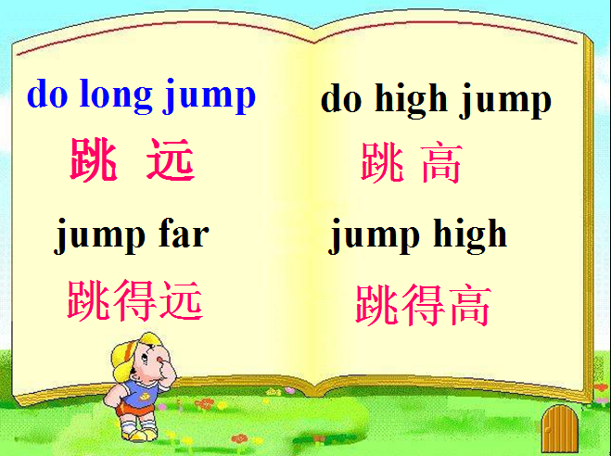

T: When you meet“do”, please speak higher/ lower.（生齐读）
3. Sum up the simple future tense
T: Look at the blackboard, what have you found?
Ss: 都有“going to”
T: Good. After “going to”, what should we use?
Ss: 动词原形
T: Yes. Before “going to”, what should we use?
Ss: Be动词
T: Look at the screen.（课件呈现一般将来时的结构）


4. Listen and repeat.
5. Role play （小组合作2: 4人组，真实情境表演）
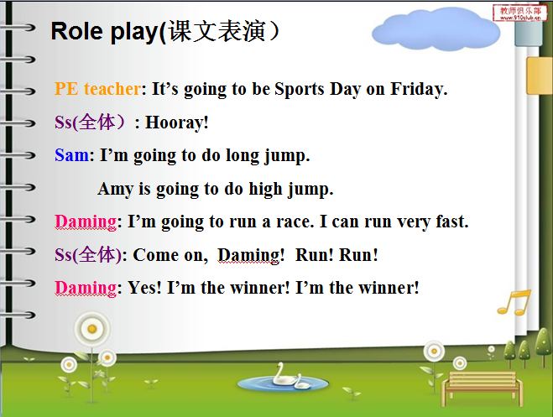

Step4. Production
1. Talk about Sports Day（小组合作3: 4人组，完成表格）
T: Let’s talk about Sports Day. Write your English names in the first line.
And then choose the sports what are you going to do and tick it. Try to say
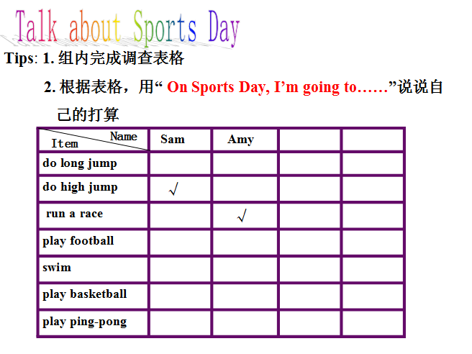
“On Sports Day, I’m going to……”

- Let the Ss fill in the tables.
- Show their tables（投影展示小组作品）
2. Guessing game
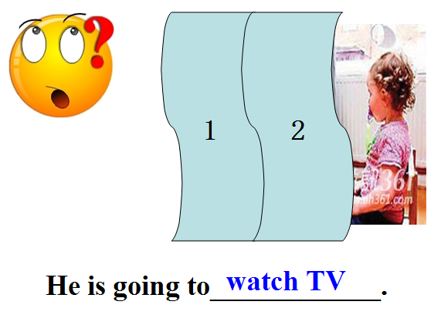
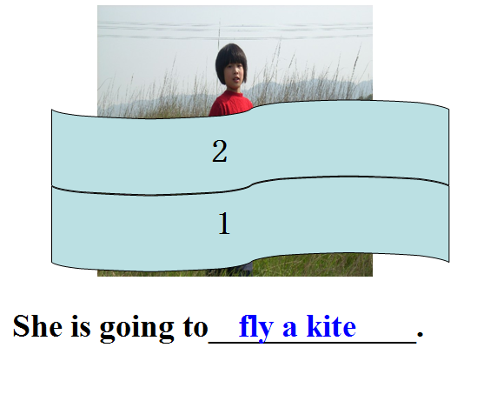
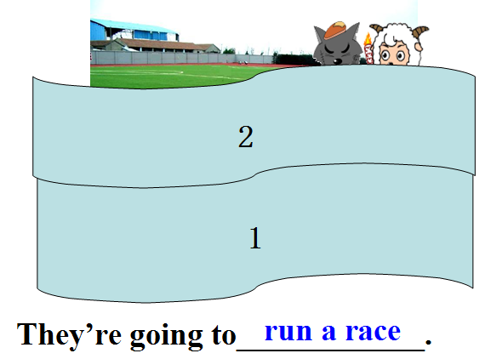

T: What is she/ he going to do?
Ss: She/ He is going to ……
3. Talk show
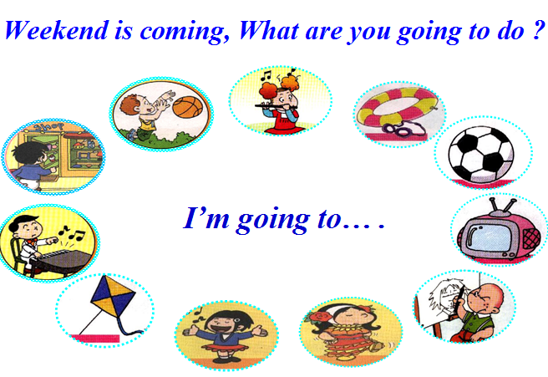

T: Weekend is coming, what are you going to do?
S: I’m going to……
4. Exercise: 学案P34-四（1,5）（小组合作4: 4人组，互批互改）

Step5. Summary and homework
1. Sun up
1) What have we learnt today?
2) T: Who is the winner? Ss: G2
T: You can get the flag.
2. Homework
必做：
1. 背写M9U1单词，功能句各2遍，汉意1遍
2. 2人一组谈谈自己的周末计划
选做：
用“ I’m going to…”写1~2句话，说说你周末的打算

板书设计：
Module9 Unit1
一般将来时：主语+be going to+动原
I’m going to do long jump.
run a race.
She is going to do high jump. （评价机制）

教学反思：
本课选自新标准英语（一年级起点）第五册Module9 Unit1，本模块的学习内容围绕着将来的行为和状态进行。本课的话题与Sports有关，谈论运动会将要参加的项目，要求学生能够用“I’m going to …”来表达自己要做的事情。
结合本节课教学内容，我主要采用任务型活动化教学模式，通过听、说、玩、演、做等多种任务活动为主要学习途径，充分发挥学生的主体地位，让学生积极参与到学习中。反思这节课，感触颇多：
一、情境教学，激发兴趣
热身环节，我利用自编的与运动有关的chant和学生一起律动，自然引出问题“On Sports Day, I’m going to……”，导入课题。
在课文对话学习后，以小组合作方式进行对话表演，学生们积极参与，大胆创新，勇于表现，也真正地将所学知识运用到真实的情景中。
二、小组合作，优势互补
整节课，我结合班级情况，采用小班化教学策略，以小组合作学习为主，展开教学活动。本节课，共有四次小组合作：听音找“going to”，对话表演，小组谈论运动日，小组互批学案。在每个环节的落实上，主要关注班级C层学生的基础知识接受情况和B、C层学生的能力提升。这几次小组合作，我认为在对话表演和完成表格活动实效性较强，做到了A帮C，B和B互补。
三、游戏教学，寓教于乐
本节课的操练环节，我设计了三个活动：小组填表格，guessing game和talk show，主要是引导学生将所学语言及时转化为语言技能。活动的设计由易到难，螺旋上升，不仅激发了学生的兴趣，也使不同学生的能力得到了提升，掀起了课堂教学的一个小高潮。
当然，回顾本课教学，也有需要改进的地方：
1.对话表演，出于对学生安全的考虑，没有达到预期的效果。
2.由于时间关系，学生展示小组完成的表格时，没有给学生更多的机会展示，另外可以根据表格，适当提问“What’s she/ he going to do?”问答。
最后非常感谢于红老师和学校给我提供了这次机会，通过这段时间的磨课，使我的教学能力有了进一步的提高，我也将以此作为起点，全力打造高效英语课堂。

2012-11-15

