新标准英语一起M1
Revise M1 教学设计
大长山小学 骆文芳

教材分析
语言功能：
语言结构：能够用形容词来简单叙述他人和自己的性格特点，以及他人的困难和自己打算提供的帮助。
教学目标：1. 复习本模块的重点单词和句型。
- 能够简单的复述课文
- 能够用本模块的语言在实际环境中应用。
语言知识目标：
单词：nice , shy , loud , quiet , helpful , plus , but , twenty , more a bit and so on.
目标语句：This is Xiaoyong. He’s very clever . But he’s a bit quiet.
I’m helpful. This little girl can’t do her Maths.
I’m going to help her / him.
语言技能目标：能够用所学的形容词来描述他人和自己的性格并提供的帮助。
情感态度目标：善于倾听，愿意与人合作。对所谈话题感兴趣，并能积极投入到教学活动中去。教会学生要爱自己和他人并能适当的提供帮助。
教学重点：运用形容词来描述性格特点。
教学难点：如何用所学词语来描述自己和他人的性格特点。

教学过程：
Step 1.Preparation
- Greetings each other.

- listen to the song “ the family”

- Revise the adjective words:

Students know and read :

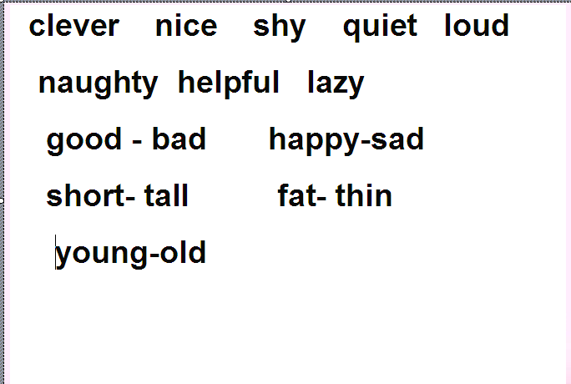

- Look at the pictures and talk about them

Teacher asks : What are they like?

Studens answer them one by one (CAI)

① He’s very clever. ② She’s very beautiful /nice.


③ He’s very lazy. ④ He’s very naughty/…....
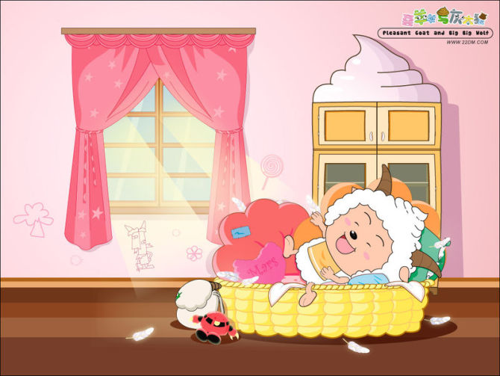

Step 2. Presentation

1. Play a game.

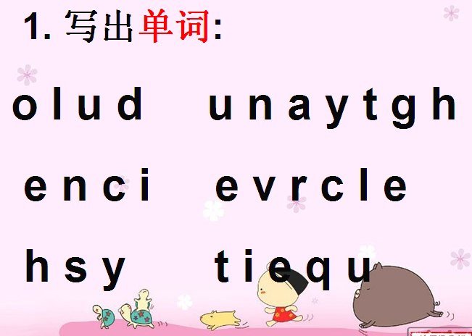

2. Ask and answer about the text .
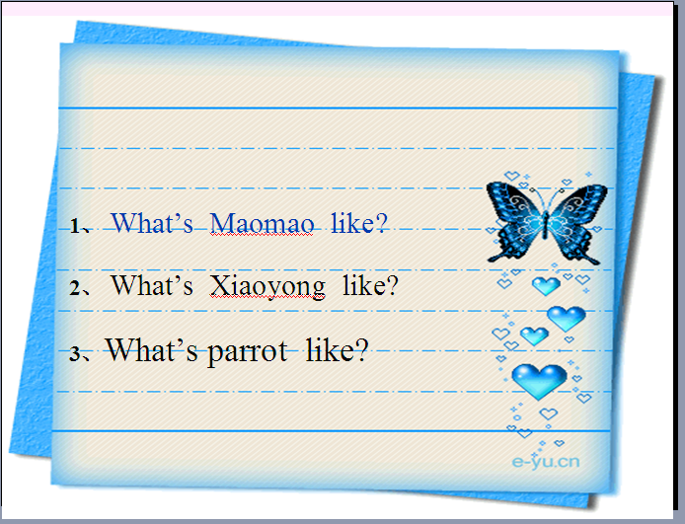

Ss read and answer :

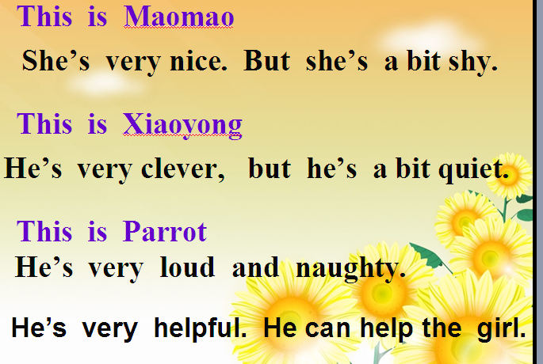

3. Let talk and change the objects(由上面的自然导入这一环节的复习)
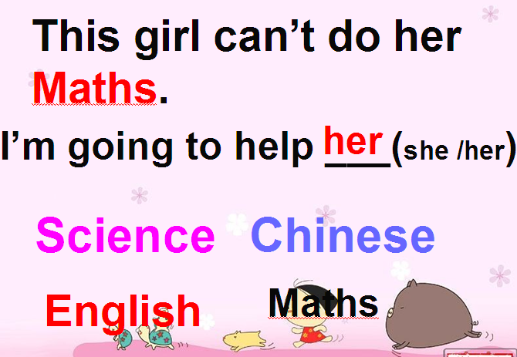

4. Talk and offer some help

(CAI) T says : I can’t do some Maths. Are you helpful?
Can you help me?

Ss answer : Yes. Let’s say

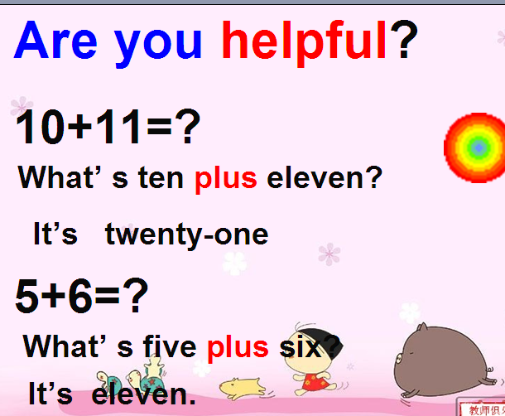

5. Practise listening choosing the right numbers.
T: Using : What’s …….plus(and)…..?

Step3. Practice .
- Strenghten the knowledge

(1) Fill in the blanks according to the text.

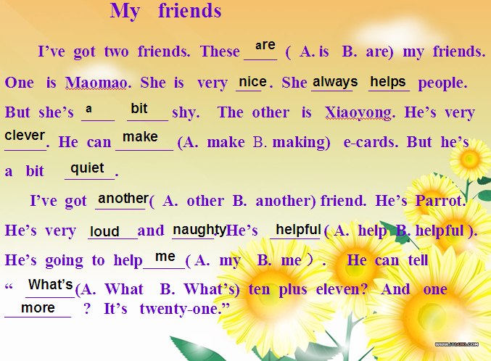

(2)Check the spelling words

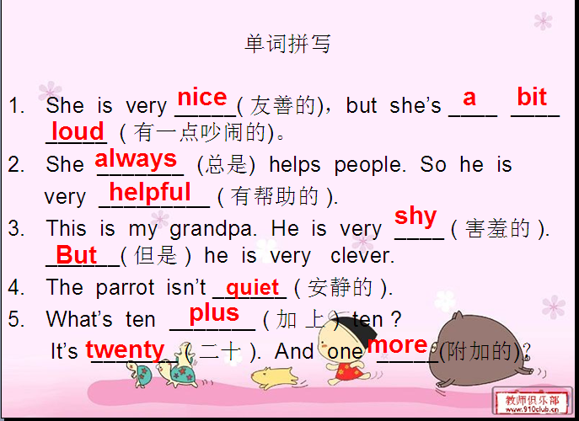

（3）Put the sentences in oder.
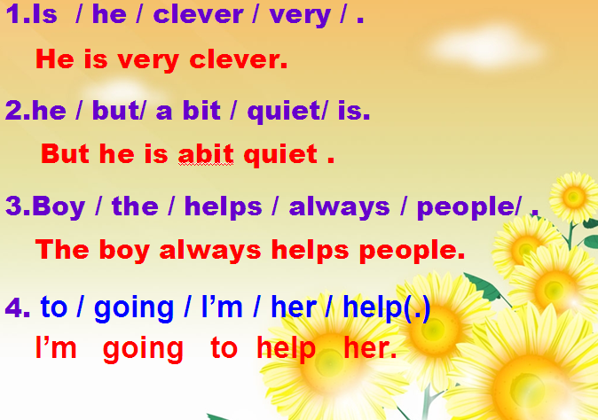

2. Describe the family and remember their characters, then fill them.

T says : 考考你，看谁记得快

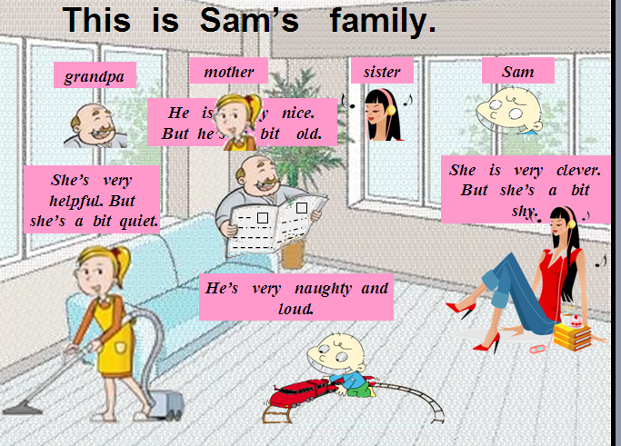

Listen and fill the blanks.
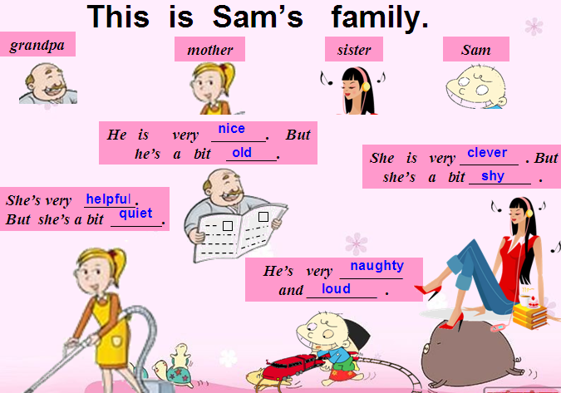

3. Talk your classmates using the adjective words.

4. Read the passage and choose “T” or “F”

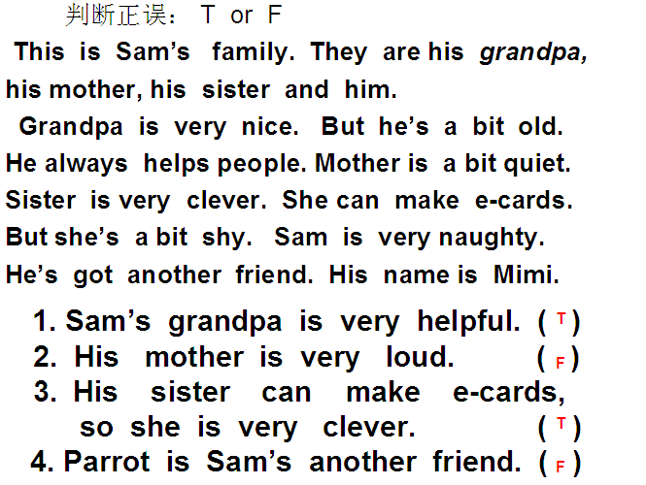

Step4. Production

1. Let’s guess : Who are they ?

Who is he? Who is he? Who is she?
He is short . He is a bit quiet. She is very nice.
He is loud. He is tall. She is very clever.
He is very naughty. He is very fat. She is very helpful.
She can help English teacher
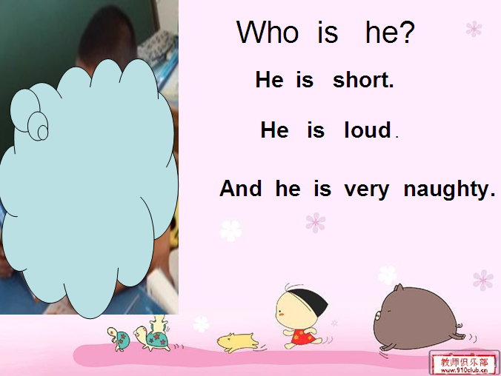
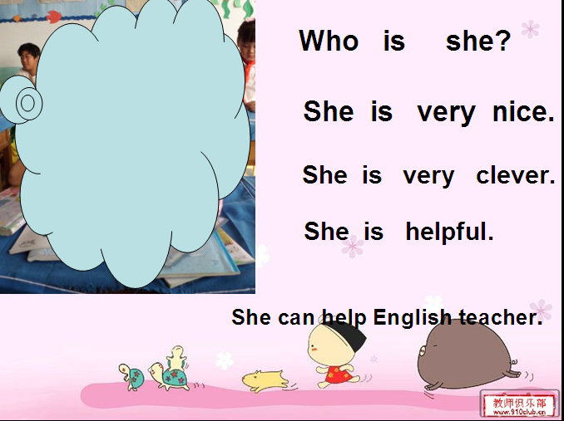
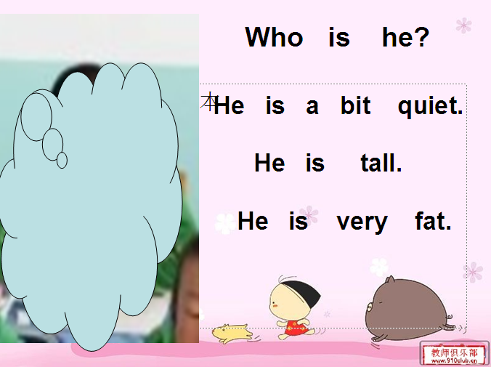

2.

]
2.Talk myself and write them ( 小练笔 )
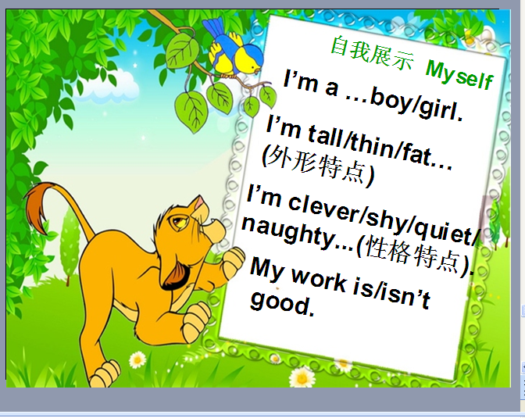

Step5. Summary

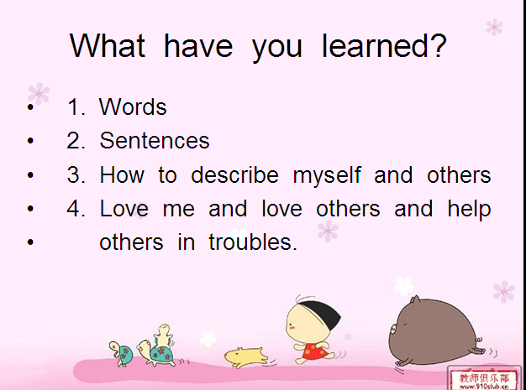

Step6. Homework

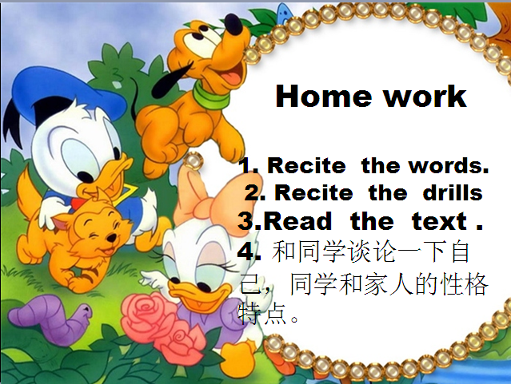

Step7. 板书设计

My family

Grandpa Mother Sister Sam
nice helpful clever loud
old quiet shy naughty

2012年6月12日

