长海县2011~2012学年度第一学期期末质量检测
小学五年级 英语 完成时间：80分钟
题号 | 听 力 部 分 |  |  |  | 笔 试 部 分 |  |  |  |  |  |  |  | 总分
题号 | Ⅰ | Ⅱ | Ⅲ | Ⅳ | Ⅰ | Ⅱ | Ⅲ | Ⅳ | Ⅴ | Ⅵ | Ⅶ | Ⅷ | 总分
得分
听力部分( 40分)

Ⅰ、 听辨单词，选出你所听到的句子中的单词。（10分）
( ) 1. A. laughing B. lift C. like
( ) 2. A. her B. hear C. hers
( ) 3. A. will B. well C. sell
( ) 4. A. pond B. points C. park
( ) 5. A. your B. yours C. you
Ⅱ、 听音辨图。(15分)
一、听音找图，用数字（1、2、3、4、5）给下列图片重新排序。
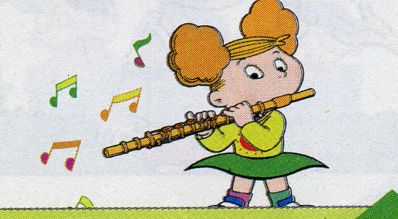
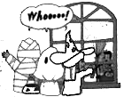
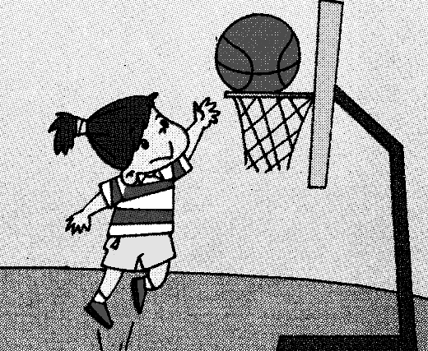
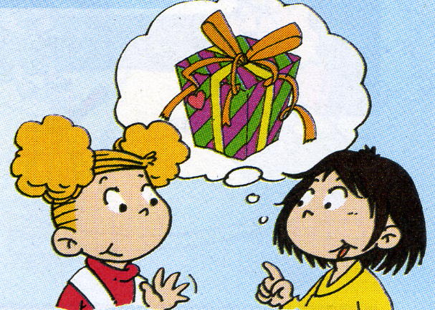
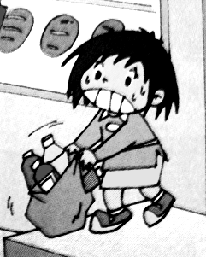

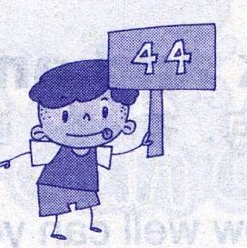
二、听音识图，判断正（√）误（×） 。
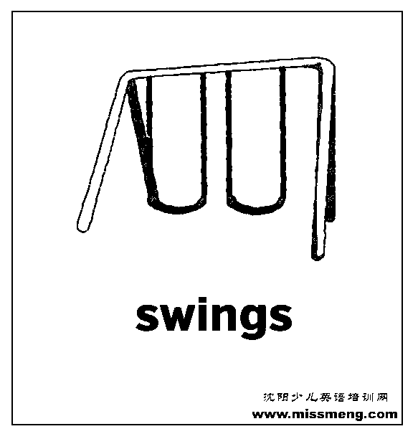
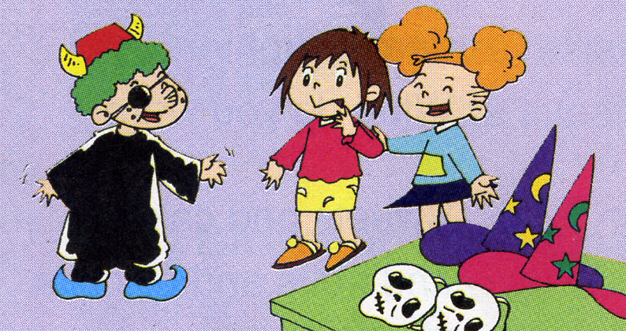
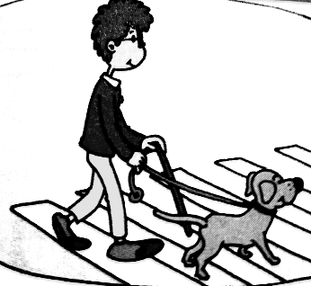
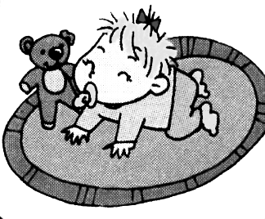

( ) ( ) ( ) ( ) ( )

Ⅲ、 听问句选答语，将其序号填在括号内。（10分）
( ) 1. A. No, I’m not. B. No, she isn’t.
( ) 2. A. It’s red. B. It’s mine.
( ) 3. A. We’re going to sing. B. Her friends are going to go home.
( ) 4. A. No, you can’t. B. No, I can’t.
( ) 5. A. They go to people’s houses. B. They give the children sweets.
Ⅳ、 听音，按所听顺序用数字（1、2、3、4、5）给下列句子重新排序。(5分)
( ) Children are running home.
( ) Sam’s shoes are wet and dirty.
( ) It is raining.
( ) Amy’s blue dress is wet.
( ) Lingling’s favourite skirt is dirty.

笔试部分（60分）
Ⅰ、英汉互译。 （5分）
1. 晚安！ ____________________
2. 做早操 ____________________
3. 请回复！ ____________________
4. 吃午饭 ____________________
5. Sometimes there are small eggs in the big eggs. ____________________________。
Ⅱ、单项选择。（10分）
( ) 1. Look ______ the picture _______our school.
A. in ， of B. at ， of C. at ， for
( ) 2. In England, they sit______ tables. We sit______ lines in China.
A. in , around B. around , in C. around , on
( ) 3. School finishes_____ half past four.
A. in B. on C. at

( ) 4. ---Whose T-shirt is it? ---It’s _______.
A. my B. your C. his
( ) 5. She ________ speak English then. But now she_______speak.
A. couldn’t, can B. could, can C. can’t, could
Ⅲ、根据语境补全句中的单词。 （5分）
1. Do you know ________________(为什么)?
2. It’s an ___________________(请柬) to my birthday party.
3. You were in China for two __________________(年).
4．Now there is a big __________________(操场).
5. I don’t have anything to do. I’m _________________(无聊的).

Ⅳ、连词成句。（10分）

1. angry / you /are (?) ____________________________________________
2. late / you/ be / shouldn’t (.) __________________________________

3. hear / could / it / people / the (.) _______________________________

4. any / there / before / swings / weren’t / here (.) _________________________
5. isn’t / it / but / yours (.) ____________________________________

Ⅴ、 根据问句选出答句，将序号填在括号里。 (10分)
( ) 1. Are you going to have a birthday cake? A. No, she isn’t.
( ) 2. What are we going to do? B. No, I can’t.
( ) 3. Is she happy? C. No, he can’t.
( ) 4. Can you run fast? D. No, I’m not.
( ) 5. Can Fifi help the blind people? E. We are going to sing and dance.

Ⅵ、 选词填空，将单词的适当形式填入横线上。（5分）

supermarket , sometimes , restaurant , sell , country

Many English supermarkets are big. They_______ different things. They sell food from lots of __________.They also sell clothes, toys and CDs. __________ there are __________ at the _____________.

Ⅶ、阅读理解，根据短文内容判断正（√）误（X）。（10分）
Hello, I’m Jim. I’m in an English school. Our school starts at eight o’clock. It finishes at half past three. There are sixteen boys and eighteen girls in my class. We have our class rules: We shouldn’t be late. We should listen in class. And we should try hard. So we all study hard. At break time, we can play lots of games.

( ) 1. Jim is in an English school.
( ) 2. Jim’s school finishes at 3 o’clock.
( ) 3. There are eighteen boys in Jim’s class.
( ) 4. Jim shouldn’t be late.
( ) 5. They can’t play games at break time.

Ⅷ、 写作园地。 (5分)
同学们，很快就要放寒假了，你有什么打算呢？请以My Plan为题，并参照以下提示词：be going to ，study ，play …写写你的假期计划。要求不少于5句话。
____________
___________________________________________________________________________________________________________________________________________________________________________________________________
五年级英语听力题签:
※注意：每道听力试题读二遍。时间控制在20分钟以内。

Ⅰ、 听辨单词，选出你所听到的句子中的单词。（10分）
1. Tom is laughing.
2. It could hear the people.
3. They sell different things.
4. They got thirty-six points.
5. It isn’t yours. It’s mine.
Ⅱ、 听音辨图。(15分)
一、听音找图，用数字（1、2、3、4、5）给下列图片重新排序。
1. I’m going to make you a surprise present for Christmas.
2. She can play basketball well.
3. They go to people’s houses.
4. This bag is heavy. I can’t lift it.
5. She is playing the flute now.
二、听音识图，判断正（√）误（×） 。
1、She couldn’t walk then.
2、There was a slide here before.
3、Children wear beautiful clothes.
4、He’s got thirty-six points.
5、This dog can help him.
Ⅲ、 听问句选答语，将其序号填在括号内。(10分)
1 Are you sad?
2 Whose T-shirt is it?
3 What are we going to do？
4 Can you run fast?
5 What do children do at Halloween?
Ⅳ、 听音，按所听顺序用数字（1、2、3、4、5）给下列句子重新排序。(5分)
It is raining. Children are running home. Look! Amy’s blue dress is wet. Lingling’s favourite skirt is dirty. Sam’s shoes are wet and dirty. Tom is laughing.

听力部分到此结束！

五年级英语答案及评分标准：
听力部分
Ⅰ、(2×5＝10分) ABCBB
Ⅱ、(1×5 + 2×5＝15分) 4----2-----3----5-----1 √ ╳ ╳ ╳ √
Ⅲ、(2×5＝10分) ABABA

Ⅳ、(1×5＝5分) 2-----5------1-----3------4
笔试部分
Ⅰ、(1×5＝5分)
1、Good night! 2、do morning exercises
3、Please reply! 或 Reply, please! 4、have lunch
（注意 ：1——4必须完全准确方可得1分）
5、有时候大的彩蛋里有小的彩蛋。（不离句子大意即可得分）
Ⅱ、(2×5＝10分) B B C C A
Ⅲ、(1×5＝5分) 1.why 2. invitation 3. years 4. playground 5.bored
(注意: 第3题没加s扣0.5分)
Ⅳ、(2×5＝10分)
- Are you angry?
- You shouldn’t be late.
- It could hear the people.
- There weren’t any swings here before.
- But it isn’t yours.
Ⅴ、(2×5＝10分) DEABC
Ⅵ、(1×5＝5分)
1. sell 2. countries 3. Sometimes 4. restaurants 5. supermarket
(第2、4题没变复数扣0.5分，第3题S没大写扣0.5分)
Ⅶ、(2×5＝10分) 1. √ 2. X 3. X 4 .√ 5. X
Ⅷ、(5分) 答案略。
请任教五年级的英语老师批阅作文，并自行把握评分标准,做到心中有数。
一等：4----5分（主题鲜明，表述恰当，语言结构准确。）
二等：3分（主题较为鲜明，表述较为恰当，语言结构较为准确。）
三等：0-----2分（主题朦胧，语言表述不清，错词乱句，信息模糊。）
备注：卷面满分为100分。（听力40分，笔试60分。）
优秀：90---100
良好：80---89
及格：60---79 2012年1月1日
不及格：0---59

