六年级英语单元测试（M1-M3）
听力部分：（35 分)
I. 听句子，选出所听到的单词。(5分)
（ ）1. A. stamp B. present C. address
（ ）2. A. long B. old C. tall
（ ）3. A. different from B. difficult for C. different of
（ ）4. A. coconut B. collect C. Canada
（ ）5. A. Halloween B. Christmas C. Thanksgiving
II. 听句子，在与本句内容相符的图片下画√，不符的画×。 (10分)

你好
1. 2. 3. 3. 4. 5.
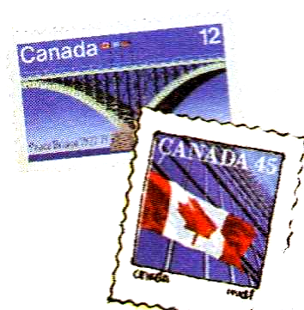

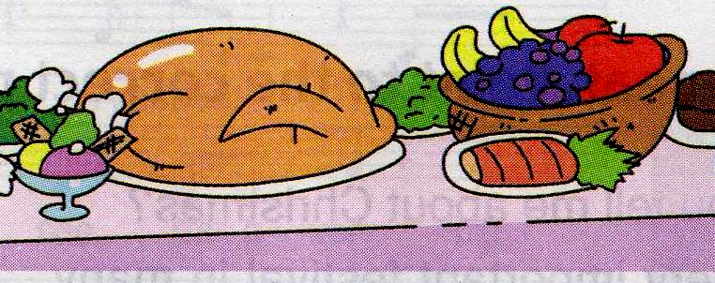


_________ _________ _________ _________ _______
Ⅲ. 听句子，选答语。(10分)
( )1. A. Yes, she can. B. No, she isn’t. C. she can ride a bike.
( )2. A. What’s your name? B. I’m her friend, too. C. Pleased to meet you.
( )3. A. It’s in New York. B. It’s in November. C. It’s my favourite festival.
( )4. A. It’s 30 metres wide. B. It’s 20 kilometres long C. It’s 60 metres long.
( )5. A.Sorry, I don’t know. B. I want a Chinese pen pal. C. I sent an email.
IV. 听音，填入所缺单词。(10)
- Tell me more about this ________.
- There were Chinese shops ____________.
- We saw American __________ in the street.
- I went to a ________ yesterday.
- Do you ________ stamps?
- Now we can both have stamp __________.
- Yesterday I had a big ____________.
- It’s __________ of years old.
- It’s five thousand ___________ long.
- It’s a tall ____________.

笔试部分（65’）

一．填入所缺单词：(5’)
beautiful high metres thousand place

1. Tell me about this________________.
2. It’s about two _______________ years old.
3. The supermarket is twenty ________________ tall.
4. The clock is fifty metres _________________.
5. It is a _______________building.

二．选择：(10’)
( )1. I ’m sending ______ email to my mum.
A. a B. an C. the
( ) 2. Have you got _______ stamps from China? No, I haven’t got ______
A. any…any B. some…any C. much…any
( ) 3. Simon, please tell ________ more about this place.
A. I B. me C. my
( )4. Now I am ________ some new stamps into my album.
A. putting B. puting C. put
( ) 5. We often go swimming _____ the weekend.
A. in B. at C. off
( ) 6. Daming ______ to the library yesterday.
A. go B. goes C. went
( ) 7. She can ________ some English.
A. speak B. spoke C. speaks
( ) 8. ________ is he? He’s at the Great Wall.
A.What B.Where c.how
( ) 9. Can we walk all _________ the Great Wall, Daming?
A. of B. in C.on
( ) 10. She can make ____ album ___ this book.
A. an, with B. a, with C. an, for
三．介词填空：(6’)
1. You can see Chinese dancing _________the street.
2. I’m going to send an email __________Mum.
3. The food was different ________Chinese food.
4. Lucy is very happy here _________China.
5. This stamp is ____________1988.
6. It’s a picture ____ Chinese stamp.

四．动词适当形式填空：（5’）
1. We can___________(walk) all of it.
2. I want to _________(go) there.
3. We ________(eat) in an American Chinese restaurant yesterday.
4. She always ___________(send) me emails.
5. Lingling __________(put) her new stamps into her album now.

五．句型转换：(34’)
1.ate, in, Chinese, a, we, restaurant (连词成句)
_______________________________________________
2.went, a, library, to, I, yesterday(连词成句)
________________________________________________
3. I’ve got some stamps from China.
(否定句)__________________________________________
(一般疑问句)______________________________________
(肯定回答)_______________________________
（否定回答）____________________________
(对画线部分提问)____________________________________
(用Sam改写)_________________________________________
4. I’m reading a letter. (对画线部分提问)
_________________________________________________

5. The Great Wall is ten thousand li long. (同义句)
_________________________________________________
6. It’s a beautiful building! (感叹句)
_________________________________________________
7. These stamps are from China.
（单数句子）_______________________________________
（就划线部分提问）____________________________________
- Do you collect stamps? (否定回答)
_______________________________________________________
- Did you do sports? (否定回答)
____________________________________________________
- We saw Chinese dancing. (对画线部分提问)
________________________________________________________
- I need to sleep. (对画线部分提问)
________________________________________________________

六．阅读并判断对错：(5’)
Old Smith likes reading very, very much because he wants to know everything .He has got many books in his library. Some old books about China are in Chinese. Old Smith can’t understand the words in the books. But he thinks he can understand the pictures in them. In fact, Chinese pictures are not easy to understand. Such as on Qi Baishi’s pictures, you can’t see the water, but you can see the fish swimming in the water. How can the fish swim without water? Old Smith thinks maybe he can see the water if he has got some glasses from China. Can he?

( )1. Old Smith likes reading because he wants to know the words in the books.
( ) 2. Old Smith has got a library.
( ) 3. Chinese pictures are hard to understand.
( ) 4. You can see the water on Qi Baishi’s pictures.
( ) 5. Old Smith can see the water if he has got some glasses from China.

