长海县2010~2011学年度第一学期期末学业质量检测
小学六年级英语 考试时间：80分钟
题号 | Ⅰ | Ⅱ | Ⅲ | Ⅳ | Ⅴ | Ⅵ | Ⅶ | Ⅷ | Ⅸ | Ⅹ | Ⅺ | Ⅻ | 总分
得分
听力部分( 35分)
Ⅰ、 听辨单词，选出你所听到的句子中的单词。
（ ）1、 A. world B . what C. week
（ ）2、 A. surprise B. special C. speak
（ ）3、 A. really B. round C. restaurant
（ ）4、 A. place B. pretty C. please
（ ）5、 A. might B. mother C. million
Ⅱ、听句子选图片，根据所听顺序将其序号填写在相应的横线上。

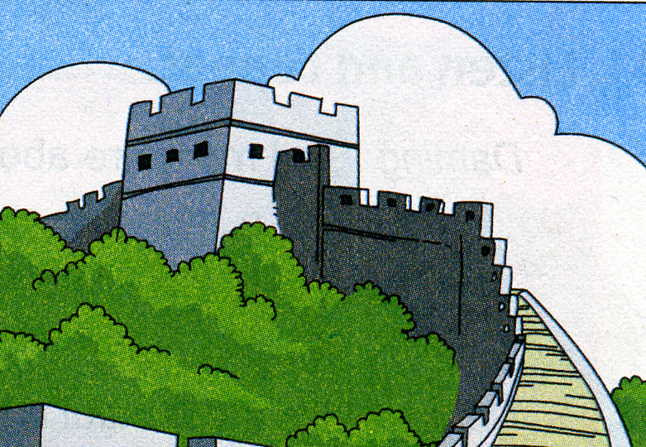
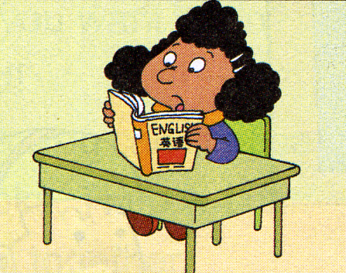

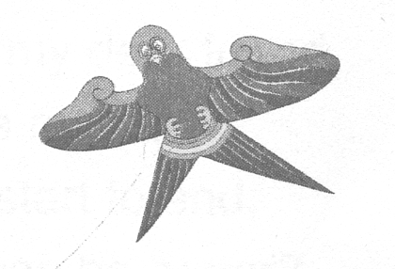

A B C D E

1. ________ 2. ________ 3. ________ 4. _______ 5. _______

Ⅲ、听问句选答语，根据所听顺序将其序号填写在相应的横线上。
A. I love hamburgers. B. I’ve got a computer. C. I’m reading books.
D. No, I can’t. E. We saw Chinese dancing.

1. _________ 2. ________ 3. _________ 4. _________ 5. _________
Ⅵ、听短文，判断正(√)误(╳)。
（ ）1、Thanksgiving is an English festival.
（ ）2、Simon’s favourite festival is Christmas.
（ ）3、Thanksgiving is in November.
（ ）4、They say “Happy New Year” on Thanksgiving.
（ ）5、Families are together. They have a big special dinner on Thanksgiving.

Ⅴ、听短文，根据短文内容完成下列表格, 在正确的选项空格中划“√” 。

 | football | basketball | swimming | running | flying kites
Tom
Simon
Laura
Lucy
笔试部分（共65分）
Ⅵ、请根据所给语境补全句子中的单词或短语。
1、I’m ____________ (口渴). I want to drink some water.
2、She often ________________(收拾) her room.
3、The river is ten ____________ (千) li long.
4、Do you ________________ (收集) stamps?
5、 __________________(袋鼠) like jumping.
6、I want to ________________(选择) a shirt.
7、The old __________________(大楼) is our library.
8、What’s this _______ ________________ (用英语说)?
9、The UN________ ____ _______ _________(想要保持和平)in the world.
10、Please __________ ______(写给) me soon.
11、There are _____ __________ _____(许多) children in the park.
12.、 ____________ _______(看)this photo, I was six years old then.
Ⅶ、选择。
（ ）1、Please stand ________ a line at the bus stop.
A.on B.in C. at
（ ）2、A fox in the day and is awake at night.
A. sleep B. sleeping C. sleeps
（ ）3、I ______ to a library yesterday.
A. go B. going C. went
（ ）4、Look! This is a photo ______ the Great Wall.
A. off B. of C. in
（ ）5、These ______ some stamps from Canada.
A. are B. is C. am
（ ）6、Does Xiaoqiang like playing football? _____
A. Yes, she doesn’t. B. Yes, he does. C. No, I don’t.
（ ）7、I _____________ got ___________ books about America.
A. haven’t , some B. has , any C. haven’t , any
（ ）8、Chinese food is quite ______________ from American food.
A. special B. different C. difficult
（ ）9、Yao Ming is 2.26 metres ________. He can play basketball very well.
A. high B. far C. tall
（ ）10、It’s fun ______________English.
A. to learn B. learn C. learnt
Ⅷ、情景反应。连一连。
1、How long is the Great Wall? A、I like painting .
2、Have you got any stamps from China? B、Yes, I have.
3、What do you like doing ? C、I often help my mum.
4、What do you do at the weekend? D、It’s on the 25th of December.
5、When is Christmas? E、It’s 5000 kilometres long.

Ⅸ、 根据所给语境选择恰当单词补全短文，并将序号填入横线上。
A. chopsticks B. answer C. city D. difficult E. finishes

My name’s Laura. I’m from New York. It’s a very big ________. I love China.
I like Chinese food and I’ve got some Chinese ________. But we don’t use chopsticks in America. Because they are ________ for us. Here in America, our school starts at nine o’clock in the morning. It __ at half past three in the afternoon. What time do Chinese schools start and finish? Can you________ my questions?
Ⅹ、情景交际，补全对话。
Simon: Hi, Laura. This is my new friend, Lingling. She’s from China.
Laura: Pleased to meet you.
Lingling: ___________________.
Laura: _______________________？
Lingling: No. I’m visiting my grandpa.
Laura: I love China very much. ________________. Can you help me?
Lingling: Of course! I’ve got a friend in China. Her name’s Lanlan.
She can tell you more about China.
- You’re welcome.
B. And I really want a Chinese pen pal.
C. Can I write to her?
D. Pleased to meet you, too.
E. Do you live here now?
Laura: Great! ____________________?
Lingling: Yes. Here is her address.
Laura: Thank you very much.
Lingling: _____________________.
Ⅺ、阅读短文，判断正（T）误（F）。
My name is Li Fang. I’ve got a new friend. Her name is Linda. She lives in New York. Linda is eleven years old. She likes playing chess. My hobby is playing chess, too. She often goes to school by bus. Her mother is a doctor. She walks to work. Her father is a teacher. He goes to work by car. Every evening Linda does her homework at home. Her mother watches TV and her father reads newspapers. Linda is in England now. She will come to China soon. I’m very excited.

（ ）1、Linda is a Chinese girl.
（ ）2、Linda’s father is a doctor.
（ ）3、Linda’s father reads newspapers in the evening.
（ ）4、Linda’s mother goes to work by bus.
（ ）5、Li Fang also likes playing chess.

Ⅻ、写作园地。
美国笔友Simon想了解中国的春节。假如你是Daming，请你向他简要介绍中国春节。
提示词：have a big meal , set off firecrackers（鞭炮） , delicious food ( dumplings) , wear new clothes ，get some money for good luck , visit relatives and friends , …（要求写出5~10句话）

Dear Simon,

Spring Festival is the most important festival in China .It comes in January or

February every year. ______________________________________________________

_______________________________________________________________________
__________________________________________________________________________________________________________________________________________________________________________________________________________________________________________________________________________________________________________________________________________________________________________________________________________________________________________
From,
Daming
六年级英语听力题签:
※注意：每道听力试题读二遍。时间控制在20分钟以内。

Ⅰ、听辨单词，选出你所听到的句子中的单词。
1、There are many countries in the world.
2、Today is a special day. It’s my mother’s birthday.
3、There is a restaurant near our school.
4、Lucy is a pretty girl.
5、The moon is millions of years old.

Ⅱ、听句子选图片，根据所听顺序将其序号填写在相应的横线上。
1. -----How old is the Great Wall?
-----It’s more than 2000 years old.
2. I’ve got some Chinese chopsticks. My brother has got a Chinese kite.
3. She’s got a letter from Laura. She is reading to her friends.
4. ------What does your mother do at the weekend?
------She often reads English stories.
5. ------What is Daming doing?
------He is sending an email to Sam.

Ⅲ、听问句选答语，根据所听顺序将其序号填写在相应的横线上。
1. Can you play the flute?
2. What did you see last Sunday?
3. What have you got in your room?
4. What food do you love?
5. What are you doing?

Ⅵ、听短文，判断正(√)误(╳)。
My name’s Simon. I’m from America. I’ll tell you something about American festivals. Thanksgiving is my favourite festival. It’s in November. Families are together. We have a big special dinner. We say thank you for all the good things we have. We have a lot of fun. Thanksgiving is very important in America.

Ⅴ、听短文，根据短文内容完成下列表格, 在正确的选项空格中划“√” 。
Tom, Simon, Laura and Lucy are good friends. They all love sports. Tom and Laura like ball sports. Tom likes playing football. Laura likes playing basketball.Lucy likes swimming. She often goes swimming on Sunday afternoon. Simon doesn’t like football. He likes running. He often runs in the morning. He also likes flying kites.

听力部分到此结束！

六年级英语答案及评分标准：
听力部分
Ⅰ、(2×5＝10分) ABCBC
Ⅱ、(2×5＝10分) CAEDB
Ⅲ、(1×5＝5分) DEBAC
Ⅳ、(1×5＝5分) ╳ ╳ √ ╳ √
Ⅴ、(1×5＝5分)
 | football | basketball | swimming | running | flying kites
Tom | √
Simon |  |  |  | √ | √
Laura |  | √
Lucy |  |  | √
笔试部分
Ⅵ、(1×20空＝20分)
thirsty , tidies , thousand , collect , Kangaroos , choose , building ,
in English , wants to make peace , write to , a lot of , Look at
（注意 ：共计20个单词，其中画有“—”的4个单词如果没有形式的变化将扣0.5分， 其余单词必须完全拼写准确方可得1分。）
Ⅶ、(1×10＝10分) BCCBA BCBCA
Ⅷ、(2×5＝10分) 1----E , 2-----B , 3-----A , 4----C , 5------D
Ⅸ、(1×5＝5分) CADEB
Ⅹ、(1×5＝5分) DEBCA
XI、(2×5＝10分) F F T F T
XII、(5分) 答案略。
请任教六年级的英语老师批阅作文，并自行把握评分标准,做到心中有数。
一等：4----5分（主题鲜明，表述恰当，语言结构准确。）
二等：3分（主题较为鲜明，表述较为恰当，语言结构较为准确。）
三等：0-----2分（主题朦胧，语言表述不清，错词乱句，信息模糊。）

备注：卷面满分为100分。（听力35分，笔试65分。）
优秀：90---100
良好：80---89
及格：60---79 2011年1月8日
不及格：0---59

