长海县2010~2011学年度第一学期期末学业质量检测
小学五年级英语 考试时间：80分钟

题号 | Ⅰ | Ⅱ | Ⅲ | Ⅳ | Ⅴ | Ⅵ | Ⅶ | Ⅷ | Ⅸ | Ⅹ | Ⅺ | Ⅻ | 总分
得分
听力部分( 40分)

Ⅰ、 听辨单词，选出你所听到的句子中的单词。
( ) 1. A. last B. laugh C. line
( ) 2. A. fifteen B. sixty-five C. twenty-two
( ) 3. A. October B. November C. December
( ) 4. A. sell B. tidy C. study
( ) 5. A. library B. restaurant C. supermarket

Ⅱ、 听音辨图。
一、听音找图，用数字（1、2、3、4、5）给下列图片重新排序。
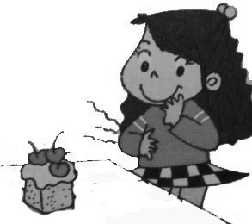
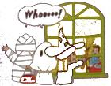
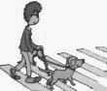
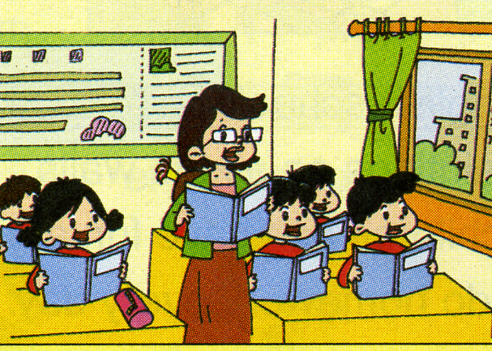
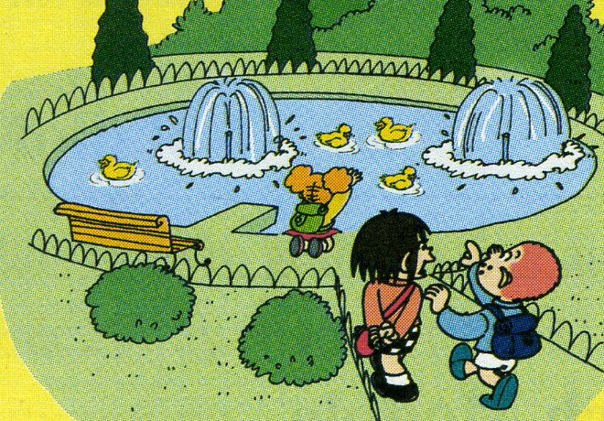

二、听音识图，判断正（√）误（×） 。
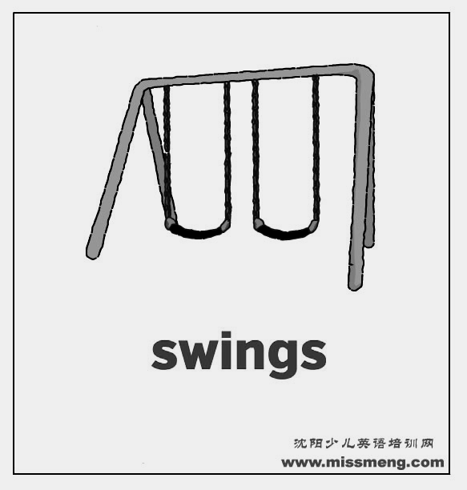
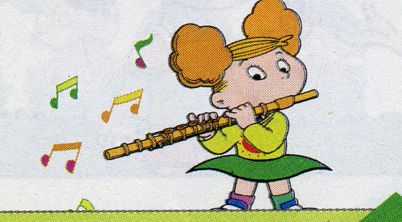
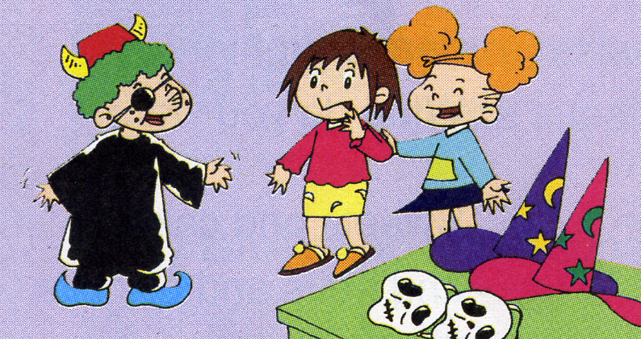
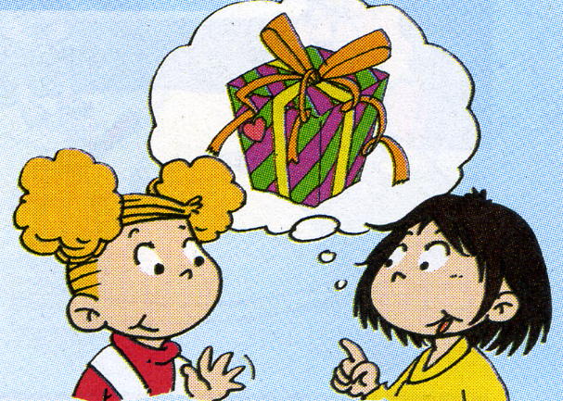
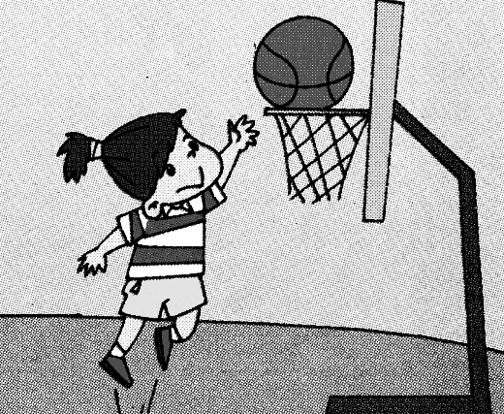

( ) ( ) ( ) ( ) ( )
Ⅲ、 听问句选答语，将其序号填在括号内。
( )1. A. Yes, she is. B. Yes, I am.
( )2. A. I’m sorry. B. You are welcome.
( )3. A. We are playing basketball. B. We’re going to clean the room.
( )4. A. Yes, he does. B. Yes, he can.
( )5. A.I want a white T-shirt. B. I went to a zoo.

Ⅵ、 听音，按所听顺序用数字（1、2、3、4、5）给下列句子重新排序。
2( ) They also sell clothes, toys and CDs.
( ) Many English supermarkets are very big.
( ) Sometimes there are restaurants at the supermarket.
( ) They sell food from lots of countries.
( ) They sell different things.

笔试部分（60分）
Ⅴ、英汉互译。
1._________________________(你不应该玩火。) 2.______________(晚安！)
3.__________________(下国际象棋) 4.____________________(玩玩具)
5. They go to people’s houses. And they scare the people.
________________________________________________________
Ⅵ、根据语境补全句子中的单词。
1. She was very thirsty. She drank some__________(水).
2. It isn’t _______________(他的). It’s mine.
3. We are doing ______________ __________________. (早操 )
4. Our team won. That’s ____________(真实的).
5. Amy’s ____________( 短裙 ) is dirty.

Ⅶ、 选择。
( ) 1. A: ________you sad? B: Yes, I am.
A. Were B. Are C. Is
( ) 2. We are going to_____________.
A. having lunch B. took photos C. dance together
( ) 3. This is _________book. That one is ____________.
A. me , yours B. my , yours C. my , your
( ) 4. In England, school starts at 9 o’clock and __________ at 3:30.
A. finishes B. finish C. finished
( ) 5. You ______________be late for school.
A. shouldn’t B. could C. should
Ⅷ、根据所提供的语境选择恰当的单词填空,将其序号填在前面的括号里。
A. break B. inside C. special D.miss E. kind

( ) 1. There were people _______the house.
( ) 2. I _______my grandma very much. I’m going to visit her.
( ) 3. English children can have fun at _______time.
( ) 4. The firemen had a _______dog. It could hear the people.
( ) 5. You should be __________.

Ⅸ、 根据问句选出答句，将序号填在括号里。
( ) 1.You shouldn’t play with the CDs! A、Yes, I am.
( ) 2. What’s the matter? B、It’s mine.
( ) 3. Are you going to sing a song? C、Yes, I can.
( ) 4. Whose bag is it? D、Nothing.
( ) 5. Can you run fast ? E、I’m sorry.
Ⅹ、 连词成句。
1. is / one / heavy / this / (.) _____________________________________________
2. too / many / there /sweets / are / (.) _____________________________________
3. to / what / going / are / do / you / (?) ___________________________________
4. the /can’t /people / Fifi / blind / help / (.) ________________________________
5. tidy / should / toys / you / your /(.) _____________________________________
Ⅺ、 阅读理解，判断正（T）误（F）。
Mrs White is from America. She works in a Chinese school. She has a lot of things(事情) to do next week. On Monday she is going to visit a school. On Tuesday afternoon she is going to the library. On Wednesday, after work she is going to see a film with her son, Tom. She is going to swim on Thursday. On Friday she is going to clean her house. Saturday is her birthday. She is going to have a birthday party with her family. On Sunday morning, she is going to the supermarket. She is going to buy lots of things(东西) for the family. What a busy( 繁忙的 ) woman !

( ) 1、Mrs White is a Chinese teacher.
( ) 2、She is going to swim on Friday.
( ) 3、She is going to have a birthday party On Saturday.
( ) 4、Tom is going to see a film on Wednesday.
( ) 5、She will be bored next week.
Ⅻ、 写作园地
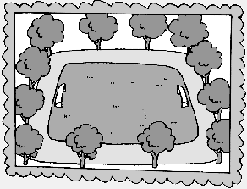
玲玲所在学校的校园进行了整修，她保留了整修前后的照片，请你仔细观察一下这两张照片，根据提示词写一写它们的不同之处。（3~5句话）
提示词：there was, there is, before, now.
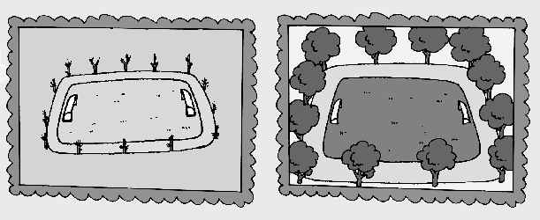
____________________________________
now
_____

before now
五年级英语听力题签:
※注意：每道听力试题读二遍。时间控制在20分钟以内。

Ⅰ、 听辨单词，选出你所听到的句子中的单词。
1. Don’t laugh here!
2. Sam got thirteen points and Amy got twenty-two points.
3. In October, every school in England has a food festival.
4. Students in our school study very hard.
5. They often have dinner in a restaurant.

Ⅱ、 听音辨图。
一、听音找图，用数字（1、2、3、4、5）给下列图片重新排序。
1. Today is Halloween.
2. This man is blind. This dog can help him.
3. We sit in lines in China.
4. She was hungry. She ate the cake.
5. There was a slide here before. But there is a pond here now.

二、听音识图，判断正（√）误（× ）。
1、Amy and Lingling are having a birthday cake now.
2、There are two swings here .
3、Children wear beautiful clothes.
4、Amy can play the flute well.
5、She can jump really high.

Ⅲ、 听问句选答语，将其序号填在括号内。
1. Is Amy angry?
2. Thank you for your help!
3. What are you going to do?
4. Can Sam catch the ball well?
5. What do you want?

Ⅵ、 听音，按所听顺序用数字（1、2、3、4、5）给下列句子重新排序。
Many English supermarkets are very big. They sell different things. They sell food from lots of countries. They also sell clothes, toys and CDs. Sometimes there are restaurants at the supermarket.

听力部分到此结束！

五年级英语答案及评分标准：
听力部分
Ⅰ、(2×5＝10分) BCACB
Ⅱ、(1×5 + 2×5＝15分) 5----2-----1----4-----3 ╳ √ ╳ √ √
Ⅲ、(2×5＝10分) ABBBA
Ⅳ、(1×5＝5分) 4----1----5----3----2
笔试部分
Ⅴ、(1×5＝5分)
1、You shouldn’t play with fire.
2、Good night !
3、play chess
4、play with toys
（注意 ：1——4必须完全准确方可得1分， 以上画有“——”的部分按0.5分扣除积分。）
5、他们常去人们的房子去吓唬人。（不离句子大意即可得分）
Ⅵ、(1×5＝5分) water , his , morning exercises (2个词各是0.5分) , true , skirt
（注意 ： 单词完全拼写准确方可得1分）
Ⅶ、(2×5＝10分) BCBAA
Ⅷ、(1×5＝5分) BDACE
Ⅸ、(2×5＝10分) EDABC
Ⅹ、(2×5＝10分)
1、This one is heavy.
2、There are many sweets , too. （学生没额外写上逗号，将扣掉0.5分）
3、What are you going to do ?
4、Fifi can’t help the blind people.
5、You should tidy your toys.
XI、(2×5＝10分) F F T T F
XII、(5分) 答案略。
请任教五年级的英语老师批阅作文，并自行把握评分标准,做到心中有数。
一等：4----5分（主题鲜明，表述恰当，语言结构准确。）
二等：3分（主题较为鲜明，表述较为恰当，语言结构较为准确。）
三等：0-----2分（主题朦胧，语言表述不清，错词乱句，信息模糊。）
备注：卷面满分为100分。（听力40分，笔试60分。）
优秀：90---100
良好：80---89
及格：60---79 2011年1月8日
不及格：0---59

